**Supplementary Materials for**

**Multi Contact-based Folding Method for *de novo* Protein Structure Prediction**

Minghua Hou, Chunxiang Peng, Xiaogen Zhou, Biao Zhang and Guijun Zhang∗

∗To whom correspondence should be addressed;

E-mail: zgj@zjut.edu.cn (Guijun Zhang);

**S6. Others.**

**Table S15**. Precision of five contact maps (Protein ID: 1AUU_A)

|  |  |  |  |  |  |  |  |  |  |  |  |
| --- | --- | --- | --- | --- | --- | --- | --- | --- | --- | --- | --- |
| ID: 1AUU_A | | MetaContact | | DeepMetaPSICOV | | RaptorX | | SpotContact | | TripletRes | |
| Range | List size | Precision | Count | Precision | Count | Precision | Count | Precision | Count | Precision | Count |
| medium and long | Top-L/5 | 1.000 | 11 | 0.909 | 11 | 0.909 | 11 | 1.000 | 11 | 1.000 | 11 |
| Top-L/2 | 0.929 | 28 | 0.929 | 28 | 0.857 | 28 | 0.964 | 28 | 0.964 | 28 |
| Top-L | 0.927 | 55 | 0.836 | 55 | 0.727 | 55 | 0.945 | 55 | 0.891 | 55 |
| Top-NC | 0.770 | 87 | 0.747 | 87 | 0.609 | 87 | 0.793 | 87 | 0.747 | 87 |
| long | Top-L/5 | 1.000 | 11 | 0.909 | 11 | 0.818 | 11 | 1.000 | 11 | 1.000 | 11 |
| Top-L/2 | 0.929 | 28 | 0.857 | 28 | 0.786 | 28 | 0.929 | 28 | 0.857 | 28 |
| Top-L | 0.618 | 55 | 0.582 | 55 | 0.545 | 55 | 0.600 | 55 | 0.600 | 55 |
| Top-NC | 0.861 | 36 | 0.778 | 36 | 0.667 | 36 | 0.861 | 36 | 0.778 | 36 |

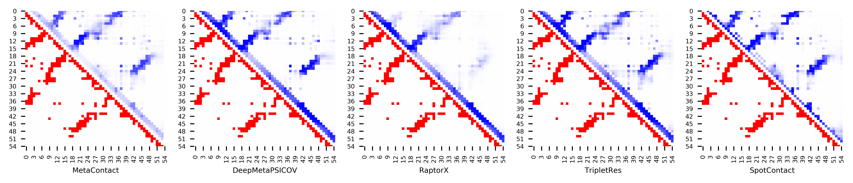

**Figure S9.** Five predicted contact maps (blue) with nature contacts (red) of target protein (1AUU_A)

**Table S16**. Precision of five contact maps (Protein ID: 1B4R_A)

|  |  |  |  |  |  |  |  |  |  |  |  |
| --- | --- | --- | --- | --- | --- | --- | --- | --- | --- | --- | --- |
| ID: 1B4R_A | | MetaContact | | DeepMetaPSICOV | | RaptorX | | SpotContact | | TripletRes | |
| Range | List size | Precision | Count | Precision | Count | Precision | Count | Precision | Count | Precision | Count |
| medium and long | Top-L/5 | 1.000 | 16 | 1.000 | 16 | 0.938 | 16 | 1.000 | 16 | 1.000 | 16 |
| Top-L/2 | 1.000 | 40 | 0.975 | 40 | 0.875 | 40 | 1.000 | 40 | 1.000 | 40 |
| Top-L | 0.963 | 80 | 0.950 | 80 | 0.788 | 80 | 0.963 | 80 | 0.913 | 80 |
| Top-NC | 0.783 | 189 | 0.640 | 189 | 0.646 | 189 | 0.757 | 189 | 0.783 | 189 |
| long | Top-L/5 | 1.000 | 16 | 1.000 | 16 | 0.938 | 16 | 1.000 | 16 | 1.000 | 16 |
| Top-L/2 | 0.975 | 40 | 0.950 | 40 | 0.875 | 40 | 0.975 | 40 | 0.950 | 40 |
| Top-L | 0.900 | 80 | 0.775 | 80 | 0.700 | 80 | 0.850 | 80 | 0.888 | 80 |
| Top-NC | 0.793 | 111 | 0.640 | 111 | 0.649 | 111 | 0.784 | 111 | 0.784 | 111 |

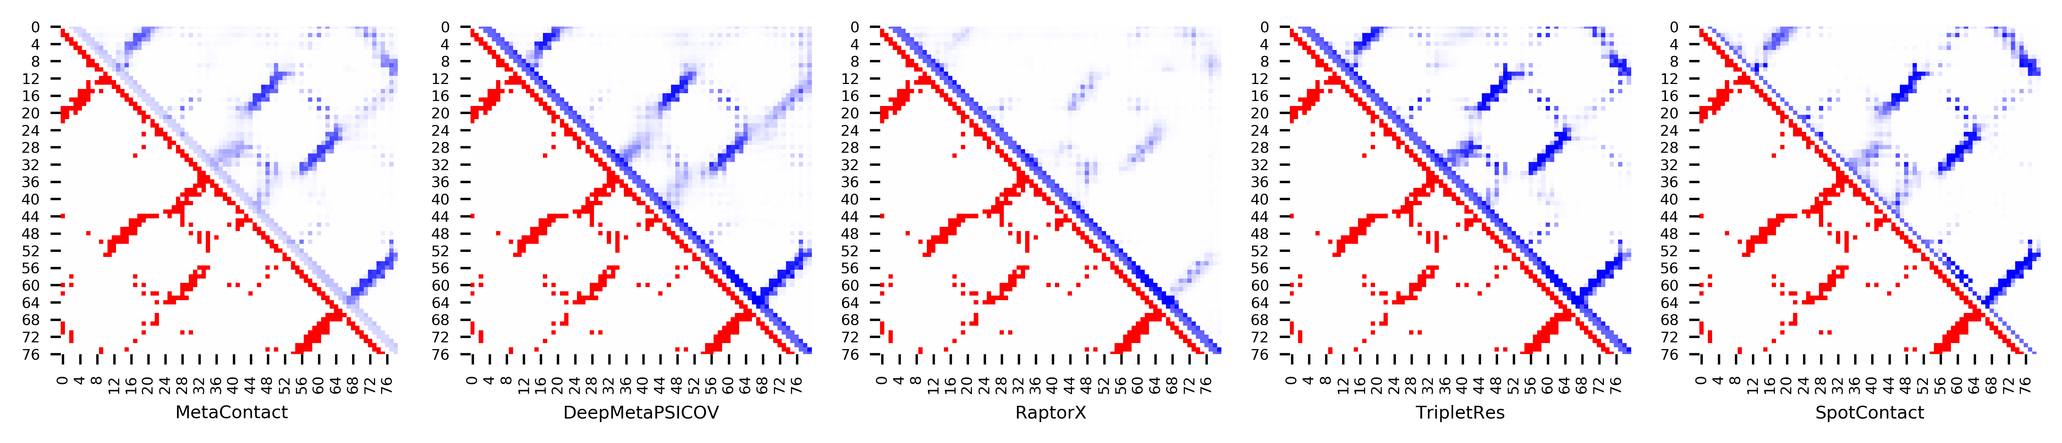

**Figure S10.** Five predicted contact maps (blue) with nature contacts (red) of target protein (1B4R_A)

**Table S17**. Precision of five contact maps (Protein ID: 1BJX_A)

|  |  |  |  |  |  |  |  |  |  |  |  |
| --- | --- | --- | --- | --- | --- | --- | --- | --- | --- | --- | --- |
| ID: 1BJX_A | | MetaContact | | DeepMetaPSICOV | | RaptorX | | SpotContact | | TripletRes | |
| Range | List size | Precision | Count | Precision | Count | Precision | Count | Precision | Count | Precision | Count |
| medium and long | Top-L/5 | 0.955 | 22 | 0.864 | 22 | 0.909 | 22 | 1.000 | 22 | 1.000 | 22 |
| Top-L/2 | 0.891 | 55 | 0.909 | 55 | 0.927 | 55 | 0.945 | 55 | 0.909 | 55 |
| Top-L | 0.927 | 110 | 0.864 | 110 | 0.891 | 110 | 0.927 | 110 | 0.818 | 110 |
| Top-NC | 0.781 | 160 | 0.719 | 160 | 0.781 | 160 | 0.806 | 160 | 0.731 | 160 |
| long | Top-L/5 | 0.955 | 22 | 0.955 | 22 | 0.909 | 22 | 1.000 | 22 | 1.000 | 22 |
| Top-L/2 | 0.945 | 55 | 0.927 | 55 | 0.945 | 55 | 0.945 | 55 | 0.945 | 55 |
| Top-L | 0.882 | 110 | 0.855 | 110 | 0.882 | 110 | 0.927 | 110 | 0.809 | 110 |
| Top-NC | 0.789 | 142 | 0.746 | 142 | 0.810 | 142 | 0.810 | 142 | 0.739 | 142 |

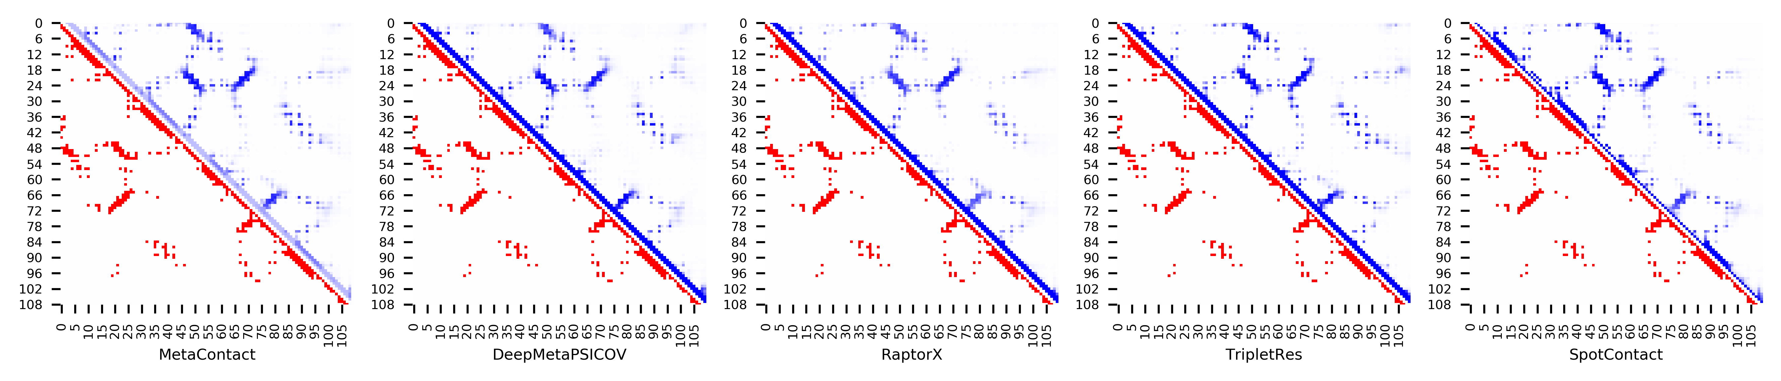

**Figure S11.** Five predicted contact maps (blue) with nature contacts (red) of target protein (1BJX_A)

**Table S18**. Precision of five contact maps (Protein ID: 1C03_A)

|  |  |  |  |  |  |  |  |  |  |  |  |
| --- | --- | --- | --- | --- | --- | --- | --- | --- | --- | --- | --- |
| ID: 1C03_A | | MetaContact | | DeepMetaPSICOV | | RaptorX | | SpotContact | | TripletRes | |
| Range | List size | Precision | Count | Precision | Count | Precision | Count | Precision | Count | Precision | Count |
| medium and long | Top-L/5 | 0.970 | 33 | 1.000 | 33 | 0.970 | 33 | 1.000 | 33 | 0.970 | 33 |
| Top-L/2 | 0.939 | 82 | 0.829 | 82 | 0.915 | 82 | 0.915 | 82 | 0.890 | 82 |
| Top-L | 0.687 | 163 | 0.595 | 163 | 0.650 | 163 | 0.718 | 163 | 0.638 | 163 |
| Top-NC | 0.615 | 200 | 0.510 | 200 | 0.555 | 200 | 0.610 | 200 | 0.550 | 200 |
| long | Top-L/5 | 0.970 | 33 | 1.000 | 33 | 0.909 | 33 | 1.000 | 33 | 0.939 | 33 |
| Top-L/2 | 0.866 | 82 | 0.744 | 82 | 0.841 | 82 | 0.890 | 82 | 0.817 | 82 |
| Top-L | 0.601 | 163 | 0.497 | 163 | 0.546 | 163 | 0.607 | 163 | 0.540 | 163 |
| Top-NC | 0.609 | 161 | 0.503 | 161 | 0.553 | 161 | 0.615 | 161 | 0.540 | 161 |

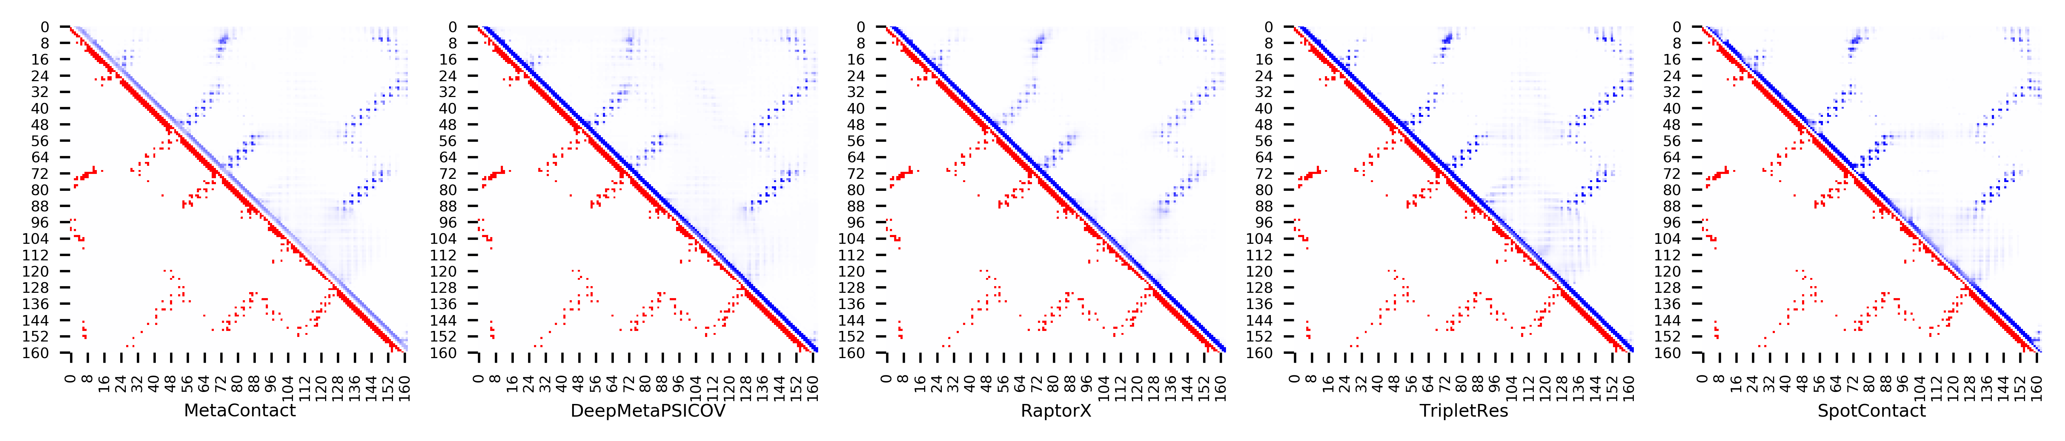

**Figure S12.** Five predicted contact maps (blue) with nature contacts (red) of target protein (1C03_A)

**Table S19**. Precision of five contact maps (Protein ID: 1C41_A)

|  |  |  |  |  |  |  |  |  |  |  |  |
| --- | --- | --- | --- | --- | --- | --- | --- | --- | --- | --- | --- |
| ID: 1C41_A | | MetaContact | | DeepMetaPSICOV | | RaptorX | | SpotContact | | TripletRes | |
| Range | List size | Precision | Count | Precision | Count | Precision | Count | Precision | Count | Precision | Count |
| medium and long | Top-L/5 | 0.970 | 33 | 0.939 | 33 | 1.000 | 33 | 0.970 | 33 | 0.939 | 33 |
| Top-L/2 | 0.976 | 82 | 0.976 | 82 | 0.988 | 82 | 0.976 | 82 | 0.963 | 82 |
| Top-L | 0.970 | 165 | 0.945 | 165 | 0.988 | 165 | 0.964 | 165 | 0.921 | 165 |
| Top-NC | 0.839 | 311 | 0.772 | 311 | 0.859 | 311 | 0.839 | 311 | 0.743 | 311 |
| long | Top-L/5 | 0.970 | 33 | 0.939 | 33 | 1.000 | 33 | 0.970 | 33 | 0.939 | 33 |
| Top-L/2 | 0.976 | 82 | 0.976 | 82 | 0.988 | 82 | 0.976 | 82 | 0.963 | 82 |
| Top-L | 0.970 | 165 | 0.903 | 165 | 0.970 | 165 | 0.952 | 165 | 0.897 | 165 |
| Top-NC | 0.840 | 281 | 0.765 | 281 | 0.854 | 281 | 0.840 | 281 | 0.740 | 281 |

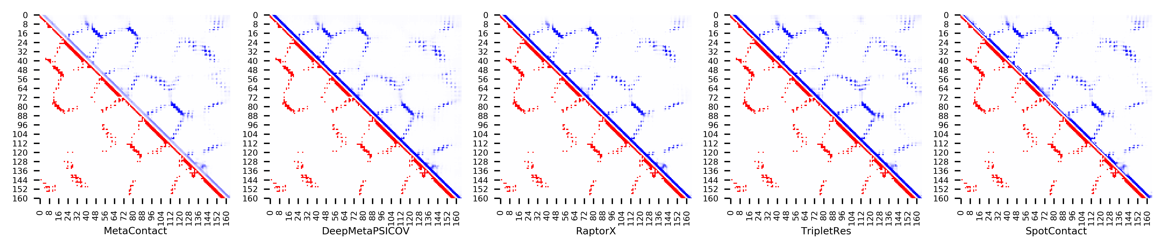

**Figure S13.** Five predicted contact maps (blue) with nature contacts (red) of target protein (1C41_A)

**Table S20**. Precision of five contact maps (Protein ID: 1CTO_A)

|  |  |  |  |  |  |  |  |  |  |  |  |
| --- | --- | --- | --- | --- | --- | --- | --- | --- | --- | --- | --- |
| ID: 1CTO_A | | MetaContact | | DeepMetaPSICOV | | RaptorX | | SpotContact | | TripletRes | |
| Range | List size | Precision | Count | Precision | Count | Precision | Count | Precision | Count | Precision | Count |
| medium and long | Top-L/5 | 0.909 | 22 | 0.909 | 22 | 0.864 | 22 | 0.955 | 22 | 0.955 | 22 |
| Top-L/2 | 0.889 | 54 | 0.907 | 54 | 0.815 | 54 | 0.907 | 54 | 0.852 | 54 |
| Top-L | 0.761 | 109 | 0.725 | 109 | 0.761 | 109 | 0.752 | 109 | 0.752 | 109 |
| Top-NC | 0.677 | 198 | 0.601 | 198 | 0.621 | 198 | 0.667 | 198 | 0.616 | 198 |
| long | Top-L/5 | 0.909 | 22 | 0.955 | 22 | 0.818 | 22 | 0.955 | 22 | 0.909 | 22 |
| Top-L/2 | 0.852 | 54 | 0.815 | 54 | 0.796 | 54 | 0.833 | 54 | 0.815 | 54 |
| Top-L | 0.725 | 109 | 0.633 | 109 | 0.679 | 109 | 0.688 | 109 | 0.587 | 109 |
| Top-NC | 0.620 | 142 | 0.592 | 142 | 0.599 | 142 | 0.627 | 142 | 0.563 | 142 |

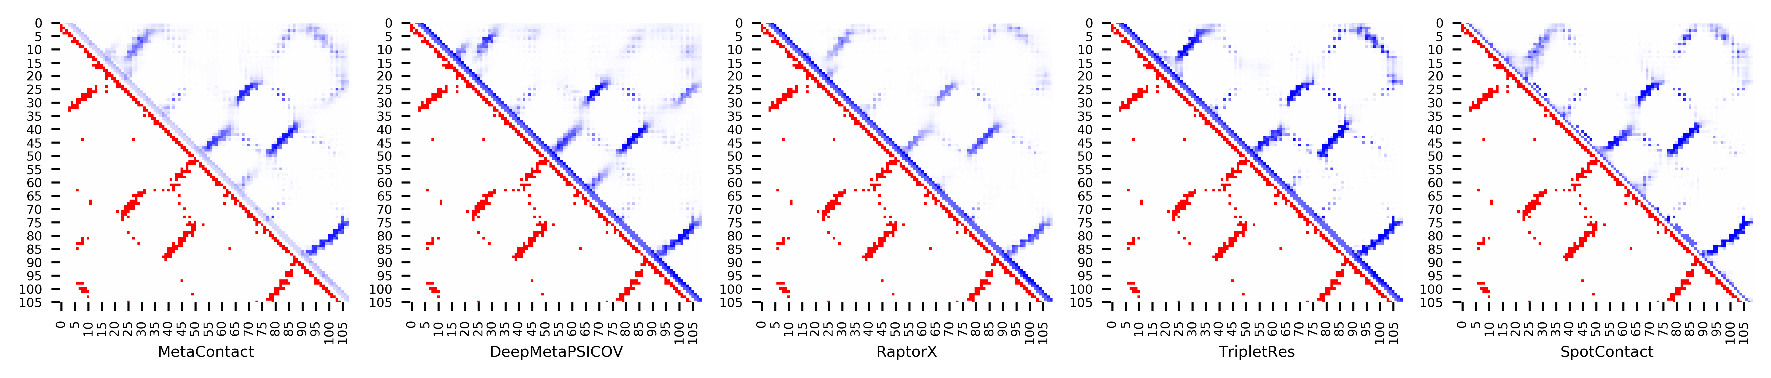

**Figure S14.** Five predicted contact maps (blue) with nature contacts (red) of target protein (1CTO_A)

**Table S21**. Precision of five contact maps (Protein ID: 1D8B_A)

|  |  |  |  |  |  |  |  |  |  |  |  |
| --- | --- | --- | --- | --- | --- | --- | --- | --- | --- | --- | --- |
| ID: 1D8B_A | | MetaContact | | DeepMetaPSICOV | | RaptorX | | SpotContact | | TripletRes | |
| Range | List size | Precision | Count | Precision | Count | Precision | Count | Precision | Count | Precision | Count |
| medium and long | Top-L/5 | 0.875 | 16 | 0.625 | 16 | 0.688 | 16 | 1.000 | 16 | 0.938 | 16 |
| Top-L/2 | 0.750 | 40 | 0.525 | 40 | 0.600 | 40 | 0.800 | 40 | 0.750 | 40 |
| Top-L | 0.593 | 81 | 0.370 | 81 | 0.420 | 81 | 0.593 | 81 | 0.556 | 81 |
| Top-NC | 0.677 | 65 | 0.431 | 65 | 0.492 | 65 | 0.708 | 65 | 0.631 | 65 |
| long | Top-L/5 | 0.750 | 16 | 0.625 | 16 | 0.750 | 16 | 0.938 | 16 | 1.000 | 16 |
| Top-L/2 | 0.700 | 40 | 0.450 | 40 | 0.575 | 40 | 0.750 | 40 | 0.700 | 40 |
| Top-L | 0.444 | 81 | 0.346 | 81 | 0.370 | 81 | 0.481 | 81 | 0.432 | 81 |
| Top-NC | 0.673 | 49 | 0.429 | 49 | 0.510 | 49 | 0.694 | 49 | 0.612 | 49 |

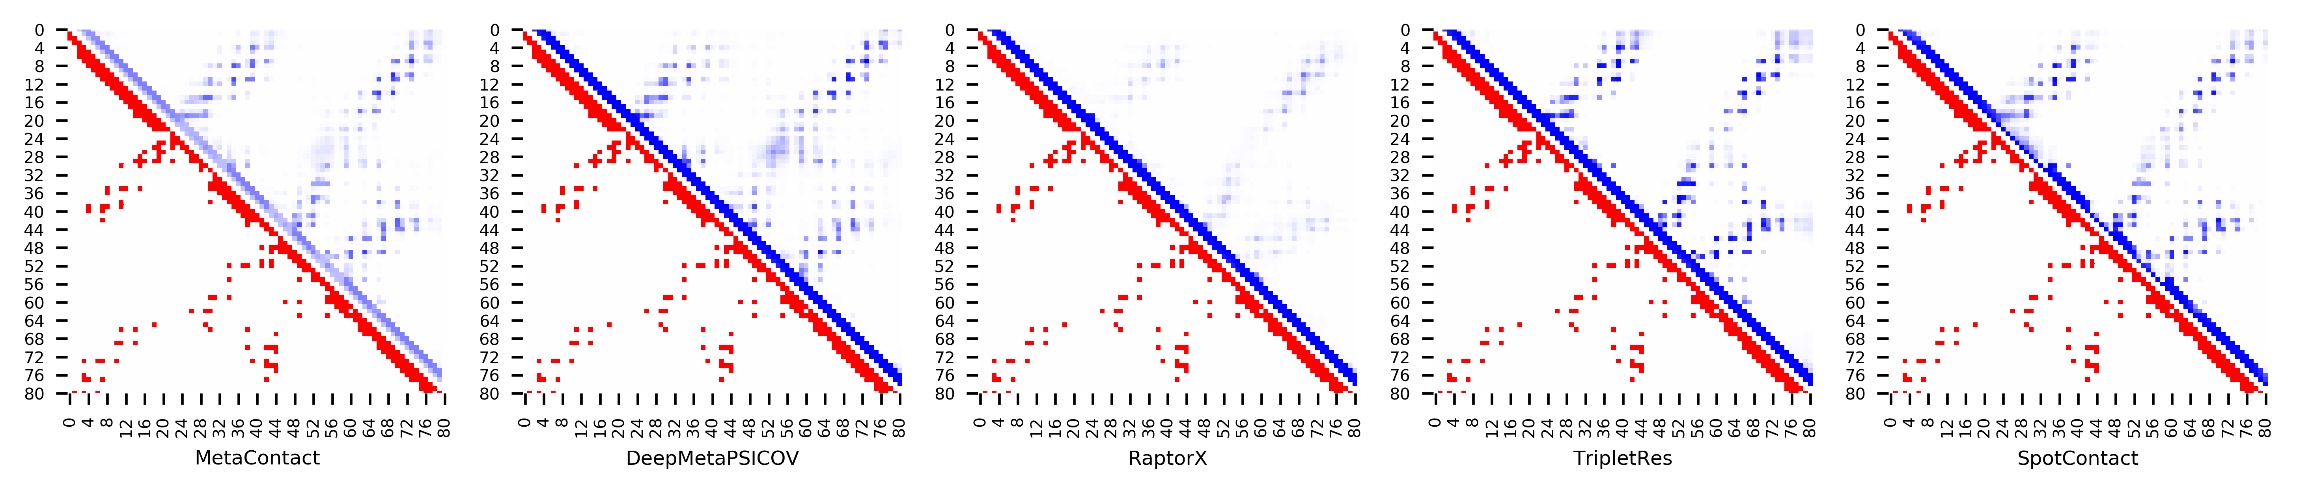

**Figure S15.** Five predicted contact maps (blue) with nature contacts (red) of target protein (1D8B_A)

**Table S22**. Precision of five contact maps (Protein ID: 1DCF_A)

|  |  |  |  |  |  |  |  |  |  |  |  |
| --- | --- | --- | --- | --- | --- | --- | --- | --- | --- | --- | --- |
| ID: 1DCF_A | | MetaContact | | DeepMetaPSICOV | | RaptorX | | SpotContact | | TripletRes | |
| Range | List size | Precision | Count | Precision | Count | Precision | Count | Precision | Count | Precision | Count |
| medium and long | Top-L/5 | 0.963 | 27 | 1.000 | 27 | 0.741 | 27 | 1.000 | 27 | 0.963 | 27 |
| Top-L/2 | 0.970 | 66 | 0.985 | 66 | 0.758 | 66 | 1.000 | 66 | 0.985 | 66 |
| Top-L | 0.932 | 133 | 0.865 | 133 | 0.639 | 133 | 0.962 | 133 | 0.895 | 133 |
| Top-NC | 0.775 | 231 | 0.710 | 231 | 0.524 | 231 | 0.814 | 231 | 0.753 | 231 |
| long | Top-L/5 | 0.963 | 27 | 0.963 | 27 | 0.741 | 27 | 1.000 | 27 | 1.000 | 27 |
| Top-L/2 | 0.970 | 66 | 0.924 | 66 | 0.682 | 66 | 0.985 | 66 | 0.955 | 66 |
| Top-L | 0.827 | 133 | 0.737 | 133 | 0.564 | 133 | 0.880 | 133 | 0.812 | 133 |
| Top-NC | 0.752 | 165 | 0.679 | 165 | 0.509 | 165 | 0.806 | 165 | 0.745 | 165 |

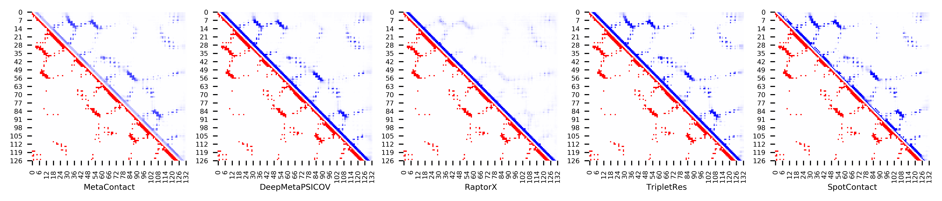

**Figure S16.** Five predicted contact maps (blue) with nature contacts (red) of target protein (1DCF_A)

**Table S23**. Precision of five contact maps (Protein ID: 1DWM_A)

|  |  |  |  |  |  |  |  |  |  |  |  |
| --- | --- | --- | --- | --- | --- | --- | --- | --- | --- | --- | --- |
| ID: 1DWM_A | | MetaContact | | DeepMetaPSICOV | | RaptorX | | SpotContact | | TripletRes | |
| Range | List size | Precision | Count | Precision | Count | Precision | Count | Precision | Count | Precision | Count |
| medium and long | Top-L/5 | 1.000 | 14 | 1.000 | 14 | 0.929 | 14 | 1.000 | 14 | 1.000 | 14 |
| Top-L/2 | 1.000 | 34 | 1.000 | 34 | 0.941 | 34 | 1.000 | 34 | 1.000 | 34 |
| Top-L | 0.942 | 69 | 0.913 | 69 | 0.826 | 69 | 0.942 | 69 | 0.913 | 69 |
| Top-NC | 0.723 | 130 | 0.700 | 130 | 0.662 | 130 | 0.738 | 130 | 0.723 | 130 |
| long | Top-L/5 | 1.000 | 14 | 1.000 | 14 | 1.000 | 14 | 1.000 | 14 | 1.000 | 14 |
| Top-L/2 | 1.000 | 34 | 0.912 | 34 | 0.912 | 34 | 0.971 | 34 | 0.882 | 34 |
| Top-L | 0.609 | 69 | 0.623 | 69 | 0.638 | 69 | 0.623 | 69 | 0.609 | 69 |
| Top-NC | 0.656 | 64 | 0.656 | 64 | 0.672 | 64 | 0.625 | 64 | 0.656 | 64 |

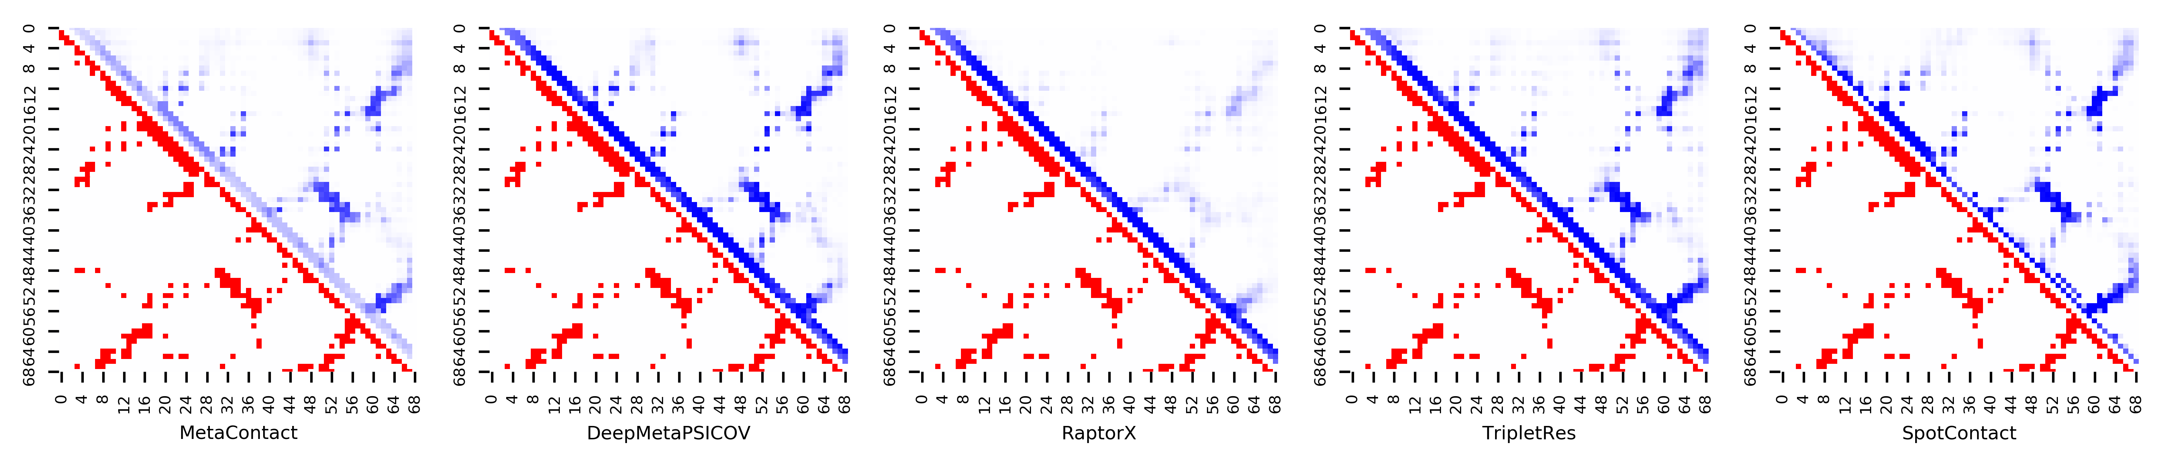

**Figure S17.** Five predicted contact maps (blue) with nature contacts (red) of target protein (1DWM_A)

**Table S24**. Precision of five contact maps (Protein ID: 1EKZ_A)

|  |  |  |  |  |  |  |  |  |  |  |  |
| --- | --- | --- | --- | --- | --- | --- | --- | --- | --- | --- | --- |
| ID: 1EKZ_A | | MetaContact | | DeepMetaPSICOV | | RaptorX | | SpotContact | | TripletRes | |
| Range | List size | Precision | Count | Precision | Count | Precision | Count | Precision | Count | Precision | Count |
| medium and long | Top-L/5 | 0.867 | 15 | 1.000 | 15 | 0.867 | 15 | 1.000 | 15 | 1.000 | 15 |
| Top-L/2 | 0.921 | 38 | 0.895 | 38 | 0.684 | 38 | 0.895 | 38 | 0.895 | 38 |
| Top-L | 0.868 | 76 | 0.816 | 76 | 0.605 | 76 | 0.855 | 76 | 0.816 | 76 |
| Top-NC | 0.782 | 101 | 0.762 | 101 | 0.525 | 101 | 0.772 | 101 | 0.752 | 101 |
| long | Top-L/5 | 1.000 | 15 | 1.000 | 15 | 0.667 | 15 | 1.000 | 15 | 0.933 | 15 |
| Top-L/2 | 0.763 | 38 | 0.737 | 38 | 0.553 | 38 | 0.737 | 38 | 0.684 | 38 |
| Top-L | 0.447 | 76 | 0.421 | 76 | 0.342 | 76 | 0.474 | 76 | 0.434 | 76 |
| Top-NC | 0.725 | 40 | 0.725 | 40 | 0.525 | 40 | 0.725 | 40 | 0.675 | 40 |

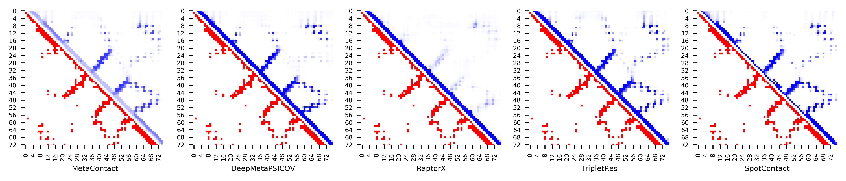

**Figure S18.** Five predicted contact maps (blue) with nature contacts (red) of target protein (1EKZ_A)

**Table S25**. Precision of five contact maps (Protein ID: 1ELW_A)

|  |  |  |  |  |  |  |  |  |  |  |  |
| --- | --- | --- | --- | --- | --- | --- | --- | --- | --- | --- | --- |
| ID: 1ELW_A | | MetaContact | | DeepMetaPSICOV | | RaptorX | | SpotContact | | TripletRes | |
| Range | List size | Precision | Count | Precision | Count | Precision | Count | Precision | Count | Precision | Count |
| medium and long | Top-L/5 | 1.000 | 23 | 1.000 | 23 | 1.000 | 23 | 1.000 | 23 | 1.000 | 23 |
| Top-L/2 | 0.983 | 58 | 0.983 | 58 | 0.966 | 58 | 1.000 | 58 | 0.983 | 58 |
| Top-L | 0.957 | 117 | 0.932 | 117 | 0.769 | 117 | 0.966 | 117 | 0.923 | 117 |
| Top-NC | 0.871 | 155 | 0.813 | 155 | 0.658 | 155 | 0.865 | 155 | 0.858 | 155 |
| long | Top-L/5 | 1.000 | 23 | 1.000 | 23 | 1.000 | 23 | 1.000 | 23 | 1.000 | 23 |
| Top-L/2 | 0.983 | 58 | 0.914 | 58 | 0.810 | 58 | 0.983 | 58 | 0.914 | 58 |
| Top-L | 0.632 | 117 | 0.607 | 117 | 0.504 | 117 | 0.667 | 117 | 0.641 | 117 |
| Top-NC | 0.845 | 84 | 0.738 | 84 | 0.619 | 84 | 0.833 | 84 | 0.833 | 84 |

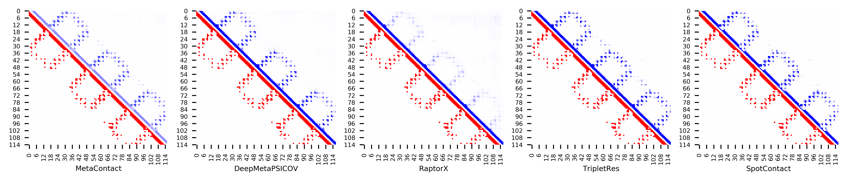

**Figure S19.** Five predicted contact maps (blue) with nature contacts (red) of target protein (1ELW_A)

**Table S26**. Precision of five contact maps (Protein ID: 1EM8_D)

|  |  |  |  |  |  |  |  |  |  |  |  |
| --- | --- | --- | --- | --- | --- | --- | --- | --- | --- | --- | --- |
| ID: 1EM8_D | | MetaContact | | DeepMetaPSICOV | | RaptorX | | SpotContact | | TripletRes | |
| Range | List size | Precision | Count | Precision | Count | Precision | Count | Precision | Count | Precision | Count |
| medium and long | Top-L/5 | 1.000 | 22 | 0.909 | 22 | 1.000 | 22 | 1.000 | 22 | 1.000 | 22 |
| Top-L/2 | 0.964 | 56 | 0.839 | 56 | 0.982 | 56 | 0.911 | 56 | 0.857 | 56 |
| Top-L | 0.839 | 112 | 0.714 | 112 | 0.884 | 112 | 0.830 | 112 | 0.777 | 112 |
| Top-NC | 0.728 | 169 | 0.627 | 169 | 0.775 | 169 | 0.651 | 169 | 0.675 | 169 |
| long | Top-L/5 | 0.955 | 22 | 0.818 | 22 | 1.000 | 22 | 0.955 | 22 | 0.909 | 22 |
| Top-L/2 | 0.893 | 56 | 0.732 | 56 | 0.929 | 56 | 0.875 | 56 | 0.821 | 56 |
| Top-L | 0.723 | 112 | 0.607 | 112 | 0.777 | 112 | 0.625 | 112 | 0.661 | 112 |
| Top-NC | 0.730 | 111 | 0.613 | 111 | 0.775 | 111 | 0.631 | 111 | 0.667 | 111 |

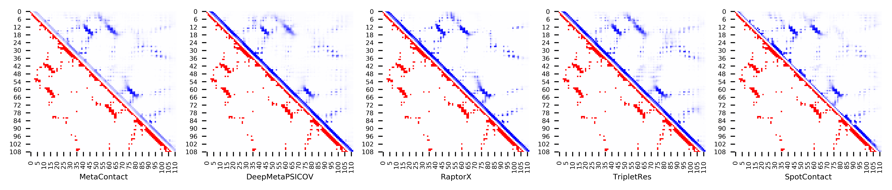

**Figure S20.** Five predicted contact maps (blue) with nature contacts (red) of target protein (1EM8_D)

**Table S27**. Precision of five contact maps (Protein ID: 1F43_A)

|  |  |  |  |  |  |  |  |  |  |  |  |
| --- | --- | --- | --- | --- | --- | --- | --- | --- | --- | --- | --- |
| ID: 1F43_A | | MetaContact | | DeepMetaPSICOV | | RaptorX | | SpotContact | | TripletRes | |
| Range | List size | Precision | Count | Precision | Count | Precision | Count | Precision | Count | Precision | Count |
| medium and long | Top-L/5 | 0.667 | 12 | 0.500 | 12 | 0.083 | 12 | 0.667 | 12 | 0.667 | 12 |
| Top-L/2 | 0.467 | 30 | 0.433 | 30 | 0.133 | 30 | 0.533 | 30 | 0.433 | 30 |
| Top-L | 0.295 | 61 | 0.295 | 61 | 0.115 | 61 | 0.295 | 61 | 0.279 | 61 |
| Top-NC | 0.412 | 34 | 0.412 | 34 | 0.118 | 34 | 0.471 | 34 | 0.441 | 34 |
| long | Top-L/5 | 0.417 | 12 | 0.417 | 12 | 0.083 | 12 | 0.500 | 12 | 0.417 | 12 |
| Top-L/2 | 0.300 | 30 | 0.267 | 30 | 0.100 | 30 | 0.300 | 30 | 0.267 | 30 |
| Top-L | 0.180 | 61 | 0.180 | 61 | 0.098 | 61 | 0.164 | 61 | 0.164 | 61 |
| Top-NC | 0.300 | 20 | 0.350 | 20 | 0.100 | 20 | 0.400 | 20 | 0.300 | 20 |

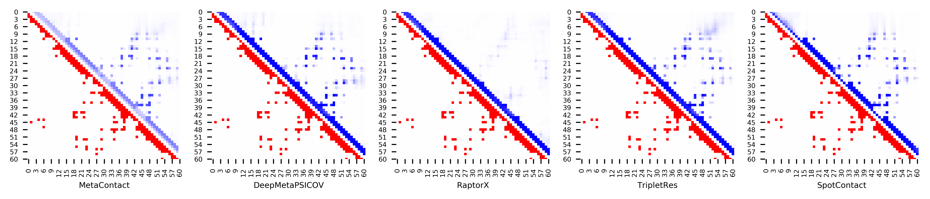

**Figure S21.** Five predicted contact maps (blue) with nature contacts (red) of target protein (1F43_A)

**Table S28**. Precision of five contact maps (Protein ID: 1FCA_A)

|  |  |  |  |  |  |  |  |  |  |  |  |
| --- | --- | --- | --- | --- | --- | --- | --- | --- | --- | --- | --- |
| ID: 1FCA_A | | MetaContact | | DeepMetaPSICOV | | RaptorX | | SpotContact | | TripletRes | |
| Range | List size | Precision | Count | Precision | Count | Precision | Count | Precision | Count | Precision | Count |
| medium and long | Top-L/5 | 0.909 | 11 | 0.909 | 11 | 1.000 | 11 | 1.000 | 11 | 0.909 | 11 |
| Top-L/2 | 0.857 | 28 | 0.786 | 28 | 0.679 | 28 | 0.929 | 28 | 0.786 | 28 |
| Top-L | 0.782 | 55 | 0.600 | 55 | 0.582 | 55 | 0.818 | 55 | 0.618 | 55 |
| Top-NC | 0.646 | 82 | 0.439 | 82 | 0.463 | 82 | 0.671 | 82 | 0.622 | 82 |
| long | Top-L/5 | 1.000 | 11 | 0.909 | 11 | 0.909 | 11 | 1.000 | 11 | 1.000 | 11 |
| Top-L/2 | 0.821 | 28 | 0.821 | 28 | 0.643 | 28 | 0.964 | 28 | 0.679 | 28 |
| Top-L | 0.673 | 55 | 0.509 | 55 | 0.491 | 55 | 0.727 | 55 | 0.618 | 55 |
| Top-NC | 0.673 | 55 | 0.509 | 55 | 0.491 | 55 | 0.727 | 55 | 0.618 | 55 |

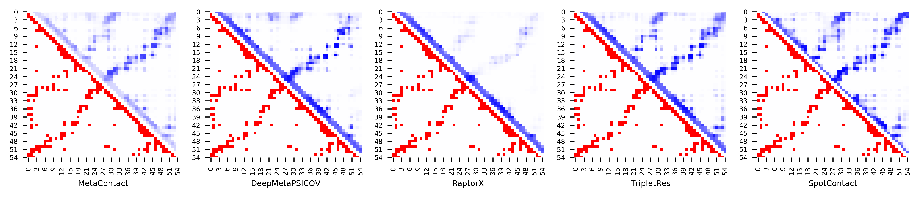

**Figure S22.** Five predicted contact maps (blue) with nature contacts (red) of target protein (1FCA_A)

**Table S29**. Precision of five contact maps (Protein ID: 1FEX_A)

|  |  |  |  |  |  |  |  |  |  |  |  |
| --- | --- | --- | --- | --- | --- | --- | --- | --- | --- | --- | --- |
| ID: 1FEX_A | | MetaContact | | DeepMetaPSICOV | | RaptorX | | SpotContact | | TripletRes | |
| Range | List size | Precision | Count | Precision | Count | Precision | Count | Precision | Count | Precision | Count |
| medium and long | Top-L/5 | 0.833 | 12 | 0.667 | 12 | 0.750 | 12 | 0.583 | 12 | 0.833 | 12 |
| Top-L/2 | 0.667 | 30 | 0.633 | 30 | 0.667 | 30 | 0.533 | 30 | 0.600 | 30 |
| Top-L | 0.424 | 59 | 0.390 | 59 | 0.458 | 59 | 0.407 | 59 | 0.390 | 59 |
| Top-NC | 0.513 | 39 | 0.513 | 39 | 0.564 | 39 | 0.462 | 39 | 0.487 | 39 |
| long | Top-L/5 | 0.583 | 12 | 0.500 | 12 | 0.583 | 12 | 0.417 | 12 | 0.500 | 12 |
| Top-L/2 | 0.400 | 30 | 0.333 | 30 | 0.367 | 30 | 0.333 | 30 | 0.300 | 30 |
| Top-L | 0.288 | 59 | 0.288 | 59 | 0.305 | 59 | 0.288 | 59 | 0.254 | 59 |
| Top-NC | 0.360 | 25 | 0.400 | 25 | 0.440 | 25 | 0.360 | 25 | 0.320 | 25 |

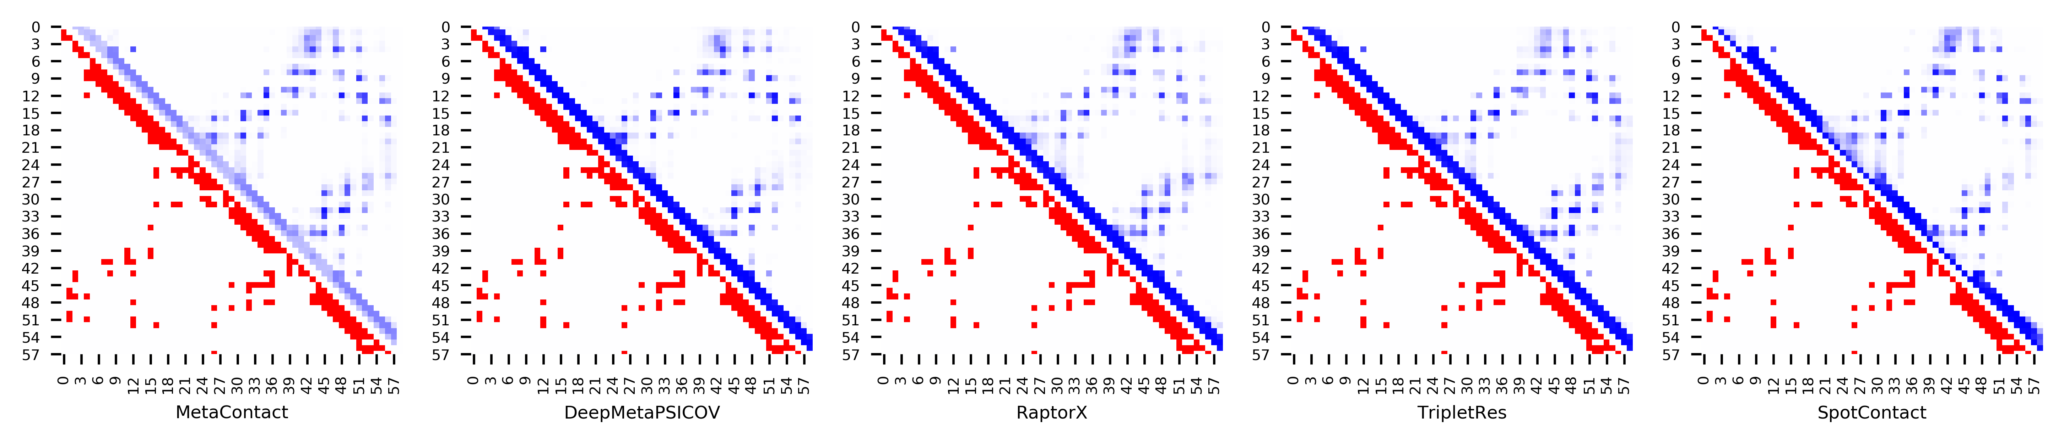

**Figure S23.** Five predicted contact maps (blue) with nature contacts (red) of target protein (1FEX_A)

**Table S30**. Precision of five contact maps (Protein ID: 1FRD_A)

|  |  |  |  |  |  |  |  |  |  |  |  |
| --- | --- | --- | --- | --- | --- | --- | --- | --- | --- | --- | --- |
| ID: 1FRD_A | | MetaContact | | DeepMetaPSICOV | | RaptorX | | SpotContact | | TripletRes | |
| Range | List size | Precision | Count | Precision | Count | Precision | Count | Precision | Count | Precision | Count |
| medium and long | Top-L/5 | 1.000 | 20 | 1.000 | 20 | 0.950 | 20 | 1.000 | 20 | 1.000 | 20 |
| Top-L/2 | 1.000 | 49 | 1.000 | 49 | 0.878 | 49 | 1.000 | 49 | 0.980 | 49 |
| Top-L | 0.949 | 98 | 0.929 | 98 | 0.765 | 98 | 0.918 | 98 | 0.918 | 98 |
| Top-NC | 0.737 | 190 | 0.711 | 190 | 0.563 | 190 | 0.753 | 190 | 0.700 | 190 |
| long | Top-L/5 | 1.000 | 20 | 1.000 | 20 | 0.900 | 20 | 1.000 | 20 | 0.950 | 20 |
| Top-L/2 | 0.980 | 49 | 0.980 | 49 | 0.796 | 49 | 0.959 | 49 | 0.939 | 49 |
| Top-L | 0.827 | 98 | 0.827 | 98 | 0.622 | 98 | 0.816 | 98 | 0.776 | 98 |
| Top-NC | 0.754 | 126 | 0.722 | 126 | 0.563 | 126 | 0.738 | 126 | 0.722 | 126 |

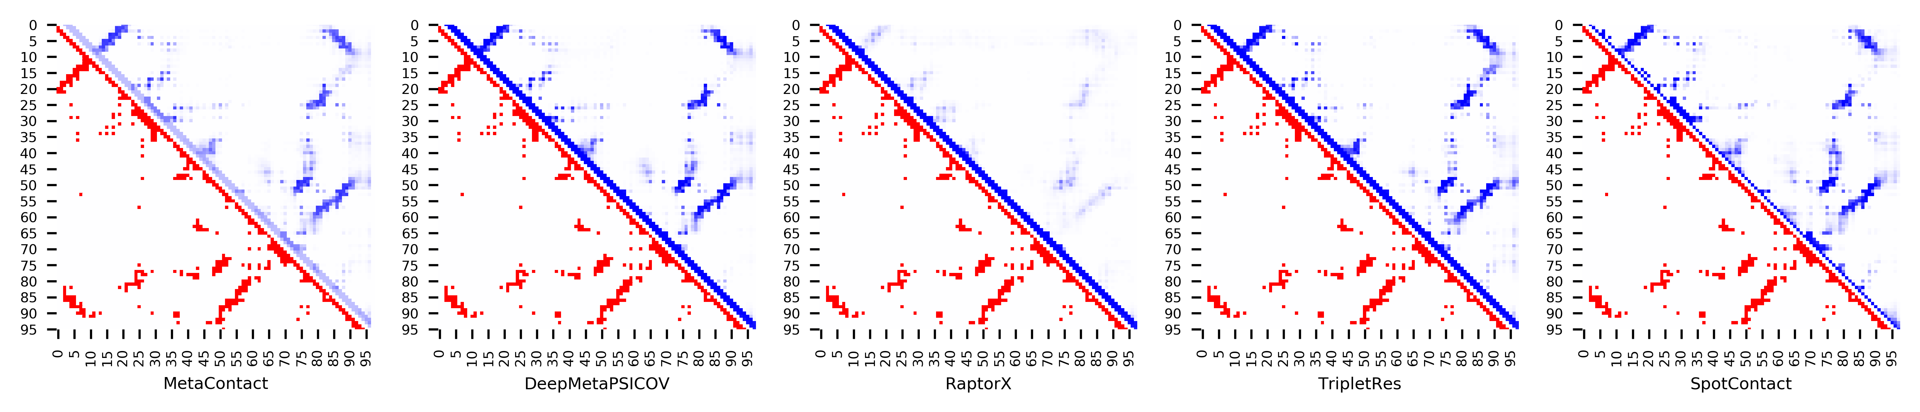

**Figure S24.** Five predicted contact maps (blue) with nature contacts (red) of target protein (1FRD_A)

**Table S31**. Precision of five contact maps (Protein ID: 1FSP_A)

|  |  |  |  |  |  |  |  |  |  |  |  |
| --- | --- | --- | --- | --- | --- | --- | --- | --- | --- | --- | --- |
| ID: 1FSP_A | | MetaContact | | DeepMetaPSICOV | | RaptorX | | SpotContact | | TripletRes | |
| Range | List size | Precision | Count | Precision | Count | Precision | Count | Precision | Count | Precision | Count |
| medium and long | Top-L/5 | 1.000 | 25 | 1.000 | 25 | 0.840 | 25 | 1.000 | 25 | 1.000 | 25 |
| Top-L/2 | 0.984 | 62 | 0.984 | 62 | 0.790 | 62 | 0.968 | 62 | 0.968 | 62 |
| Top-L | 0.911 | 124 | 0.887 | 124 | 0.621 | 124 | 0.911 | 124 | 0.871 | 124 |
| Top-NC | 0.773 | 194 | 0.753 | 194 | 0.546 | 194 | 0.799 | 194 | 0.763 | 194 |
| long | Top-L/5 | 1.000 | 25 | 1.000 | 25 | 0.840 | 25 | 1.000 | 25 | 1.000 | 25 |
| Top-L/2 | 0.984 | 62 | 0.952 | 62 | 0.758 | 62 | 0.935 | 62 | 0.952 | 62 |
| Top-L | 0.823 | 124 | 0.782 | 124 | 0.581 | 124 | 0.839 | 124 | 0.823 | 124 |
| Top-NC | 0.770 | 135 | 0.756 | 135 | 0.548 | 135 | 0.800 | 135 | 0.763 | 135 |

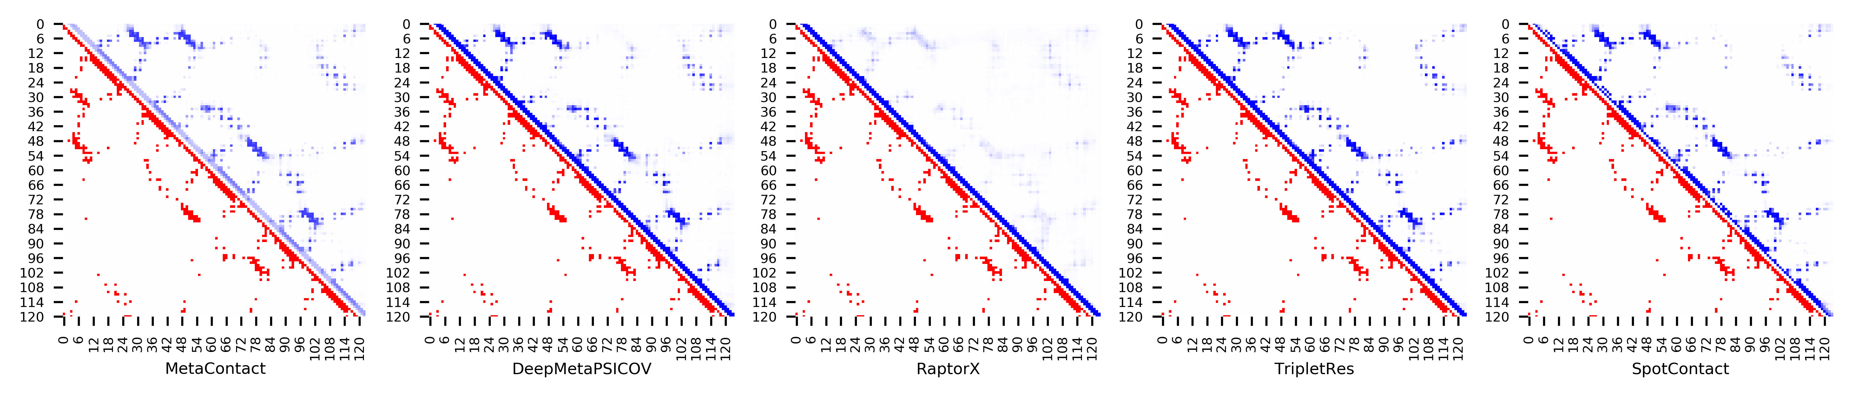

**Figure S25.** Five predicted contact maps (blue) with nature contacts (red) of target protein (1FSP_A)

**Table S32**. Precision of five contact maps (Protein ID: 1FW9_A)

|  |  |  |  |  |  |  |  |  |  |  |  |
| --- | --- | --- | --- | --- | --- | --- | --- | --- | --- | --- | --- |
| ID: 1FW9_A | | MetaContact | | DeepMetaPSICOV | | RaptorX | | SpotContact | | TripletRes | |
| Range | List size | Precision | Count | Precision | Count | Precision | Count | Precision | Count | Precision | Count |
| medium and long | Top-L/5 | 1.000 | 33 | 1.000 | 33 | 1.000 | 33 | 1.000 | 33 | 1.000 | 33 |
| Top-L/2 | 0.988 | 82 | 0.976 | 82 | 1.000 | 82 | 0.976 | 82 | 0.988 | 82 |
| Top-L | 0.902 | 164 | 0.878 | 164 | 0.896 | 164 | 0.921 | 164 | 0.817 | 164 |
| Top-NC | 0.640 | 333 | 0.598 | 333 | 0.643 | 333 | 0.655 | 333 | 0.547 | 333 |
| long | Top-L/5 | 0.970 | 33 | 0.970 | 33 | 1.000 | 33 | 0.970 | 33 | 0.970 | 33 |
| Top-L/2 | 0.866 | 82 | 0.841 | 82 | 0.878 | 82 | 0.890 | 82 | 0.793 | 82 |
| Top-L | 0.659 | 164 | 0.610 | 164 | 0.671 | 164 | 0.707 | 164 | 0.549 | 164 |
| Top-NC | 0.568 | 236 | 0.513 | 236 | 0.559 | 236 | 0.576 | 236 | 0.449 | 236 |

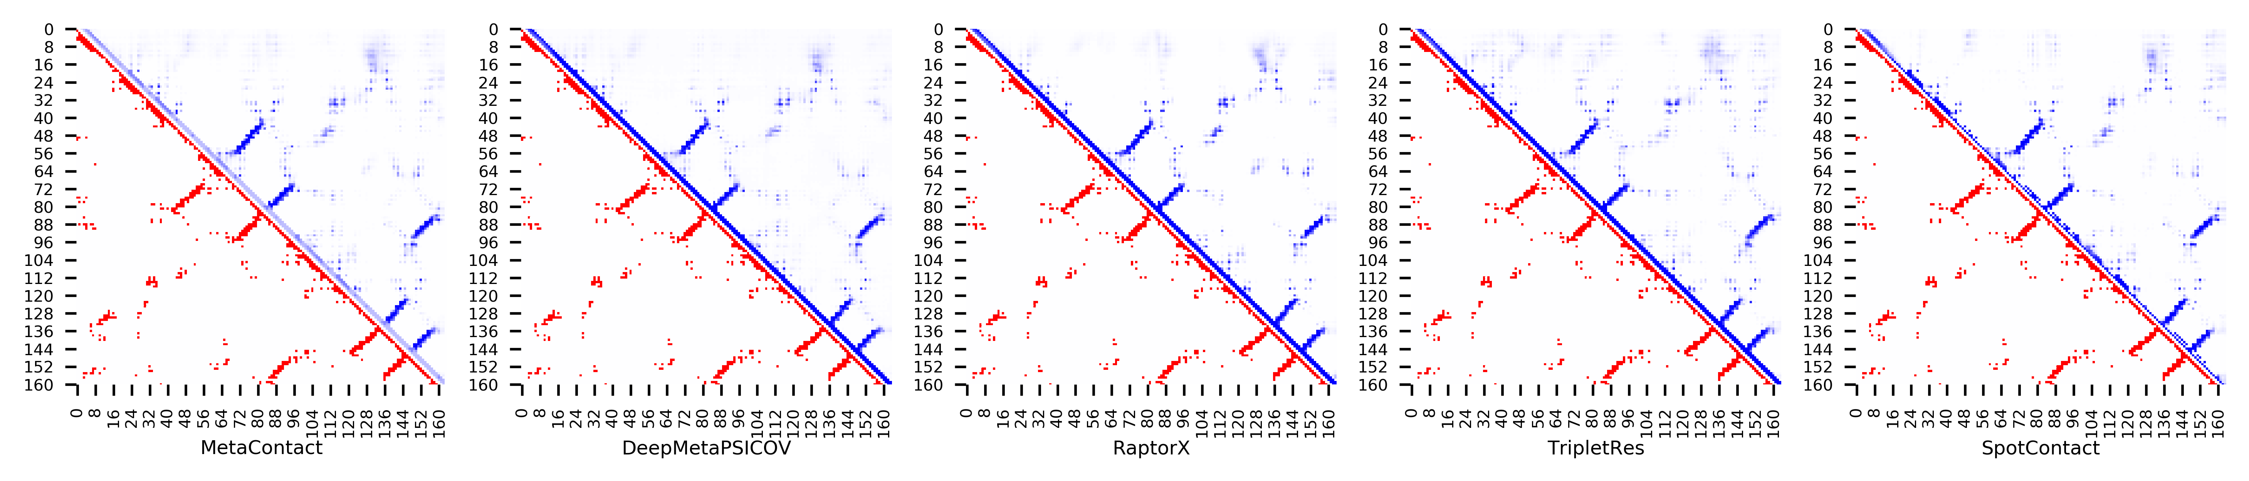

**Figure S26.** Five predicted contact maps (blue) with nature contacts (red) of target protein (1FW9_A)

**Table S33**. Precision of five contact maps (Protein ID: 1GPQ_A)

|  |  |  |  |  |  |  |  |  |  |  |  |
| --- | --- | --- | --- | --- | --- | --- | --- | --- | --- | --- | --- |
| ID: 1GPQ_A | | MetaContact | | DeepMetaPSICOV | | RaptorX | | SpotContact | | TripletRes | |
| Range | List size | Precision | Count | Precision | Count | Precision | Count | Precision | Count | Precision | Count |
| medium and long | Top-L/5 | 1.000 | 26 | 1.000 | 26 | 1.000 | 26 | 1.000 | 26 | 1.000 | 26 |
| Top-L/2 | 0.938 | 64 | 0.828 | 64 | 0.906 | 64 | 0.922 | 64 | 0.891 | 64 |
| Top-L | 0.781 | 128 | 0.617 | 128 | 0.789 | 128 | 0.836 | 128 | 0.727 | 128 |
| Top-NC | 0.660 | 197 | 0.528 | 197 | 0.670 | 197 | 0.701 | 197 | 0.584 | 197 |
| long | Top-L/5 | 0.808 | 26 | 0.577 | 26 | 0.731 | 26 | 0.885 | 26 | 0.692 | 26 |
| Top-L/2 | 0.703 | 64 | 0.406 | 64 | 0.672 | 64 | 0.797 | 64 | 0.516 | 64 |
| Top-L | 0.508 | 128 | 0.297 | 128 | 0.477 | 128 | 0.586 | 128 | 0.414 | 128 |
| Top-NC | 0.535 | 114 | 0.333 | 114 | 0.518 | 114 | 0.623 | 114 | 0.439 | 114 |

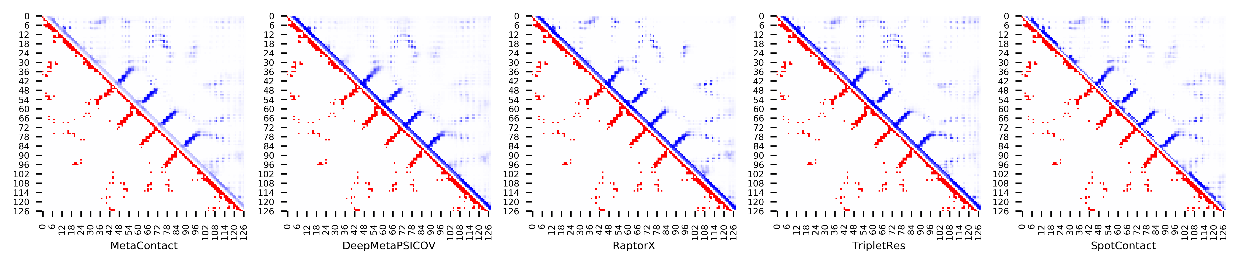

**Figure S27.** Five predicted contact maps (blue) with nature contacts (red) of target protein (1GPQ_A)

**Table S34**. Precision of five contact maps (Protein ID: 1GQA_A)

|  |  |  |  |  |  |  |  |  |  |  |  |
| --- | --- | --- | --- | --- | --- | --- | --- | --- | --- | --- | --- |
| ID: 1GQA_A | | MetaContact | | DeepMetaPSICOV | | RaptorX | | SpotContact | | TripletRes | |
| Range | List size | Precision | Count | Precision | Count | Precision | Count | Precision | Count | Precision | Count |
| medium and long | Top-L/5 | 1.000 | 26 | 1.000 | 26 | 1.000 | 26 | 1.000 | 26 | 1.000 | 26 |
| Top-L/2 | 0.923 | 65 | 0.923 | 65 | 0.923 | 65 | 0.954 | 65 | 0.862 | 65 |
| Top-L | 0.769 | 130 | 0.762 | 130 | 0.785 | 130 | 0.808 | 130 | 0.700 | 130 |
| Top-NC | 0.709 | 148 | 0.736 | 148 | 0.716 | 148 | 0.736 | 148 | 0.669 | 148 |
| long | Top-L/5 | 0.962 | 26 | 0.923 | 26 | 0.962 | 26 | 1.000 | 26 | 0.885 | 26 |
| Top-L/2 | 0.877 | 65 | 0.877 | 65 | 0.877 | 65 | 0.908 | 65 | 0.800 | 65 |
| Top-L | 0.692 | 130 | 0.700 | 130 | 0.685 | 130 | 0.692 | 130 | 0.623 | 130 |
| Top-NC | 0.697 | 119 | 0.731 | 119 | 0.689 | 119 | 0.723 | 119 | 0.647 | 119 |

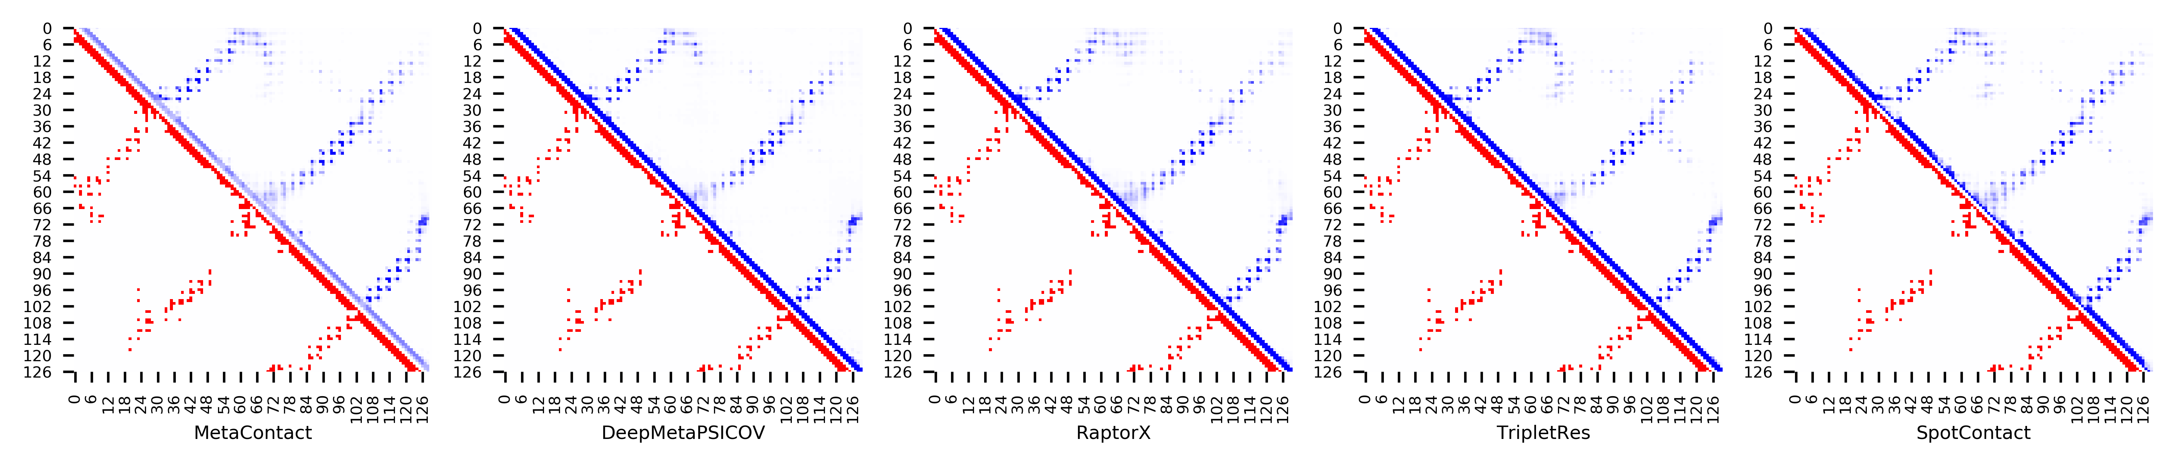

**Figure S28.** Five predicted contact maps (blue) with nature contacts (red) of target protein (1GQA_A)

**Table S35**. Precision of five contact maps (Protein ID: 1GVP_A)

|  |  |  |  |  |  |  |  |  |  |  |  |
| --- | --- | --- | --- | --- | --- | --- | --- | --- | --- | --- | --- |
| ID: 1GVP_A | | MetaContact | | DeepMetaPSICOV | | RaptorX | | SpotContact | | TripletRes | |
| Range | List size | Precision | Count | Precision | Count | Precision | Count | Precision | Count | Precision | Count |
| medium and long | Top-L/5 | 1.000 | 17 | 1.000 | 17 | 1.000 | 17 | 1.000 | 17 | 1.000 | 17 |
| Top-L/2 | 0.977 | 44 | 0.977 | 44 | 0.955 | 44 | 0.955 | 44 | 0.955 | 44 |
| Top-L | 0.908 | 87 | 0.897 | 87 | 0.862 | 87 | 0.908 | 87 | 0.805 | 87 |
| Top-NC | 0.776 | 125 | 0.744 | 125 | 0.744 | 125 | 0.792 | 125 | 0.728 | 125 |
| long | Top-L/5 | 0.941 | 17 | 0.941 | 17 | 0.941 | 17 | 0.941 | 17 | 0.882 | 17 |
| Top-L/2 | 0.864 | 44 | 0.841 | 44 | 0.795 | 44 | 0.886 | 44 | 0.750 | 44 |
| Top-L | 0.621 | 87 | 0.552 | 87 | 0.609 | 87 | 0.667 | 87 | 0.563 | 87 |
| Top-NC | 0.708 | 72 | 0.653 | 72 | 0.653 | 72 | 0.736 | 72 | 0.611 | 72 |

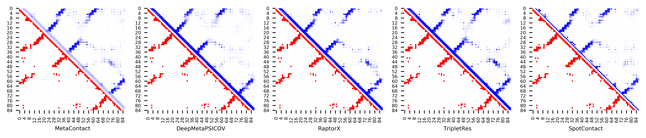

**Figure S29.** Five predicted contact maps (blue) with nature contacts (red) of target protein (1GVP_A)

**Table S36**. Precision of five contact maps (Protein ID: 1H9E_A)

|  |  |  |  |  |  |  |  |  |  |  |  |
| --- | --- | --- | --- | --- | --- | --- | --- | --- | --- | --- | --- |
| ID: 1H9E_A | | MetaContact | | DeepMetaPSICOV | | RaptorX | | SpotContact | | TripletRes | |
| Range | List size | Precision | Count | Precision | Count | Precision | Count | Precision | Count | Precision | Count |
| medium and long | Top-L/5 | 0.818 | 11 | 0.727 | 11 | 0.727 | 11 | 0.636 | 11 | 0.545 | 11 |
| Top-L/2 | 0.607 | 28 | 0.536 | 28 | 0.536 | 28 | 0.607 | 28 | 0.536 | 28 |
| Top-L | 0.464 | 56 | 0.393 | 56 | 0.357 | 56 | 0.429 | 56 | 0.411 | 56 |
| Top-NC | 0.469 | 49 | 0.408 | 49 | 0.388 | 49 | 0.449 | 49 | 0.449 | 49 |
| long | Top-L/5 | 0.545 | 11 | 0.545 | 11 | 0.455 | 11 | 0.545 | 11 | 0.545 | 11 |
| Top-L/2 | 0.393 | 28 | 0.393 | 28 | 0.250 | 28 | 0.357 | 28 | 0.357 | 28 |
| Top-L | 0.232 | 56 | 0.268 | 56 | 0.179 | 56 | 0.196 | 56 | 0.232 | 56 |
| Top-NC | 0.385 | 26 | 0.346 | 26 | 0.269 | 26 | 0.385 | 26 | 0.346 | 26 |

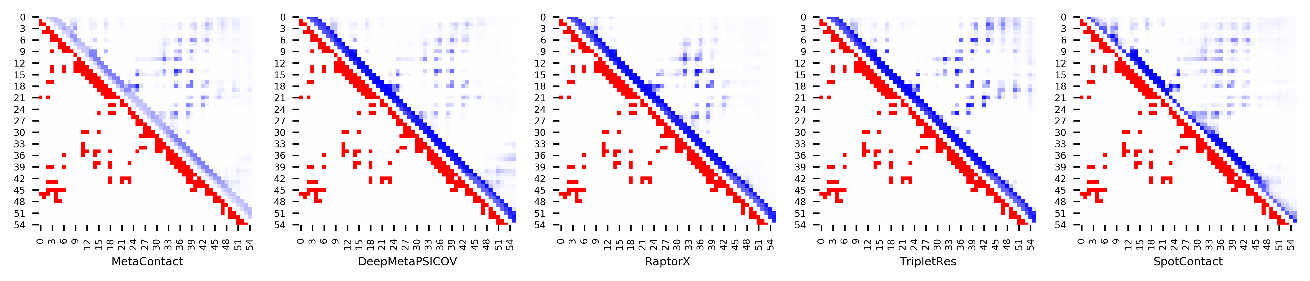

**Figure S30.** Five predicted contact maps (blue) with nature contacts (red) of target protein (1H9E_A)

**Table S37**. Precision of five contact maps (Protein ID: 1HBG_A)

|  |  |  |  |  |  |  |  |  |  |  |  |
| --- | --- | --- | --- | --- | --- | --- | --- | --- | --- | --- | --- |
| ID: 1HBG_A | | MetaContact | | DeepMetaPSICOV | | RaptorX | | SpotContact | | TripletRes | |
| Range | List size | Precision | Count | Precision | Count | Precision | Count | Precision | Count | Precision | Count |
| medium and long | Top-L/5 | 1.000 | 29 | 1.000 | 29 | 1.000 | 29 | 1.000 | 29 | 1.000 | 29 |
| Top-L/2 | 0.973 | 74 | 0.946 | 74 | 0.946 | 74 | 1.000 | 74 | 0.959 | 74 |
| Top-L | 0.871 | 147 | 0.789 | 147 | 0.837 | 147 | 0.884 | 147 | 0.837 | 147 |
| Top-NC | 0.767 | 189 | 0.677 | 189 | 0.741 | 189 | 0.788 | 189 | 0.757 | 189 |
| long | Top-L/5 | 1.000 | 29 | 1.000 | 29 | 1.000 | 29 | 1.000 | 29 | 1.000 | 29 |
| Top-L/2 | 0.973 | 74 | 0.919 | 74 | 0.932 | 74 | 1.000 | 74 | 0.959 | 74 |
| Top-L | 0.823 | 147 | 0.742 | 147 | 0.796 | 147 | 0.864 | 147 | 0.810 | 147 |
| Top-NC | 0.781 | 169 | 0.692 | 169 | 0.746 | 169 | 0.787 | 169 | 0.763 | 169 |

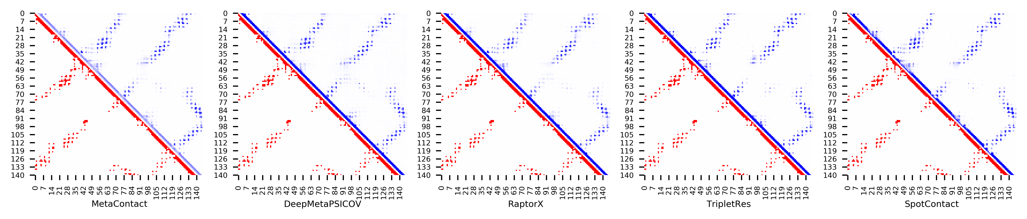

**Figure S31.** Five predicted contact maps (blue) with nature contacts (red) of target protein (1HBG_A)

**Table S38**. Precision of five contact maps (Protein ID: 1HH8_A)

|  |  |  |  |  |  |  |  |  |  |  |  |
| --- | --- | --- | --- | --- | --- | --- | --- | --- | --- | --- | --- |
| ID: 1HH8_A | | MetaContact | | DeepMetaPSICOV | | RaptorX | | SpotContact | | TripletRes | |
| Range | List size | Precision | Count | Precision | Count | Precision | Count | Precision | Count | Precision | Count |
| medium and long | Top-L/5 | 1.000 | 38 | 1.000 | 38 | 0.947 | 38 | 1.000 | 38 | 0.974 | 38 |
| Top-L/2 | 0.979 | 96 | 0.990 | 96 | 0.927 | 96 | 0.990 | 96 | 0.802 | 96 |
| Top-L | 0.792 | 192 | 0.807 | 192 | 0.661 | 192 | 0.854 | 192 | 0.656 | 192 |
| Top-NC | 0.616 | 271 | 0.638 | 271 | 0.506 | 271 | 0.694 | 271 | 0.502 | 271 |
| long | Top-L/5 | 0.947 | 38 | 0.947 | 38 | 0.895 | 38 | 0.947 | 38 | 0.711 | 38 |
| Top-L/2 | 0.740 | 96 | 0.760 | 96 | 0.646 | 96 | 0.833 | 96 | 0.573 | 96 |
| Top-L | 0.474 | 192 | 0.479 | 192 | 0.370 | 192 | 0.568 | 192 | 0.354 | 192 |
| Top-NC | 0.512 | 172 | 0.523 | 172 | 0.413 | 172 | 0.610 | 172 | 0.395 | 172 |

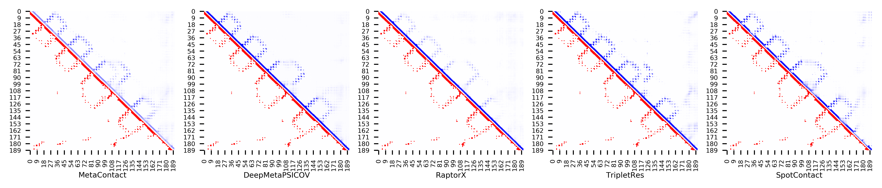

**Figure S32.** Five predicted contact maps (blue) with nature contacts (red) of target protein (1HH8_A)

**Table S39**. Precision of five contact maps (Protein ID: 1HHV_A)

|  |  |  |  |  |  |  |  |  |  |  |  |
| --- | --- | --- | --- | --- | --- | --- | --- | --- | --- | --- | --- |
| ID: 1HHV_A | | MetaContact | | DeepMetaPSICOV | | RaptorX | | SpotContact | | TripletRes | |
| Range | List size | Precision | Count | Precision | Count | Precision | Count | Precision | Count | Precision | Count |
| medium and long | Top-L/5 | 1.000 | 15 | 1.000 | 15 | 0.933 | 15 | 1.000 | 15 | 1.000 | 15 |
| Top-L/2 | 0.973 | 37 | 0.892 | 37 | 0.838 | 37 | 0.973 | 37 | 0.946 | 37 |
| Top-L | 0.743 | 74 | 0.730 | 74 | 0.662 | 74 | 0.757 | 74 | 0.703 | 74 |
| Top-NC | 0.656 | 93 | 0.645 | 93 | 0.602 | 93 | 0.677 | 93 | 0.624 | 93 |
| long | Top-L/5 | 0.933 | 15 | 0.867 | 15 | 0.800 | 15 | 1.000 | 15 | 0.933 | 15 |
| Top-L/2 | 0.730 | 37 | 0.703 | 37 | 0.595 | 37 | 0.703 | 37 | 0.649 | 37 |
| Top-L | 0.473 | 74 | 0.473 | 74 | 0.392 | 74 | 0.500 | 74 | 0.473 | 74 |
| Top-NC | 0.618 | 55 | 0.564 | 55 | 0.491 | 55 | 0.600 | 55 | 0.564 | 55 |

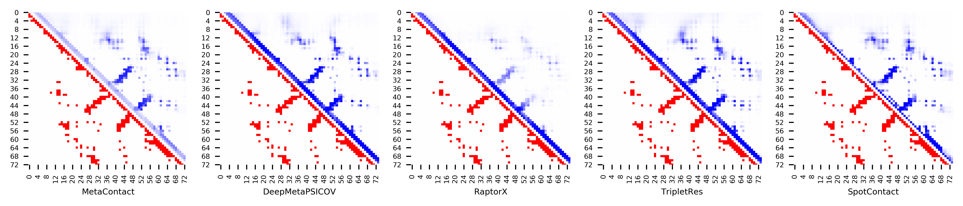

**Figure S33.** Five predicted contact maps (blue) with nature contacts (red) of target protein (1HHV_A)

**Table S40**. Precision of five contact maps (Protein ID: 1IUJ_B)

|  |  |  |  |  |  |  |  |  |  |  |  |
| --- | --- | --- | --- | --- | --- | --- | --- | --- | --- | --- | --- |
| ID: 1IUJ_B | | MetaContact | | DeepMetaPSICOV | | RaptorX | | SpotContact | | TripletRes | |
| Range | List size | Precision | Count | Precision | Count | Precision | Count | Precision | Count | Precision | Count |
| medium and long | Top-L/5 | 1.000 | 21 | 1.000 | 21 | 0.905 | 21 | 1.000 | 21 | 1.000 | 21 |
| Top-L/2 | 1.000 | 52 | 0.981 | 52 | 0.827 | 52 | 1.000 | 52 | 0.904 | 52 |
| Top-L | 0.961 | 103 | 0.932 | 103 | 0.757 | 103 | 0.971 | 103 | 0.816 | 103 |
| Top-NC | 0.851 | 161 | 0.851 | 161 | 0.652 | 161 | 0.851 | 161 | 0.708 | 161 |
| long | Top-L/5 | 1.000 | 21 | 1.000 | 21 | 0.905 | 21 | 1.000 | 21 | 0.952 | 21 |
| Top-L/2 | 0.981 | 52 | 0.962 | 52 | 0.788 | 52 | 1.000 | 52 | 0.808 | 52 |
| Top-L | 0.884 | 103 | 0.874 | 103 | 0.680 | 103 | 0.922 | 103 | 0.738 | 103 |
| Top-NC | 0.830 | 135 | 0.830 | 135 | 0.622 | 135 | 0.830 | 135 | 0.681 | 135 |

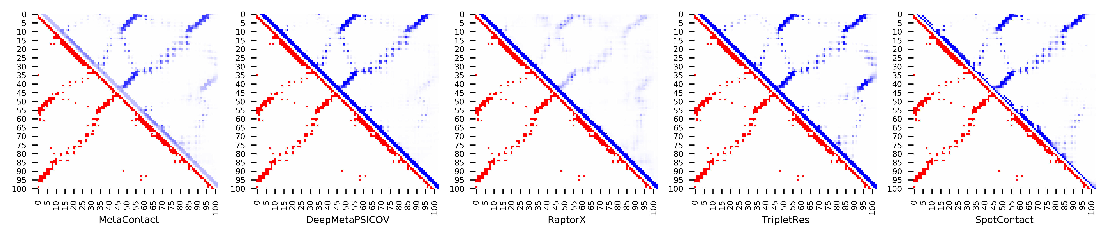

**Figure S34.** Five predicted contact maps (blue) with nature contacts (red) of target protein (1IUJ_B)

**Table S41**. Precision of five contact maps (Protein ID: 1J8I_A)

|  |  |  |  |  |  |  |  |  |  |  |  |
| --- | --- | --- | --- | --- | --- | --- | --- | --- | --- | --- | --- |
| ID: 1J8I_A | | MetaContact | | DeepMetaPSICOV | | RaptorX | | SpotContact | | TripletRes | |
| Range | List size | Precision | Count | Precision | Count | Precision | Count | Precision | Count | Precision | Count |
| medium and long | Top-L/5 | 0.947 | 19 | 0.947 | 19 | 1.000 | 19 | 0.947 | 19 | 0.947 | 19 |
| Top-L/2 | 0.870 | 46 | 0.804 | 46 | 0.870 | 46 | 0.848 | 46 | 0.783 | 46 |
| Top-L | 0.677 | 93 | 0.602 | 93 | 0.656 | 93 | 0.656 | 93 | 0.613 | 93 |
| Top-NC | 0.723 | 83 | 0.639 | 83 | 0.699 | 83 | 0.699 | 83 | 0.663 | 83 |
| long | Top-L/5 | 0.842 | 19 | 0.842 | 19 | 0.737 | 19 | 0.737 | 19 | 0.632 | 19 |
| Top-L/2 | 0.696 | 46 | 0.609 | 46 | 0.630 | 46 | 0.630 | 46 | 0.587 | 46 |
| Top-L | 0.387 | 93 | 0.387 | 93 | 0.409 | 93 | 0.409 | 93 | 0.366 | 93 |
| Top-NC | 0.647 | 51 | 0.588 | 51 | 0.608 | 51 | 0.627 | 51 | 0.588 | 51 |

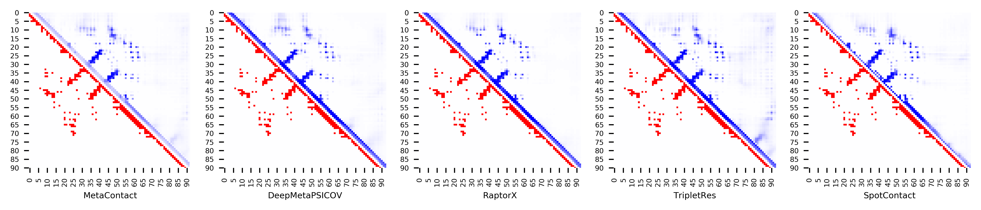

**Figure S35.** Five predicted contact maps (blue) with nature contacts (red) of target protein (1J8I_A)

**Table S42**. Precision of five contact maps (Protein ID: 1J9I_A)

|  |  |  |  |  |  |  |  |  |  |  |  |
| --- | --- | --- | --- | --- | --- | --- | --- | --- | --- | --- | --- |
| ID: 1J9I_A | | MetaContact | | DeepMetaPSICOV | | RaptorX | | SpotContact | | TripletRes | |
| Range | List size | Precision | Count | Precision | Count | Precision | Count | Precision | Count | Precision | Count |
| medium and long | Top-L/5 | 1.000 | 14 | 1.000 | 14 | 0.786 | 14 | 0.929 | 14 | 1.000 | 14 |
| Top-L/2 | 0.882 | 34 | 0.882 | 34 | 0.676 | 34 | 0.882 | 34 | 0.882 | 34 |
| Top-L | 0.662 | 68 | 0.588 | 68 | 0.500 | 68 | 0.676 | 68 | 0.632 | 68 |
| Top-NC | 0.657 | 67 | 0.597 | 67 | 0.507 | 67 | 0.672 | 67 | 0.642 | 67 |
| long | Top-L/5 | 1.000 | 14 | 1.000 | 14 | 0.857 | 14 | 0.929 | 14 | 0.929 | 14 |
| Top-L/2 | 0.765 | 34 | 0.765 | 34 | 0.559 | 34 | 0.794 | 34 | 0.735 | 34 |
| Top-L | 0.426 | 68 | 0.456 | 68 | 0.353 | 68 | 0.456 | 68 | 0.412 | 68 |
| Top-NC | 0.596 | 47 | 0.574 | 47 | 0.489 | 47 | 0.638 | 47 | 0.553 | 47 |

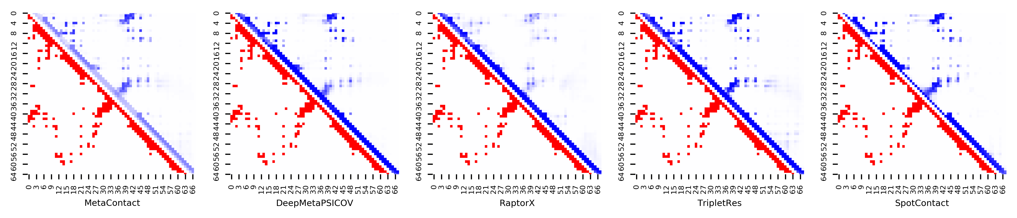

**Figure S36.** Five predicted contact maps (blue) with nature contacts (red) of target protein (1J9I_A)

**Table S43**. Precision of five contact maps (Protein ID: 1K1Z_A)

|  |  |  |  |  |  |  |  |  |  |  |  |
| --- | --- | --- | --- | --- | --- | --- | --- | --- | --- | --- | --- |
| ID: 1K1Z_A | | MetaContact | | DeepMetaPSICOV | | RaptorX | | SpotContact | | TripletRes | |
| Range | List size | Precision | Count | Precision | Count | Precision | Count | Precision | Count | Precision | Count |
| medium and long | Top-L/5 | 0.875 | 16 | 0.938 | 16 | 0.875 | 16 | 0.750 | 16 | 1.000 | 16 |
| Top-L/2 | 0.872 | 39 | 0.897 | 39 | 0.821 | 39 | 0.564 | 39 | 0.974 | 39 |
| Top-L | 0.808 | 78 | 0.718 | 78 | 0.718 | 78 | 0.500 | 78 | 0.872 | 78 |
| Top-NC | 0.675 | 114 | 0.588 | 114 | 0.588 | 114 | 0.465 | 114 | 0.728 | 114 |
| long | Top-L/5 | 0.875 | 16 | 0.813 | 16 | 0.813 | 16 | 0.375 | 16 | 1.000 | 16 |
| Top-L/2 | 0.795 | 39 | 0.641 | 39 | 0.769 | 39 | 0.410 | 39 | 0.846 | 39 |
| Top-L | 0.628 | 78 | 0.462 | 78 | 0.500 | 78 | 0.397 | 78 | 0.590 | 78 |
| Top-NC | 0.672 | 64 | 0.516 | 64 | 0.563 | 64 | 0.375 | 64 | 0.672 | 64 |

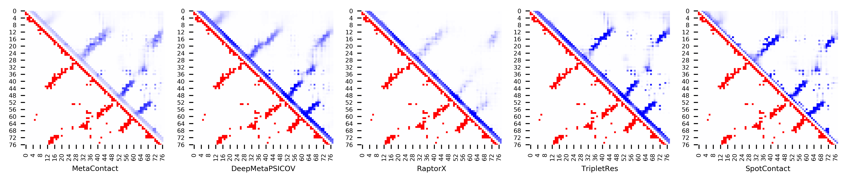

**Figure S37.** Five predicted contact maps (blue) with nature contacts (red) of target protein (1K1Z_A)

**Table S44**. Precision of five contact maps (Protein ID: 1K3S_A)

|  |  |  |  |  |  |  |  |  |  |  |  |
| --- | --- | --- | --- | --- | --- | --- | --- | --- | --- | --- | --- |
| ID: 1K3S_A | | MetaContact | | DeepMetaPSICOV | | RaptorX | | SpotContact | | TripletRes | |
| Range | List size | Precision | Count | Precision | Count | Precision | Count | Precision | Count | Precision | Count |
| medium and long | Top-L/5 | 0.955 | 22 | 0.955 | 22 | 0.955 | 22 | 0.955 | 22 | 0.909 | 22 |
| Top-L/2 | 0.833 | 54 | 0.778 | 54 | 0.926 | 54 | 0.796 | 54 | 0.685 | 54 |
| Top-L | 0.661 | 109 | 0.569 | 109 | 0.780 | 109 | 0.624 | 109 | 0.486 | 109 |
| Top-NC | 0.575 | 134 | 0.485 | 134 | 0.716 | 134 | 0.530 | 134 | 0.448 | 134 |
| long | Top-L/5 | 1.000 | 22 | 1.000 | 22 | 0.955 | 22 | 1.000 | 22 | 0.818 | 22 |
| Top-L/2 | 0.889 | 54 | 0.704 | 54 | 0.944 | 54 | 0.815 | 54 | 0.648 | 54 |
| Top-L | 0.596 | 109 | 0.523 | 109 | 0.716 | 109 | 0.560 | 109 | 0.440 | 109 |
| Top-NC | 0.596 | 109 | 0.523 | 109 | 0.716 | 109 | 0.560 | 109 | 0.440 | 109 |

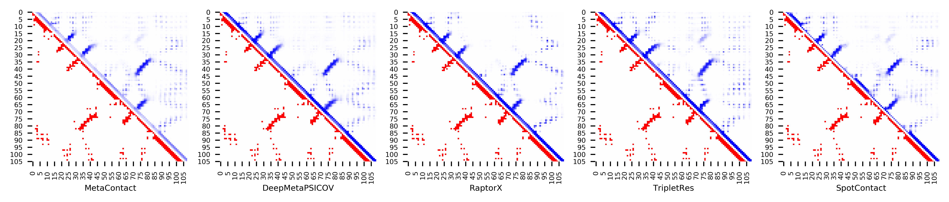

**Figure S38.** Five predicted contact maps (blue) with nature contacts (red) of target protein (1K3S_A)

**Table S45**. Precision of five contact maps (Protein ID: 1K5D_B)

|  |  |  |  |  |  |  |  |  |  |  |  |
| --- | --- | --- | --- | --- | --- | --- | --- | --- | --- | --- | --- |
| ID: 1K5D_B | | MetaContact | | DeepMetaPSICOV | | RaptorX | | SpotContact | | TripletRes | |
| Range | List size | Precision | Count | Precision | Count | Precision | Count | Precision | Count | Precision | Count |
| medium and long | Top-L/5 | 0.931 | 29 | 0.931 | 29 | 1.000 | 29 | 0.966 | 29 | 1.000 | 29 |
| Top-L/2 | 0.959 | 73 | 0.959 | 73 | 0.973 | 73 | 0.959 | 73 | 0.945 | 73 |
| Top-L | 0.938 | 146 | 0.884 | 146 | 0.945 | 146 | 0.932 | 146 | 0.877 | 146 |
| Top-NC | 0.816 | 212 | 0.783 | 212 | 0.844 | 212 | 0.825 | 212 | 0.764 | 212 |
| long | Top-L/5 | 0.931 | 29 | 0.931 | 29 | 0.931 | 29 | 0.931 | 29 | 0.931 | 29 |
| Top-L/2 | 0.945 | 73 | 0.877 | 73 | 0.945 | 73 | 0.945 | 73 | 0.890 | 73 |
| Top-L | 0.719 | 146 | 0.685 | 146 | 0.760 | 146 | 0.712 | 146 | 0.664 | 146 |
| Top-NC | 0.773 | 132 | 0.735 | 132 | 0.803 | 132 | 0.773 | 132 | 0.705 | 132 |

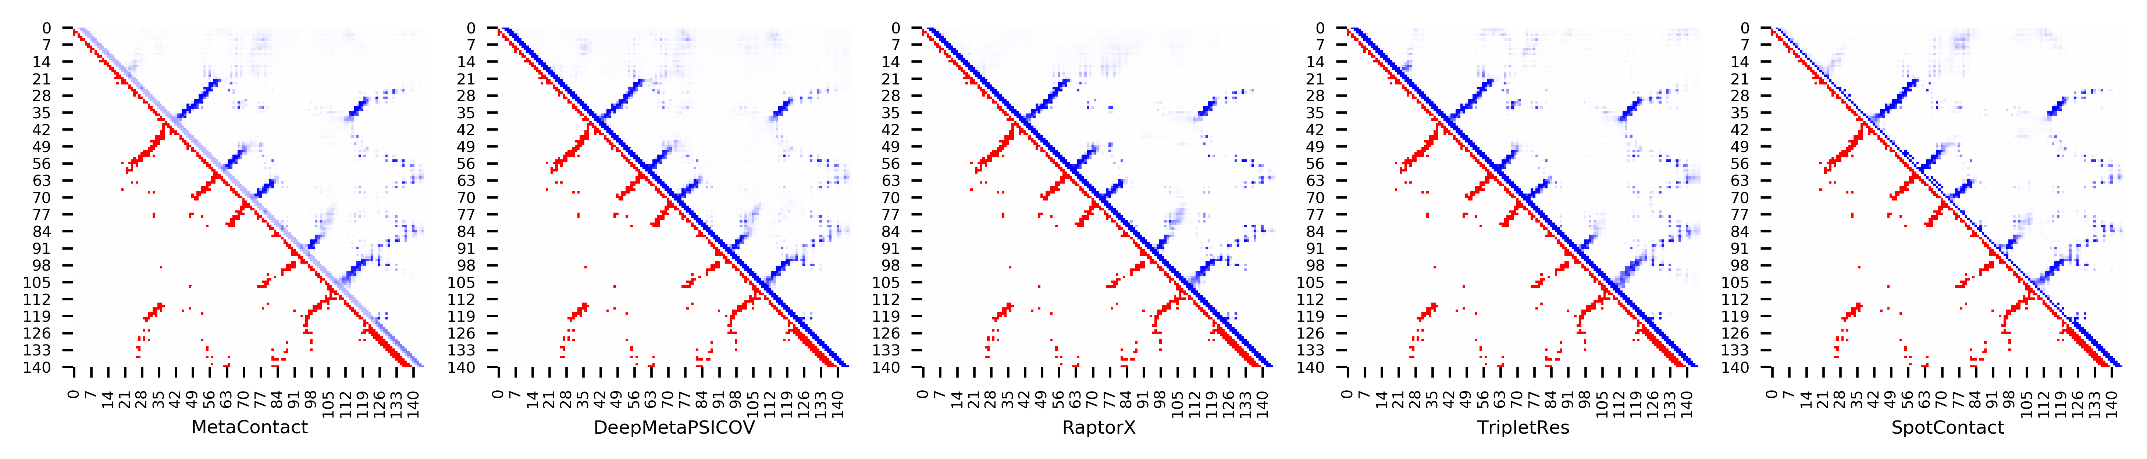

**Figure S39.** Five predicted contact maps (blue) with nature contacts (red) of target protein (1K5D_B)

**Table S46**. Precision of five contact maps (Protein ID: 1KSX_A)

|  |  |  |  |  |  |  |  |  |  |  |  |
| --- | --- | --- | --- | --- | --- | --- | --- | --- | --- | --- | --- |
| ID: 1KSX_A | | MetaContact | | DeepMetaPSICOV | | RaptorX | | SpotContact | | TripletRes | |
| Range | List size | Precision | Count | Precision | Count | Precision | Count | Precision | Count | Precision | Count |
| medium and long | Top-L/5 | 1.000 | 29 | 1.000 | 29 | 1.000 | 29 | 1.000 | 29 | 1.000 | 29 |
| Top-L/2 | 0.986 | 72 | 0.917 | 72 | 1.000 | 72 | 0.986 | 72 | 0.958 | 72 |
| Top-L | 0.931 | 144 | 0.799 | 144 | 0.938 | 144 | 0.903 | 144 | 0.826 | 144 |
| Top-NC | 0.730 | 252 | 0.631 | 252 | 0.742 | 252 | 0.698 | 252 | 0.619 | 252 |
| long | Top-L/5 | 0.966 | 29 | 0.931 | 29 | 1.000 | 29 | 0.966 | 29 | 1.000 | 29 |
| Top-L/2 | 0.986 | 72 | 0.833 | 72 | 0.958 | 72 | 0.986 | 72 | 0.917 | 72 |
| Top-L | 0.819 | 144 | 0.688 | 144 | 0.847 | 144 | 0.819 | 144 | 0.729 | 144 |
| Top-NC | 0.718 | 206 | 0.612 | 206 | 0.723 | 206 | 0.684 | 206 | 0.607 | 206 |

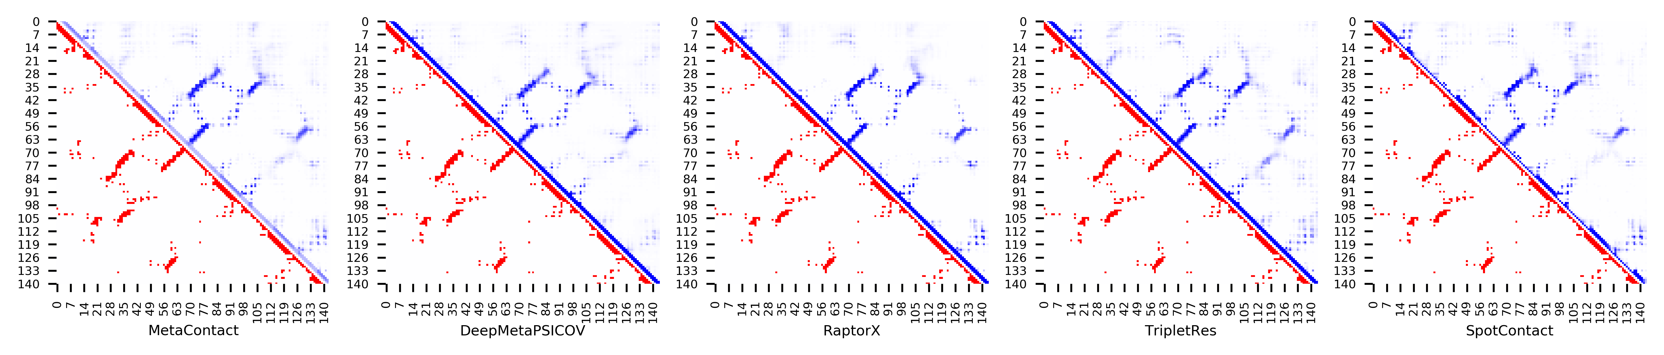

**Figure S40.** Five predicted contact maps (blue) with nature contacts (red) of target protein (1KSX_A)

**Table S47**. Precision of five contact maps (Protein ID: 1L1D_B)

|  |  |  |  |  |  |  |  |  |  |  |  |
| --- | --- | --- | --- | --- | --- | --- | --- | --- | --- | --- | --- |
| ID: 1L1D_B | | MetaContact | | DeepMetaPSICOV | | RaptorX | | SpotContact | | TripletRes | |
| Range | List size | Precision | Count | Precision | Count | Precision | Count | Precision | Count | Precision | Count |
| medium and long | Top-L/5 | 1.000 | 29 | 1.000 | 29 | 1.000 | 29 | 1.000 | 29 | 1.000 | 29 |
| Top-L/2 | 0.973 | 74 | 0.959 | 74 | 0.919 | 74 | 0.973 | 74 | 0.946 | 74 |
| Top-L | 0.878 | 147 | 0.857 | 147 | 0.878 | 147 | 0.884 | 147 | 0.789 | 147 |
| Top-NC | 0.673 | 266 | 0.665 | 266 | 0.677 | 266 | 0.699 | 266 | 0.598 | 266 |
| long | Top-L/5 | 0.966 | 29 | 0.966 | 29 | 0.966 | 29 | 0.966 | 29 | 1.000 | 29 |
| Top-L/2 | 0.932 | 74 | 0.919 | 74 | 0.905 | 74 | 0.946 | 74 | 0.878 | 74 |
| Top-L | 0.755 | 147 | 0.707 | 147 | 0.714 | 147 | 0.748 | 147 | 0.639 | 147 |
| Top-NC | 0.644 | 194 | 0.624 | 194 | 0.649 | 194 | 0.649 | 194 | 0.536 | 194 |

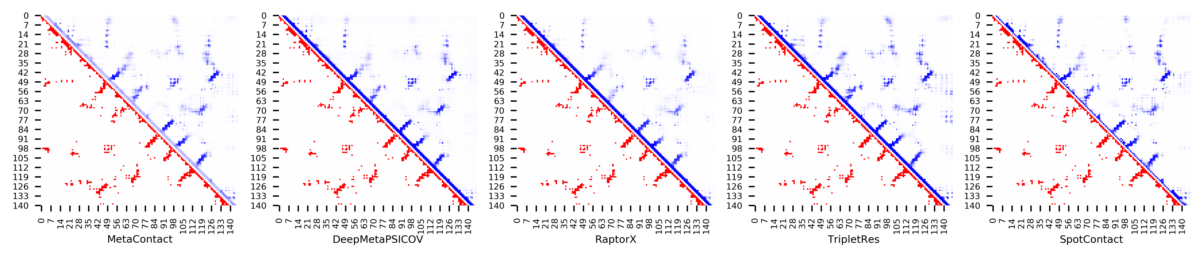

**Figure S41.** Five predicted contact maps (blue) with nature contacts (red) of target protein (1L1D_B)

**Table S48**. Precision of five contact maps (Protein ID: 1LFU_P)

|  |  |  |  |  |  |  |  |  |  |  |  |
| --- | --- | --- | --- | --- | --- | --- | --- | --- | --- | --- | --- |
| ID: 1LFU_P | | MetaContact | | DeepMetaPSICOV | | RaptorX | | SpotContact | | TripletRes | |
| Range | List size | Precision | Count | Precision | Count | Precision | Count | Precision | Count | Precision | Count |
| medium and long | Top-L/5 | 1.000 | 16 | 1.000 | 16 | 0.813 | 16 | 1.000 | 16 | 1.000 | 16 |
| Top-L/2 | 0.829 | 41 | 0.780 | 41 | 0.537 | 41 | 0.829 | 41 | 0.756 | 41 |
| Top-L | 0.524 | 82 | 0.537 | 82 | 0.317 | 82 | 0.549 | 82 | 0.451 | 82 |
| Top-NC | 0.569 | 72 | 0.583 | 72 | 0.347 | 72 | 0.597 | 72 | 0.486 | 72 |
| long | Top-L/5 | 1.000 | 16 | 1.000 | 16 | 0.688 | 16 | 0.938 | 16 | 0.938 | 16 |
| Top-L/2 | 0.707 | 41 | 0.634 | 41 | 0.390 | 41 | 0.707 | 41 | 0.585 | 41 |
| Top-L | 0.415 | 82 | 0.463 | 82 | 0.280 | 82 | 0.451 | 82 | 0.366 | 82 |
| Top-NC | 0.552 | 58 | 0.569 | 58 | 0.310 | 58 | 0.569 | 58 | 0.448 | 58 |

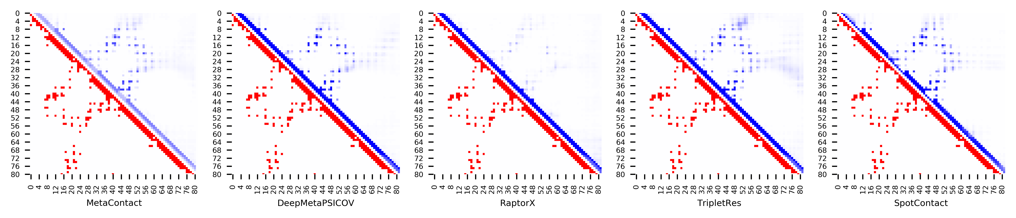

**Figure S42.** Five predicted contact maps (blue) with nature contacts (red) of target protein (1LFU_P)

**Table S49**. Precision of five contact maps (Protein ID: 1LNW_C)

|  |  |  |  |  |  |  |  |  |  |  |  |
| --- | --- | --- | --- | --- | --- | --- | --- | --- | --- | --- | --- |
| ID: 1LNW_C | | MetaContact | | DeepMetaPSICOV | | RaptorX | | SpotContact | | TripletRes | |
| Range | List size | Precision | Count | Precision | Count | Precision | Count | Precision | Count | Precision | Count |
| medium and long | Top-L/5 | 0.964 | 28 | 0.964 | 28 | 0.786 | 28 | 1.000 | 28 | 0.893 | 28 |
| Top-L/2 | 0.886 | 70 | 0.843 | 70 | 0.514 | 70 | 0.886 | 70 | 0.800 | 70 |
| Top-L | 0.626 | 139 | 0.590 | 139 | 0.374 | 139 | 0.597 | 139 | 0.561 | 139 |
| Top-NC | 0.800 | 90 | 0.789 | 90 | 0.444 | 90 | 0.833 | 90 | 0.756 | 90 |
| long | Top-L/5 | 0.929 | 28 | 0.929 | 28 | 0.643 | 28 | 0.964 | 28 | 0.750 | 28 |
| Top-L/2 | 0.743 | 70 | 0.757 | 70 | 0.457 | 70 | 0.786 | 70 | 0.700 | 70 |
| Top-L | 0.475 | 139 | 0.460 | 139 | 0.338 | 139 | 0.460 | 139 | 0.432 | 139 |
| Top-NC | 0.788 | 66 | 0.773 | 66 | 0.470 | 66 | 0.818 | 66 | 0.712 | 66 |

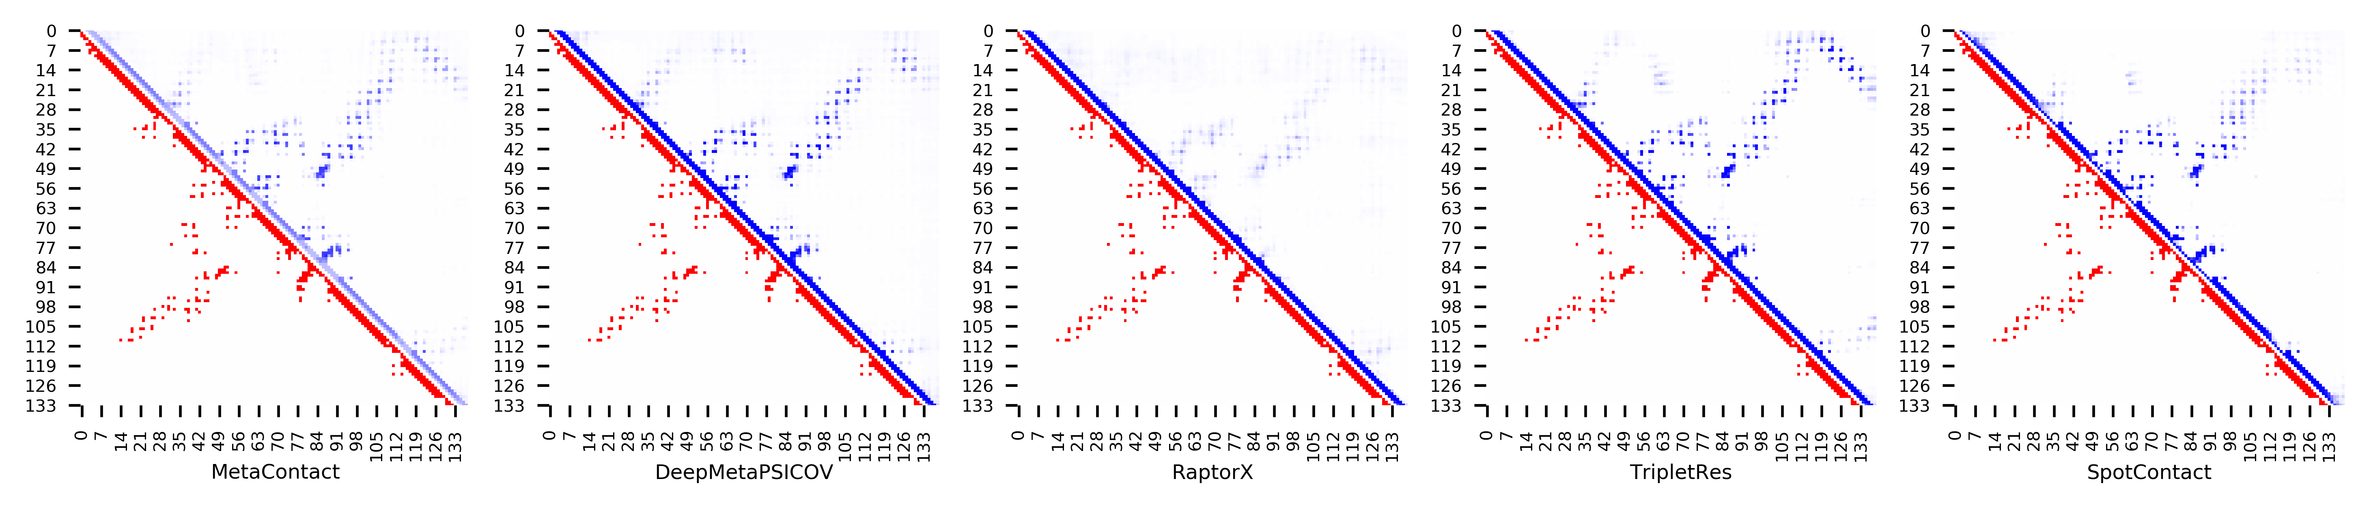

**Figure S43.** Five predicted contact maps (blue) with nature contacts (red) of target protein (1LNW_C)

**Table S50**. Precision of five contact maps (Protein ID: 1LZW_B)

|  |  |  |  |  |  |  |  |  |  |  |  |
| --- | --- | --- | --- | --- | --- | --- | --- | --- | --- | --- | --- |
| ID: 1LZW_B | | MetaContact | | DeepMetaPSICOV | | RaptorX | | SpotContact | | TripletRes | |
| Range | List size | Precision | Count | Precision | Count | Precision | Count | Precision | Count | Precision | Count |
| medium and long | Top-L/5 | 1.000 | 29 | 1.000 | 29 | 1.000 | 29 | 1.000 | 29 | 1.000 | 29 |
| Top-L/2 | 1.000 | 73 | 0.959 | 73 | 0.973 | 73 | 0.986 | 73 | 0.986 | 73 |
| Top-L | 0.925 | 146 | 0.897 | 146 | 0.925 | 146 | 0.904 | 146 | 0.890 | 146 |
| Top-NC | 0.779 | 222 | 0.743 | 222 | 0.752 | 222 | 0.793 | 222 | 0.716 | 222 |
| long | Top-L/5 | 1.000 | 29 | 1.000 | 29 | 1.000 | 29 | 0.966 | 29 | 1.000 | 29 |
| Top-L/2 | 0.945 | 73 | 0.904 | 73 | 0.959 | 73 | 0.945 | 73 | 0.945 | 73 |
| Top-L | 0.836 | 146 | 0.801 | 146 | 0.829 | 146 | 0.822 | 146 | 0.760 | 146 |
| Top-NC | 0.750 | 180 | 0.739 | 180 | 0.733 | 180 | 0.767 | 180 | 0.678 | 180 |

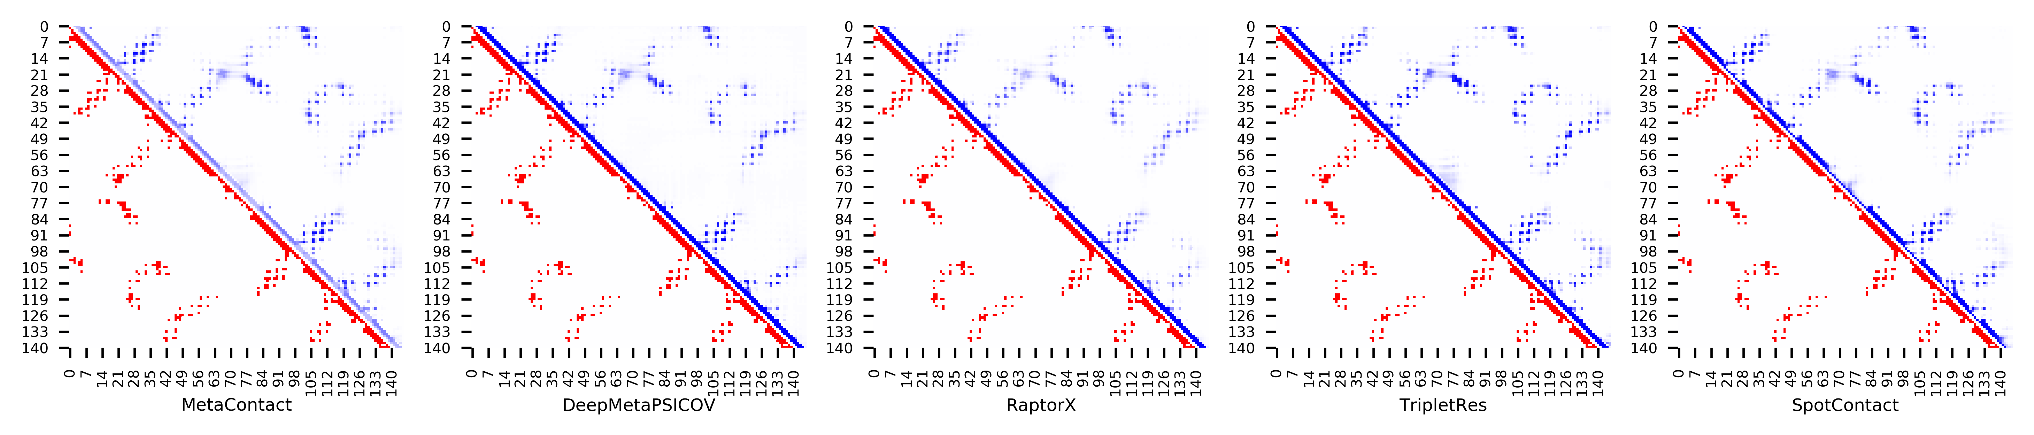

**Figure S44.** Five predicted contact maps (blue) with nature contacts (red) of target protein (1LZW_B)

**Table S51**. Precision of five contact maps (Protein ID: 1MAI_A)

|  |  |  |  |  |  |  |  |  |  |  |  |
| --- | --- | --- | --- | --- | --- | --- | --- | --- | --- | --- | --- |
| ID: 1MAI_A | | MetaContact | | DeepMetaPSICOV | | RaptorX | | SpotContact | | TripletRes | |
| Range | List size | Precision | Count | Precision | Count | Precision | Count | Precision | Count | Precision | Count |
| medium and long | Top-L/5 | 1.000 | 24 | 0.958 | 24 | 1.000 | 24 | 1.000 | 24 | 0.958 | 24 |
| Top-L/2 | 0.967 | 60 | 0.950 | 60 | 0.983 | 60 | 1.000 | 60 | 0.967 | 60 |
| Top-L | 0.933 | 119 | 0.857 | 119 | 0.941 | 119 | 0.941 | 119 | 0.899 | 119 |
| Top-NC | 0.807 | 192 | 0.719 | 192 | 0.792 | 192 | 0.828 | 192 | 0.724 | 192 |
| long | Top-L/5 | 1.000 | 24 | 0.958 | 24 | 1.000 | 24 | 1.000 | 24 | 1.000 | 24 |
| Top-L/2 | 0.933 | 60 | 0.783 | 60 | 0.950 | 60 | 0.917 | 60 | 0.850 | 60 |
| Top-L | 0.672 | 119 | 0.588 | 119 | 0.689 | 119 | 0.697 | 119 | 0.597 | 119 |
| Top-NC | 0.738 | 103 | 0.621 | 103 | 0.757 | 103 | 0.757 | 103 | 0.660 | 103 |

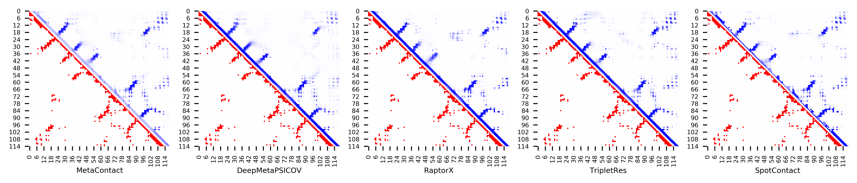

**Figure S45.** Five predicted contact maps (blue) with nature contacts (red) of target protein (1MAI_A)

**Table S52**. Precision of five contact maps (Protein ID: 1MWQ_A)

|  |  |  |  |  |  |  |  |  |  |  |  |
| --- | --- | --- | --- | --- | --- | --- | --- | --- | --- | --- | --- |
| ID: 1MWQ_A | | MetaContact | | DeepMetaPSICOV | | RaptorX | | SpotContact | | TripletRes | |
| Range | List size | Precision | Count | Precision | Count | Precision | Count | Precision | Count | Precision | Count |
| medium and long | Top-L/5 | 1.000 | 20 | 1.000 | 20 | 0.750 | 20 | 1.000 | 20 | 1.000 | 20 |
| Top-L/2 | 1.000 | 50 | 1.000 | 50 | 0.680 | 50 | 1.000 | 50 | 0.900 | 50 |
| Top-L | 0.980 | 99 | 0.980 | 99 | 0.626 | 99 | 1.000 | 99 | 0.879 | 99 |
| Top-NC | 0.836 | 159 | 0.849 | 159 | 0.572 | 159 | 0.868 | 159 | 0.736 | 159 |
| long | Top-L/5 | 1.000 | 20 | 1.000 | 20 | 0.750 | 20 | 1.000 | 20 | 1.000 | 20 |
| Top-L/2 | 1.000 | 50 | 1.000 | 50 | 0.640 | 50 | 1.000 | 50 | 0.860 | 50 |
| Top-L | 0.939 | 99 | 0.939 | 99 | 0.586 | 99 | 0.949 | 99 | 0.808 | 99 |
| Top-NC | 0.820 | 128 | 0.836 | 128 | 0.531 | 128 | 0.859 | 128 | 0.719 | 128 |

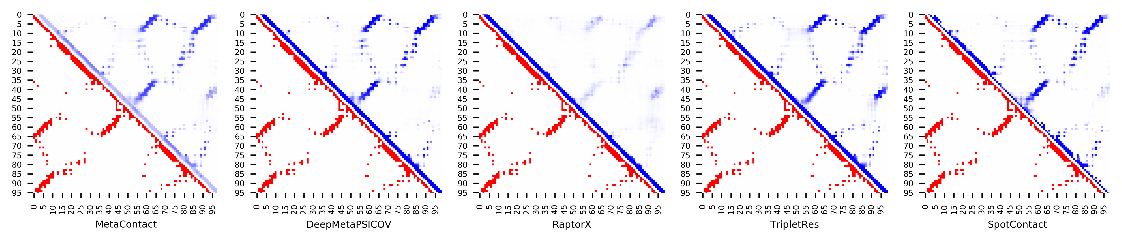

**Figure S46.** Five predicted contact maps (blue) with nature contacts (red) of target protein (1MWQ_A)

**Table S53**. Precision of five contact maps (Protein ID: 1N3G_A)

|  |  |  |  |  |  |  |  |  |  |  |  |
| --- | --- | --- | --- | --- | --- | --- | --- | --- | --- | --- | --- |
| ID: 1N3G_A | | MetaContact | | DeepMetaPSICOV | | RaptorX | | SpotContact | | TripletRes | |
| Range | List size | Precision | Count | Precision | Count | Precision | Count | Precision | Count | Precision | Count |
| medium and long | Top-L/5 | 0.957 | 23 | 0.957 | 23 | 1.000 | 23 | 1.000 | 23 | 1.000 | 23 |
| Top-L/2 | 0.964 | 56 | 0.946 | 56 | 0.929 | 56 | 0.964 | 56 | 0.946 | 56 |
| Top-L | 0.903 | 113 | 0.903 | 113 | 0.823 | 113 | 0.903 | 113 | 0.841 | 113 |
| Top-NC | 0.806 | 155 | 0.787 | 155 | 0.716 | 155 | 0.800 | 155 | 0.781 | 155 |
| long | Top-L/5 | 0.957 | 23 | 0.957 | 23 | 0.957 | 23 | 0.957 | 23 | 0.957 | 23 |
| Top-L/2 | 0.875 | 56 | 0.893 | 56 | 0.768 | 56 | 0.875 | 56 | 0.875 | 56 |
| Top-L | 0.619 | 113 | 0.628 | 113 | 0.531 | 113 | 0.619 | 113 | 0.611 | 113 |
| Top-NC | 0.747 | 83 | 0.747 | 83 | 0.651 | 83 | 0.747 | 83 | 0.711 | 83 |

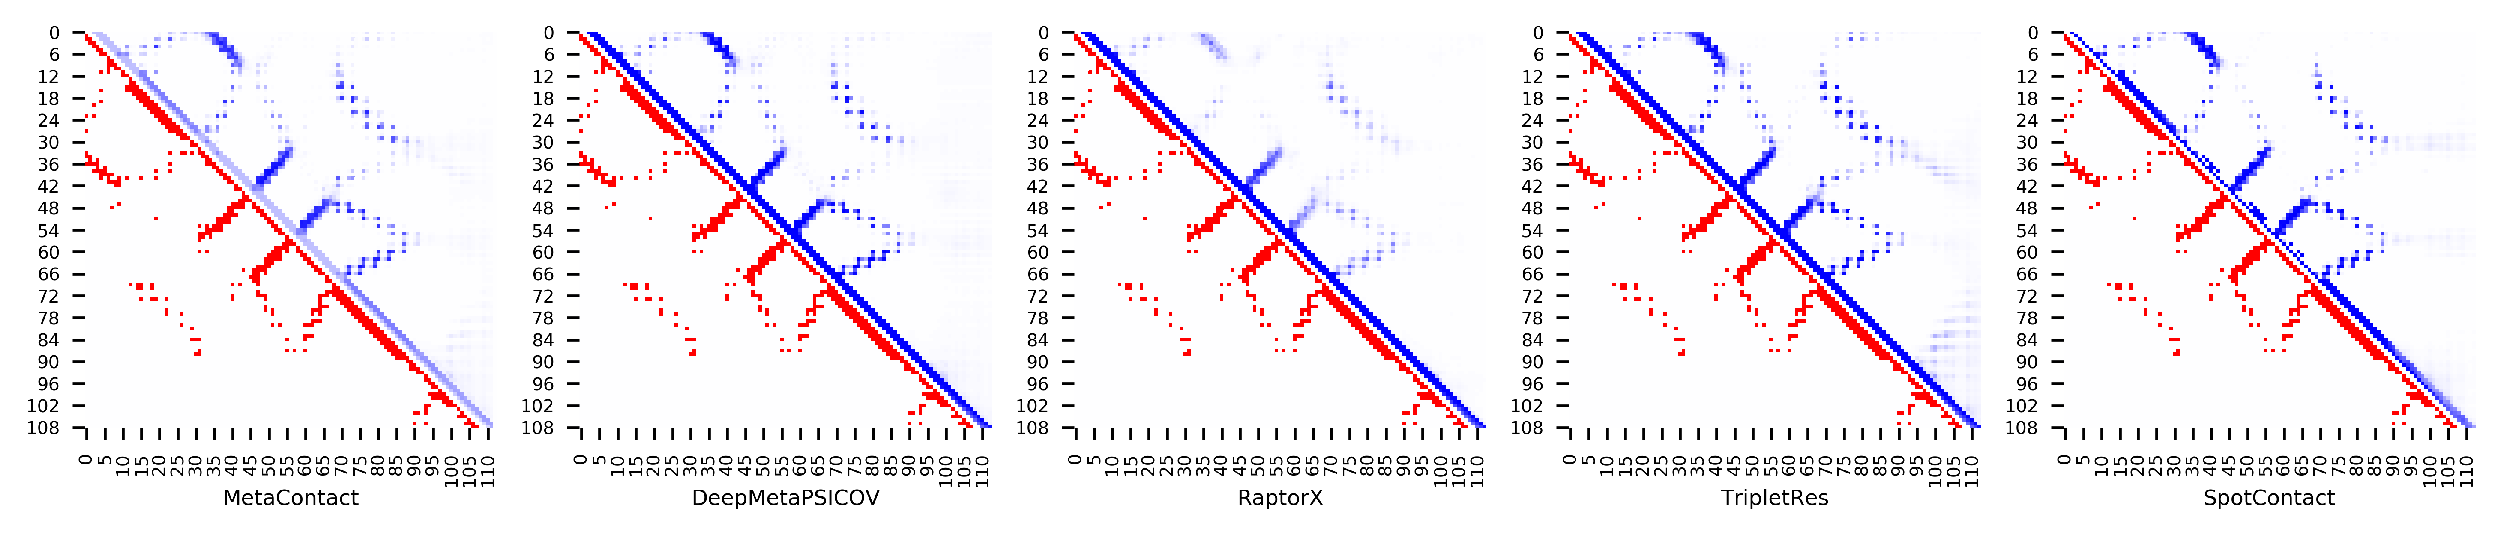

**Figure S47.** Five predicted contact maps (blue) with nature contacts (red) of target protein (1N3G_A)

**Table S54**. Precision of five contact maps (Protein ID: 1NF6_F)

|  |  |  |  |  |  |  |  |  |  |  |  |
| --- | --- | --- | --- | --- | --- | --- | --- | --- | --- | --- | --- |
| ID: 1NF6_F | | MetaContact | | DeepMetaPSICOV | | RaptorX | | SpotContact | | TripletRes | |
| Range | List size | Precision | Count | Precision | Count | Precision | Count | Precision | Count | Precision | Count |
| medium and long | Top-L/5 | 1.000 | 34 | 1.000 | 34 | 1.000 | 34 | 1.000 | 34 | 1.000 | 34 |
| Top-L/2 | 1.000 | 86 | 0.977 | 86 | 0.977 | 86 | 0.977 | 86 | 0.988 | 86 |
| Top-L | 0.830 | 171 | 0.807 | 171 | 0.784 | 171 | 0.825 | 171 | 0.795 | 171 |
| Top-NC | 0.754 | 199 | 0.724 | 199 | 0.714 | 199 | 0.759 | 199 | 0.714 | 199 |
| long | Top-L/5 | 1.000 | 34 | 1.000 | 34 | 1.000 | 34 | 1.000 | 34 | 1.000 | 34 |
| Top-L/2 | 0.965 | 86 | 0.930 | 86 | 0.965 | 86 | 0.930 | 86 | 0.953 | 86 |
| Top-L | 0.743 | 171 | 0.702 | 171 | 0.690 | 171 | 0.749 | 171 | 0.696 | 171 |
| Top-NC | 0.726 | 175 | 0.697 | 175 | 0.686 | 175 | 0.731 | 175 | 0.680 | 175 |

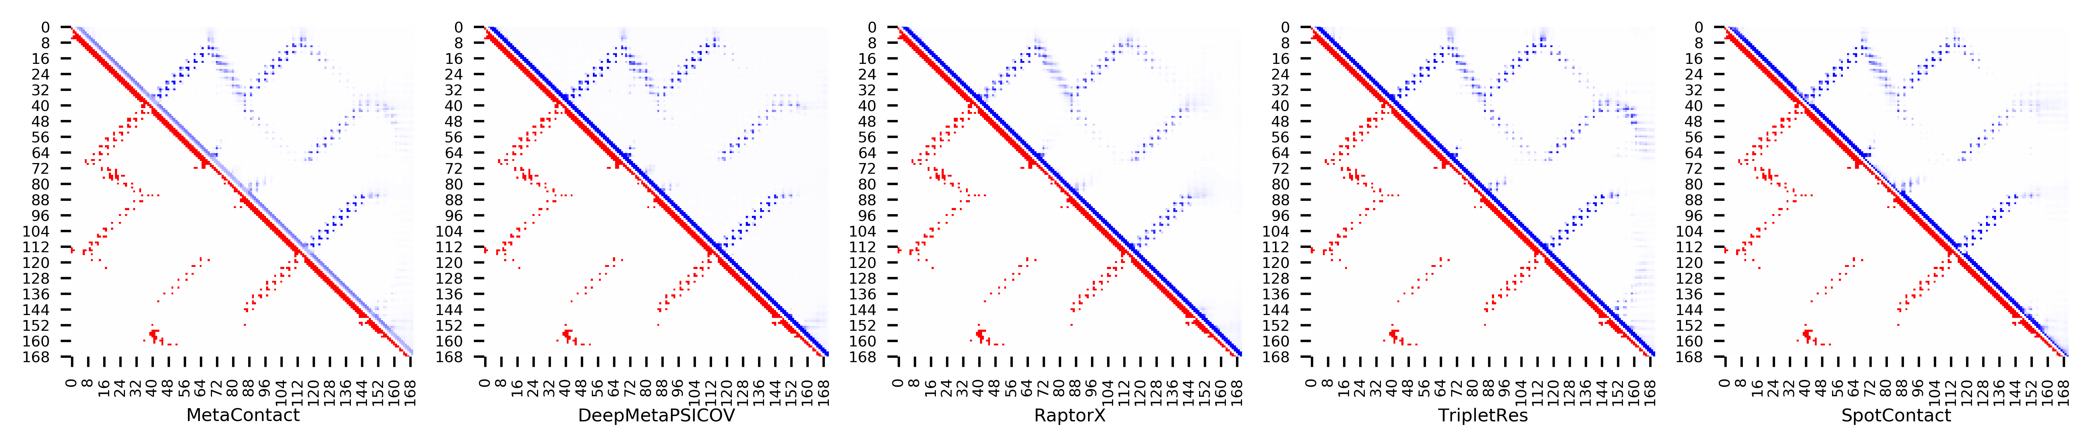

**Figure S48.** Five predicted contact maps (blue) with nature contacts (red) of target protein (1NF6_F)

**Table S55**. Precision of five contact maps (Protein ID: 1NTV_A)

|  |  |  |  |  |  |  |  |  |  |  |  |
| --- | --- | --- | --- | --- | --- | --- | --- | --- | --- | --- | --- |
| ID: 1NTV_A | | MetaContact | | DeepMetaPSICOV | | RaptorX | | SpotContact | | TripletRes | |
| Range | List size | Precision | Count | Precision | Count | Precision | Count | Precision | Count | Precision | Count |
| medium and long | Top-L/5 | 0.967 | 30 | 0.967 | 30 | 0.967 | 30 | 0.967 | 30 | 0.700 | 30 |
| Top-L/2 | 0.947 | 76 | 0.789 | 76 | 0.961 | 76 | 0.947 | 76 | 0.684 | 76 |
| Top-L | 0.875 | 152 | 0.711 | 152 | 0.901 | 152 | 0.908 | 152 | 0.612 | 152 |
| Top-NC | 0.735 | 245 | 0.576 | 245 | 0.784 | 245 | 0.763 | 245 | 0.531 | 245 |
| long | Top-L/5 | 0.933 | 30 | 0.867 | 30 | 0.967 | 30 | 0.933 | 30 | 0.533 | 30 |
| Top-L/2 | 0.868 | 76 | 0.724 | 76 | 0.895 | 76 | 0.934 | 76 | 0.539 | 76 |
| Top-L | 0.750 | 152 | 0.566 | 152 | 0.796 | 152 | 0.803 | 152 | 0.480 | 152 |
| Top-NC | 0.713 | 171 | 0.526 | 171 | 0.743 | 171 | 0.725 | 171 | 0.450 | 171 |

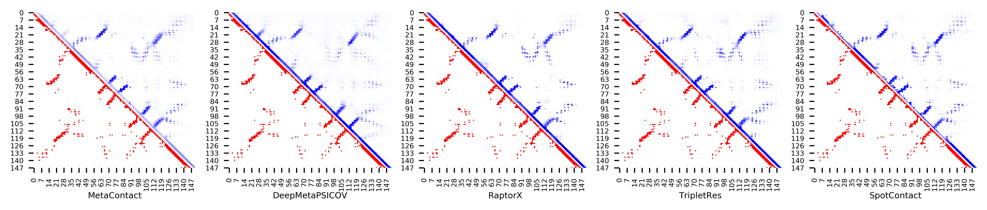

**Figure S49.** Five predicted contact maps (blue) with nature contacts (red) of target protein (1NTV_A)

**Table S56**. Precision of five contact maps (Protein ID: 1OFT_A)

|  |  |  |  |  |  |  |  |  |  |  |  |
| --- | --- | --- | --- | --- | --- | --- | --- | --- | --- | --- | --- |
| ID: 1OFT_A | | MetaContact | | DeepMetaPSICOV | | RaptorX | | SpotContact | | TripletRes | |
| Range | List size | Precision | Count | Precision | Count | Precision | Count | Precision | Count | Precision | Count |
| medium and long | Top-L/5 | 1.000 | 24 | 1.000 | 24 | 1.000 | 24 | 1.000 | 24 | 1.000 | 24 |
| Top-L/2 | 0.983 | 60 | 0.950 | 60 | 1.000 | 60 | 1.000 | 60 | 0.983 | 60 |
| Top-L | 0.899 | 119 | 0.815 | 119 | 0.916 | 119 | 0.933 | 119 | 0.874 | 119 |
| Top-NC | 0.742 | 213 | 0.643 | 213 | 0.756 | 213 | 0.761 | 213 | 0.723 | 213 |
| long | Top-L/5 | 1.000 | 24 | 1.000 | 24 | 1.000 | 24 | 1.000 | 24 | 1.000 | 24 |
| Top-L/2 | 0.967 | 60 | 0.933 | 60 | 1.000 | 60 | 1.000 | 60 | 0.967 | 60 |
| Top-L | 0.866 | 119 | 0.832 | 119 | 0.874 | 119 | 0.891 | 119 | 0.857 | 119 |
| Top-NC | 0.742 | 182 | 0.659 | 182 | 0.758 | 182 | 0.758 | 182 | 0.725 | 182 |

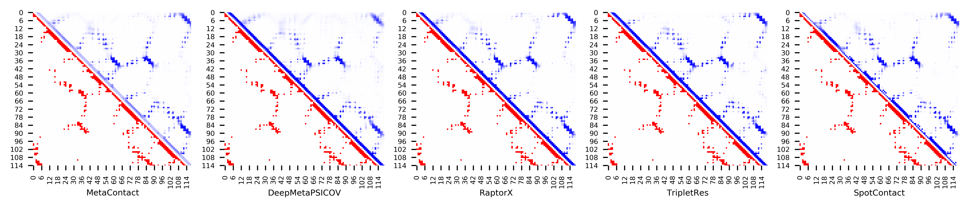

**Figure S50.** Five predicted contact maps (blue) with nature contacts (red) of target protein (1OFT_A)

**Table S57**. Precision of five contact maps (Protein ID: 1OOF_A)

|  |  |  |  |  |  |  |  |  |  |  |  |
| --- | --- | --- | --- | --- | --- | --- | --- | --- | --- | --- | --- |
| ID: 1OOF_A | | MetaContact | | DeepMetaPSICOV | | RaptorX | | SpotContact | | TripletRes | |
| Range | List size | Precision | Count | Precision | Count | Precision | Count | Precision | Count | Precision | Count |
| medium and long | Top-L/5 | 1.000 | 25 | 1.000 | 25 | 1.000 | 25 | 1.000 | 25 | 1.000 | 25 |
| Top-L/2 | 0.968 | 62 | 0.887 | 62 | 0.968 | 62 | 1.000 | 62 | 0.968 | 62 |
| Top-L | 0.790 | 124 | 0.718 | 124 | 0.734 | 124 | 0.798 | 124 | 0.758 | 124 |
| Top-NC | 0.689 | 161 | 0.652 | 161 | 0.621 | 161 | 0.727 | 161 | 0.646 | 161 |
| long | Top-L/5 | 1.000 | 25 | 0.960 | 25 | 1.000 | 25 | 1.000 | 25 | 1.000 | 25 |
| Top-L/2 | 0.887 | 62 | 0.742 | 62 | 0.823 | 62 | 0.823 | 62 | 0.887 | 62 |
| Top-L | 0.653 | 124 | 0.589 | 124 | 0.581 | 124 | 0.685 | 124 | 0.573 | 124 |
| Top-NC | 0.661 | 118 | 0.610 | 118 | 0.593 | 118 | 0.703 | 118 | 0.602 | 118 |

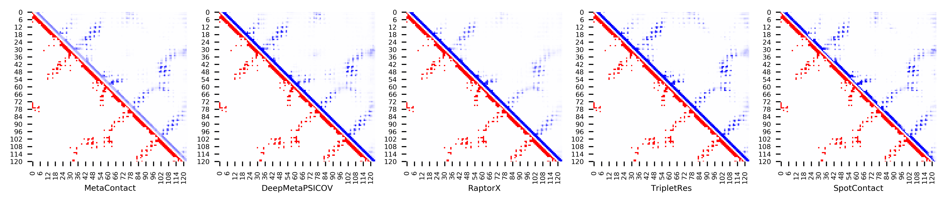

**Figure S51.** Five predicted contact maps (blue) with nature contacts (red) of target protein (1OOF_A)

**Table S58**. Precision of five contact maps (Protein ID: 1ORY_A)

|  |  |  |  |  |  |  |  |  |  |  |  |
| --- | --- | --- | --- | --- | --- | --- | --- | --- | --- | --- | --- |
| ID: 1ORY_A | | MetaContact | | DeepMetaPSICOV | | RaptorX | | SpotContact | | TripletRes | |
| Range | List size | Precision | Count | Precision | Count | Precision | Count | Precision | Count | Precision | Count |
| medium and long | Top-L/5 | 1.000 | 24 | 1.000 | 24 | 1.000 | 24 | 1.000 | 24 | 1.000 | 24 |
| Top-L/2 | 0.967 | 60 | 0.967 | 60 | 0.917 | 60 | 0.967 | 60 | 0.967 | 60 |
| Top-L | 0.723 | 119 | 0.706 | 119 | 0.697 | 119 | 0.714 | 119 | 0.706 | 119 |
| Top-NC | 0.860 | 93 | 0.839 | 93 | 0.828 | 93 | 0.849 | 93 | 0.839 | 93 |
| long | Top-L/5 | 1.000 | 24 | 1.000 | 24 | 1.000 | 24 | 1.000 | 24 | 1.000 | 24 |
| Top-L/2 | 0.917 | 60 | 0.900 | 60 | 0.883 | 60 | 0.900 | 60 | 0.850 | 60 |
| Top-L | 0.504 | 119 | 0.504 | 119 | 0.513 | 119 | 0.521 | 119 | 0.496 | 119 |
| Top-NC | 0.887 | 62 | 0.871 | 62 | 0.871 | 62 | 0.887 | 62 | 0.855 | 62 |

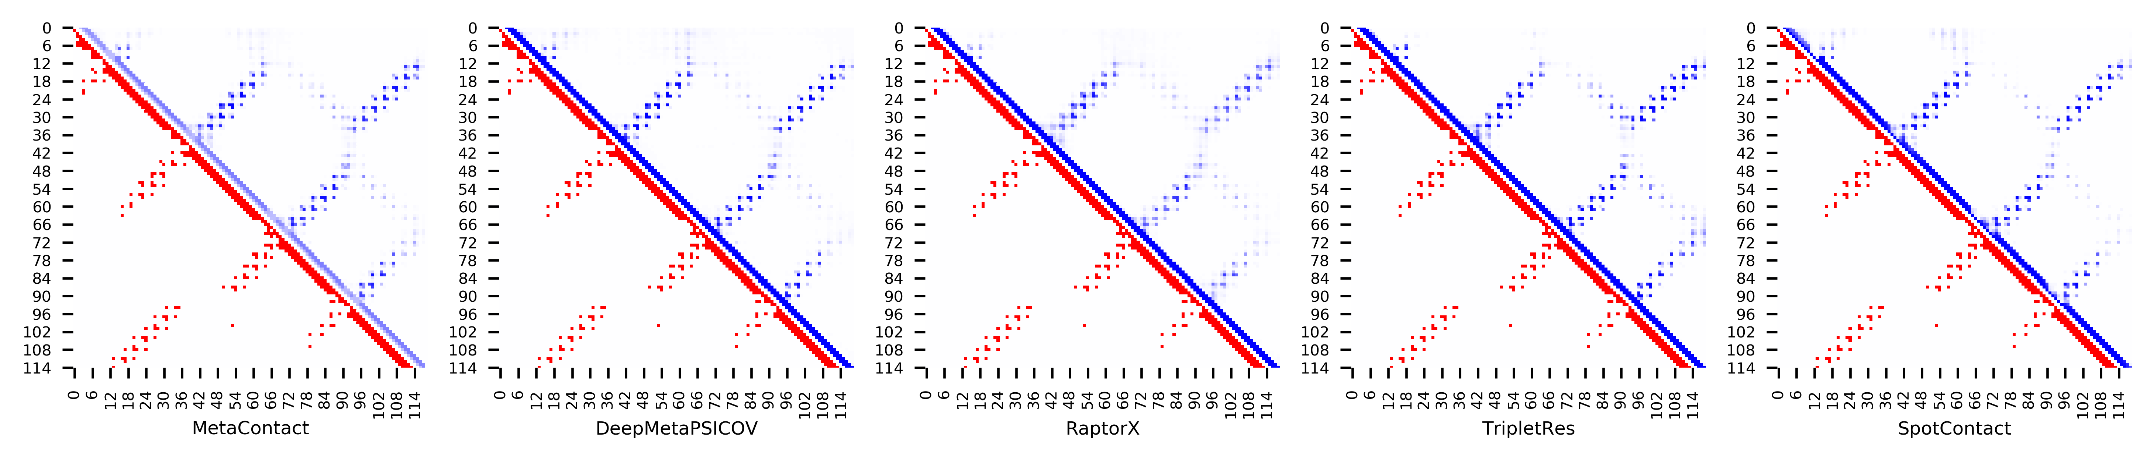

**Figure S52.** Five predicted contact maps (blue) with nature contacts (red) of target protein (1ORY_A)

**Table S59**. Precision of five contact maps (Protein ID: 1OX7_A)

|  |  |  |  |  |  |  |  |  |  |  |  |
| --- | --- | --- | --- | --- | --- | --- | --- | --- | --- | --- | --- |
| ID: 1OX7_A | | MetaContact | | DeepMetaPSICOV | | RaptorX | | SpotContact | | TripletRes | |
| Range | List size | Precision | Count | Precision | Count | Precision | Count | Precision | Count | Precision | Count |
| medium and long | Top-L/5 | 1.000 | 32 | 1.000 | 32 | 1.000 | 32 | 1.000 | 32 | 1.000 | 32 |
| Top-L/2 | 1.000 | 79 | 0.975 | 79 | 0.987 | 79 | 1.000 | 79 | 1.000 | 79 |
| Top-L | 0.975 | 158 | 0.905 | 158 | 0.918 | 158 | 0.968 | 158 | 0.956 | 158 |
| Top-NC | 0.728 | 334 | 0.653 | 334 | 0.707 | 334 | 0.787 | 334 | 0.695 | 334 |
| long | Top-L/5 | 1.000 | 32 | 1.000 | 32 | 1.000 | 32 | 1.000 | 32 | 1.000 | 32 |
| Top-L/2 | 0.987 | 79 | 0.924 | 79 | 0.962 | 79 | 0.975 | 79 | 0.962 | 79 |
| Top-L | 0.797 | 158 | 0.677 | 158 | 0.753 | 158 | 0.835 | 158 | 0.759 | 158 |
| Top-NC | 0.680 | 222 | 0.595 | 222 | 0.617 | 222 | 0.725 | 222 | 0.617 | 222 |

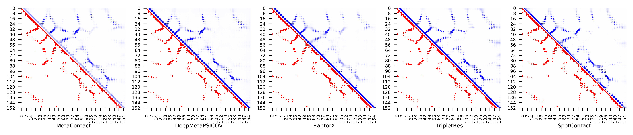

**Figure S53.** Five predicted contact maps (blue) with nature contacts (red) of target protein (1OX7_A)

**Table S60**. Precision of five contact maps (Protein ID: 1OZ9_A)

|  |  |  |  |  |  |  |  |  |  |  |  |
| --- | --- | --- | --- | --- | --- | --- | --- | --- | --- | --- | --- |
| ID: 1OZ9_A | | MetaContact | | DeepMetaPSICOV | | RaptorX | | SpotContact | | TripletRes | |
| Range | List size | Precision | Count | Precision | Count | Precision | Count | Precision | Count | Precision | Count |
| medium and long | Top-L/5 | 1.000 | 28 | 1.000 | 28 | 1.000 | 28 | 1.000 | 28 | 1.000 | 28 |
| Top-L/2 | 0.986 | 70 | 0.971 | 70 | 0.986 | 70 | 1.000 | 70 | 1.000 | 70 |
| Top-L | 0.950 | 141 | 0.929 | 141 | 0.922 | 141 | 0.979 | 141 | 0.872 | 141 |
| Top-NC | 0.769 | 229 | 0.703 | 229 | 0.755 | 229 | 0.852 | 229 | 0.664 | 229 |
| long | Top-L/5 | 1.000 | 28 | 0.964 | 28 | 1.000 | 28 | 1.000 | 28 | 1.000 | 28 |
| Top-L/2 | 0.971 | 70 | 0.957 | 70 | 0.929 | 70 | 1.000 | 70 | 0.929 | 70 |
| Top-L | 0.816 | 141 | 0.766 | 141 | 0.780 | 141 | 0.887 | 141 | 0.709 | 141 |
| Top-NC | 0.750 | 172 | 0.674 | 172 | 0.738 | 172 | 0.837 | 172 | 0.634 | 172 |

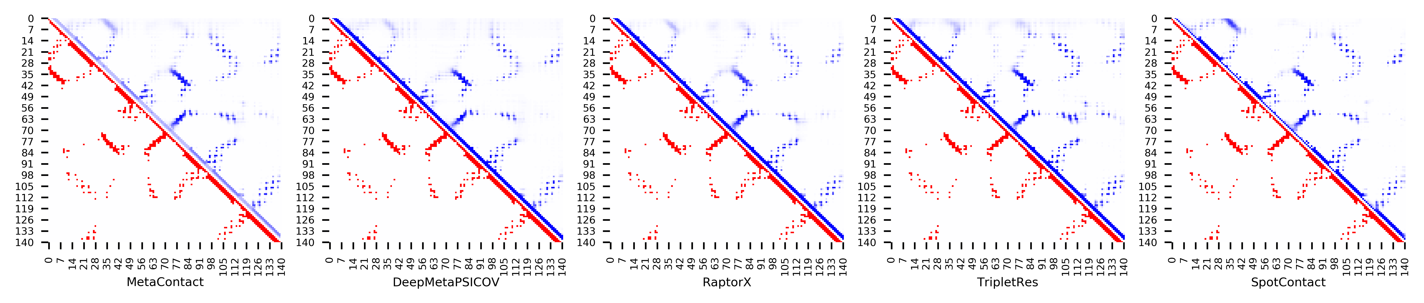

**Figure S54.** Five predicted contact maps (blue) with nature contacts (red) of target protein (1OZ9_A)

**Table S61**. Precision of five contact maps (Protein ID: 1PD6_A)

|  |  |  |  |  |  |  |  |  |  |  |  |
| --- | --- | --- | --- | --- | --- | --- | --- | --- | --- | --- | --- |
| ID: 1PD6_A | | MetaContact | | DeepMetaPSICOV | | RaptorX | | SpotContact | | TripletRes | |
| Range | List size | Precision | Count | Precision | Count | Precision | Count | Precision | Count | Precision | Count |
| medium and long | Top-L/5 | 0.947 | 19 | 1.000 | 19 | 0.842 | 19 | 1.000 | 19 | 1.000 | 19 |
| Top-L/2 | 0.957 | 47 | 0.979 | 47 | 0.830 | 47 | 0.979 | 47 | 0.979 | 47 |
| Top-L | 0.926 | 94 | 0.926 | 94 | 0.681 | 94 | 0.968 | 94 | 0.926 | 94 |
| Top-NC | 0.733 | 210 | 0.724 | 210 | 0.543 | 210 | 0.738 | 210 | 0.733 | 210 |
| long | Top-L/5 | 0.947 | 19 | 1.000 | 19 | 0.842 | 19 | 1.000 | 19 | 1.000 | 19 |
| Top-L/2 | 0.957 | 47 | 0.936 | 47 | 0.851 | 47 | 0.957 | 47 | 0.957 | 47 |
| Top-L | 0.883 | 94 | 0.819 | 94 | 0.660 | 94 | 0.862 | 94 | 0.851 | 94 |
| Top-NC | 0.712 | 156 | 0.692 | 156 | 0.519 | 156 | 0.712 | 156 | 0.705 | 156 |

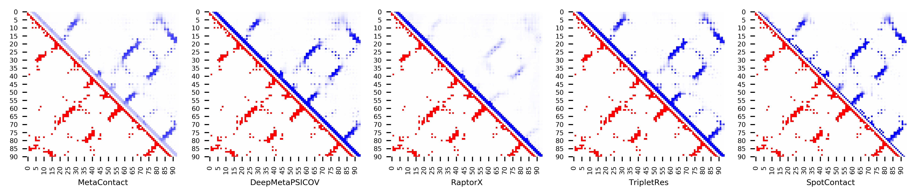

**Figure S55.** Five predicted contact maps (blue) with nature contacts (red) of target protein (1PD6_A)

**Table S62**. Precision of five contact maps (Protein ID: 1PGV_A)

|  |  |  |  |  |  |  |  |  |  |  |  |
| --- | --- | --- | --- | --- | --- | --- | --- | --- | --- | --- | --- |
| ID: 1PGV_A | | MetaContact | | DeepMetaPSICOV | | RaptorX | | SpotContact | | TripletRes | |
| Range | List size | Precision | Count | Precision | Count | Precision | Count | Precision | Count | Precision | Count |
| medium and long | Top-L/5 | 1.000 | 33 | 1.000 | 33 | 0.970 | 33 | 1.000 | 33 | 1.000 | 33 |
| Top-L/2 | 0.988 | 84 | 0.952 | 84 | 0.940 | 84 | 0.988 | 84 | 0.929 | 84 |
| Top-L | 0.934 | 167 | 0.838 | 167 | 0.862 | 167 | 0.934 | 167 | 0.856 | 167 |
| Top-NC | 0.712 | 330 | 0.667 | 330 | 0.655 | 330 | 0.721 | 330 | 0.648 | 330 |
| long | Top-L/5 | 1.000 | 33 | 0.970 | 33 | 0.970 | 33 | 1.000 | 33 | 1.000 | 33 |
| Top-L/2 | 0.976 | 84 | 0.952 | 84 | 0.940 | 84 | 0.988 | 84 | 0.917 | 84 |
| Top-L | 0.928 | 167 | 0.820 | 167 | 0.856 | 167 | 0.922 | 167 | 0.850 | 167 |
| Top-NC | 0.755 | 274 | 0.701 | 274 | 0.690 | 274 | 0.774 | 274 | 0.701 | 274 |

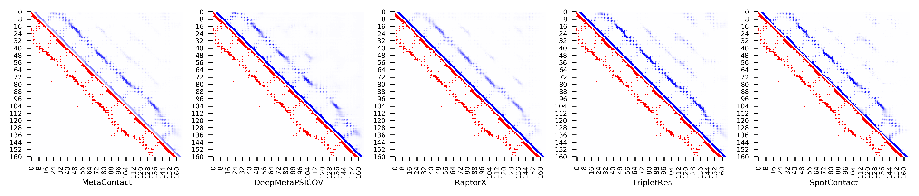

**Figure S56.** Five predicted contact maps (blue) with nature contacts (red) of target protein (1PGV_A)

**Table S63**. Precision of five contact maps (Protein ID: 1PSR_A)

|  |  |  |  |  |  |  |  |  |  |  |  |
| --- | --- | --- | --- | --- | --- | --- | --- | --- | --- | --- | --- |
| ID: 1PSR_A | | MetaContact | | DeepMetaPSICOV | | RaptorX | | SpotContact | | TripletRes | |
| Range | List size | Precision | Count | Precision | Count | Precision | Count | Precision | Count | Precision | Count |
| medium and long | Top-L/5 | 1.000 | 20 | 0.700 | 20 | 0.700 | 20 | 1.000 | 20 | 0.950 | 20 |
| Top-L/2 | 0.680 | 50 | 0.500 | 50 | 0.580 | 50 | 0.720 | 50 | 0.660 | 50 |
| Top-L | 0.410 | 100 | 0.340 | 100 | 0.390 | 100 | 0.420 | 100 | 0.370 | 100 |
| Top-NC | 0.581 | 62 | 0.435 | 62 | 0.516 | 62 | 0.613 | 62 | 0.548 | 62 |
| long | Top-L/5 | 0.900 | 20 | 0.700 | 20 | 0.600 | 20 | 0.800 | 20 | 0.750 | 20 |
| Top-L/2 | 0.460 | 50 | 0.400 | 50 | 0.420 | 50 | 0.480 | 50 | 0.400 | 50 |
| Top-L | 0.250 | 100 | 0.240 | 100 | 0.240 | 100 | 0.260 | 100 | 0.220 | 100 |
| Top-NC | 0.512 | 41 | 0.439 | 41 | 0.439 | 41 | 0.561 | 41 | 0.488 | 41 |

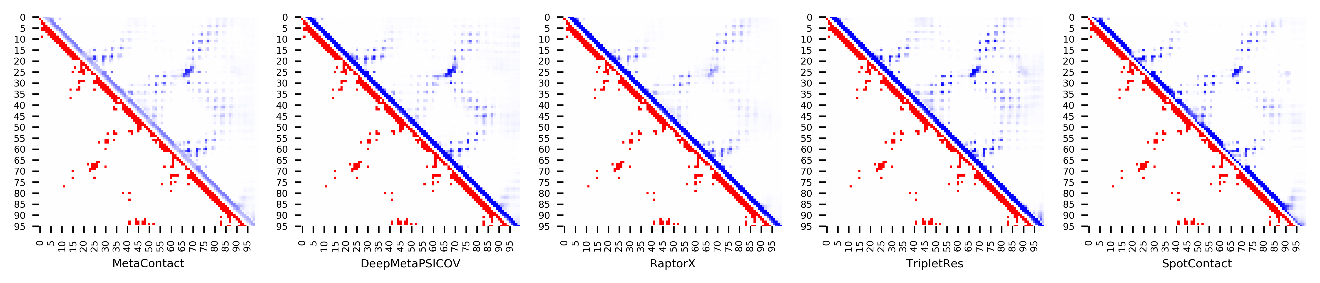

**Figure S57.** Five predicted contact maps (blue) with nature contacts (red) of target protein (1PSR_A)

**Table S64**. Precision of five contact maps (Protein ID: 1QMA_A)

|  |  |  |  |  |  |  |  |  |  |  |  |
| --- | --- | --- | --- | --- | --- | --- | --- | --- | --- | --- | --- |
| ID: 1QMA_A | | MetaContact | | DeepMetaPSICOV | | RaptorX | | SpotContact | | TripletRes | |
| Range | List size | Precision | Count | Precision | Count | Precision | Count | Precision | Count | Precision | Count |
| medium and long | Top-L/5 | 1.000 | 25 | 1.000 | 25 | 1.000 | 25 | 1.000 | 25 | 1.000 | 25 |
| Top-L/2 | 1.000 | 62 | 1.000 | 62 | 1.000 | 62 | 1.000 | 62 | 1.000 | 62 |
| Top-L | 0.984 | 123 | 0.927 | 123 | 0.984 | 123 | 0.992 | 123 | 0.919 | 123 |
| Top-NC | 0.855 | 200 | 0.795 | 200 | 0.855 | 200 | 0.845 | 200 | 0.755 | 200 |
| long | Top-L/5 | 1.000 | 25 | 1.000 | 25 | 1.000 | 25 | 1.000 | 25 | 1.000 | 25 |
| Top-L/2 | 0.952 | 62 | 0.855 | 62 | 0.968 | 62 | 0.968 | 62 | 0.855 | 62 |
| Top-L | 0.764 | 123 | 0.659 | 123 | 0.764 | 123 | 0.756 | 123 | 0.650 | 123 |
| Top-NC | 0.809 | 115 | 0.696 | 115 | 0.791 | 115 | 0.774 | 115 | 0.687 | 115 |

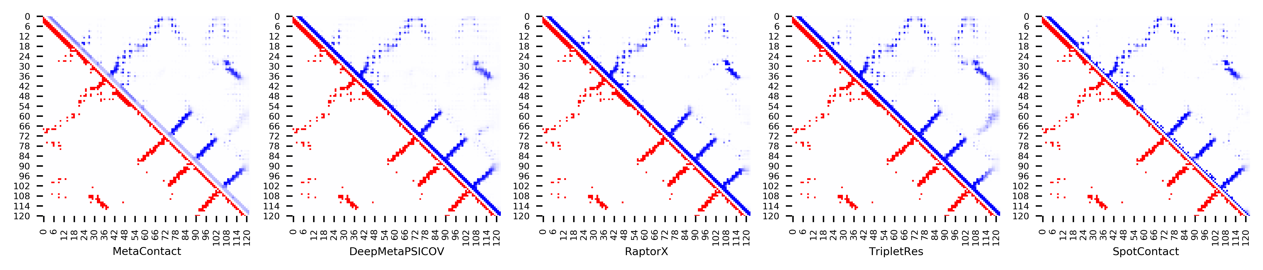

**Figure S58.** Five predicted contact maps (blue) with nature contacts (red) of target protein (1QMA_A)

**Table S65**. Precision of five contact maps (Protein ID: 1R5T_A)

|  |  |  |  |  |  |  |  |  |  |  |  |
| --- | --- | --- | --- | --- | --- | --- | --- | --- | --- | --- | --- |
| ID: 1R5T_A | | MetaContact | | DeepMetaPSICOV | | RaptorX | | SpotContact | | TripletRes | |
| Range | List size | Precision | Count | Precision | Count | Precision | Count | Precision | Count | Precision | Count |
| medium and long | Top-L/5 | 1.000 | 28 | 1.000 | 28 | 1.000 | 28 | 1.000 | 28 | 1.000 | 28 |
| Top-L/2 | 1.000 | 70 | 1.000 | 70 | 0.986 | 70 | 1.000 | 70 | 0.943 | 70 |
| Top-L | 0.972 | 141 | 0.950 | 141 | 0.965 | 141 | 0.993 | 141 | 0.858 | 141 |
| Top-NC | 0.804 | 276 | 0.746 | 276 | 0.815 | 276 | 0.837 | 276 | 0.699 | 276 |
| long | Top-L/5 | 1.000 | 28 | 1.000 | 28 | 1.000 | 28 | 1.000 | 28 | 0.929 | 28 |
| Top-L/2 | 1.000 | 70 | 0.971 | 70 | 0.971 | 70 | 1.000 | 70 | 0.900 | 70 |
| Top-L | 0.915 | 141 | 0.816 | 141 | 0.894 | 141 | 0.922 | 141 | 0.773 | 141 |
| Top-NC | 0.779 | 204 | 0.716 | 204 | 0.794 | 204 | 0.814 | 204 | 0.647 | 204 |

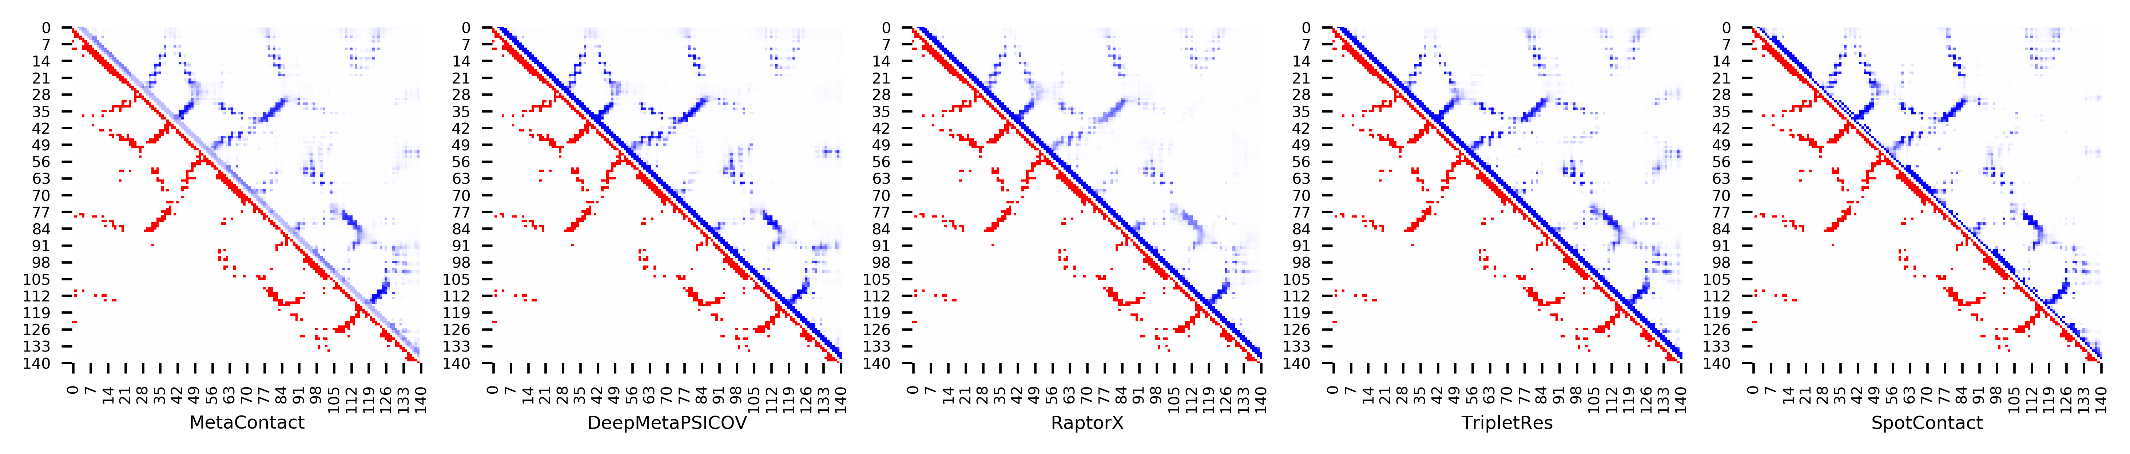

**Figure S59.** Five predicted contact maps (blue) with nature contacts (red) of target protein (1R5T_A)

**Table S66**. Precision of five contact maps (Protein ID: 1S3J_A)

|  |  |  |  |  |  |  |  |  |  |  |  |
| --- | --- | --- | --- | --- | --- | --- | --- | --- | --- | --- | --- |
| ID: 1S3J_A | | MetaContact | | DeepMetaPSICOV | | RaptorX | | SpotContact | | TripletRes | |
| Range | List size | Precision | Count | Precision | Count | Precision | Count | Precision | Count | Precision | Count |
| medium and long | Top-L/5 | 0.931 | 29 | 0.931 | 29 | 0.862 | 29 | 1.000 | 29 | 0.931 | 29 |
| Top-L/2 | 0.972 | 72 | 0.917 | 72 | 0.528 | 72 | 0.972 | 72 | 0.875 | 72 |
| Top-L | 0.650 | 143 | 0.629 | 143 | 0.406 | 143 | 0.671 | 143 | 0.608 | 143 |
| Top-NC | 0.837 | 98 | 0.816 | 98 | 0.500 | 98 | 0.867 | 98 | 0.796 | 98 |
| long | Top-L/5 | 1.000 | 29 | 0.966 | 29 | 0.655 | 29 | 1.000 | 29 | 0.966 | 29 |
| Top-L/2 | 0.792 | 72 | 0.778 | 72 | 0.486 | 72 | 0.875 | 72 | 0.778 | 72 |
| Top-L | 0.483 | 143 | 0.483 | 143 | 0.329 | 143 | 0.483 | 143 | 0.462 | 143 |
| Top-NC | 0.814 | 70 | 0.786 | 70 | 0.500 | 70 | 0.871 | 70 | 0.771 | 70 |

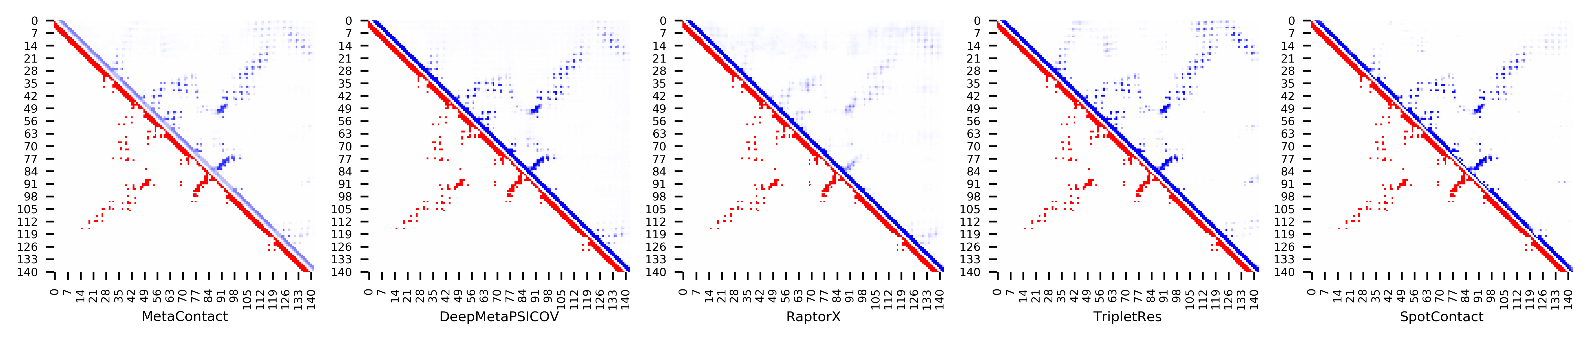

**Figure S60.** Five predicted contact maps (blue) with nature contacts (red) of target protein (1S3J_A)

**Table S67**. Precision of five contact maps (Protein ID: 1S56_B)

|  |  |  |  |  |  |  |  |  |  |  |  |
| --- | --- | --- | --- | --- | --- | --- | --- | --- | --- | --- | --- |
| ID: 1S56_B | | MetaContact | | DeepMetaPSICOV | | RaptorX | | SpotContact | | TripletRes | |
| Range | List size | Precision | Count | Precision | Count | Precision | Count | Precision | Count | Precision | Count |
| medium and long | Top-L/5 | 1.000 | 27 | 1.000 | 27 | 1.000 | 27 | 1.000 | 27 | 1.000 | 27 |
| Top-L/2 | 0.985 | 68 | 0.956 | 68 | 0.956 | 68 | 0.941 | 68 | 0.897 | 68 |
| Top-L | 0.741 | 135 | 0.756 | 135 | 0.733 | 135 | 0.748 | 135 | 0.689 | 135 |
| Top-NC | 0.713 | 143 | 0.720 | 143 | 0.699 | 143 | 0.720 | 143 | 0.657 | 143 |
| long | Top-L/5 | 1.000 | 27 | 1.000 | 27 | 0.963 | 27 | 1.000 | 27 | 1.000 | 27 |
| Top-L/2 | 0.926 | 68 | 0.926 | 68 | 0.941 | 68 | 0.912 | 68 | 0.853 | 68 |
| Top-L | 0.667 | 135 | 0.681 | 135 | 0.667 | 135 | 0.689 | 135 | 0.615 | 135 |
| Top-NC | 0.710 | 124 | 0.718 | 124 | 0.702 | 124 | 0.742 | 124 | 0.653 | 124 |

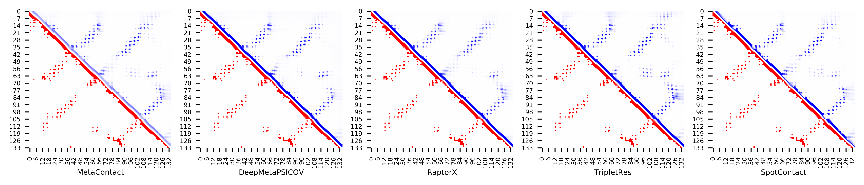

**Figure S61.** Five predicted contact maps (blue) with nature contacts (red) of target protein (1S56_B)

**Table S68**. Precision of five contact maps (Protein ID: 1TAF_A)

|  |  |  |  |  |  |  |  |  |  |  |  |
| --- | --- | --- | --- | --- | --- | --- | --- | --- | --- | --- | --- |
| ID: 1TAF_A | | MetaContact | | DeepMetaPSICOV | | RaptorX | | SpotContact | | TripletRes | |
| Range | List size | Precision | Count | Precision | Count | Precision | Count | Precision | Count | Precision | Count |
| medium and long | Top-L/5 | 1.000 | 14 | 1.000 | 14 | 1.000 | 14 | 1.000 | 14 | 1.000 | 14 |
| Top-L/2 | 0.941 | 34 | 0.882 | 34 | 0.912 | 34 | 0.941 | 34 | 0.824 | 34 |
| Top-L | 0.500 | 68 | 0.500 | 68 | 0.515 | 68 | 0.500 | 68 | 0.471 | 68 |
| Top-NC | 0.914 | 35 | 0.886 | 35 | 0.914 | 35 | 0.914 | 35 | 0.829 | 35 |
| long | Top-L/5 | 0.714 | 14 | 0.714 | 14 | 0.714 | 14 | 0.714 | 14 | 0.714 | 14 |
| Top-L/2 | 0.294 | 34 | 0.294 | 34 | 0.294 | 34 | 0.294 | 34 | 0.294 | 34 |
| Top-L | 0.147 | 68 | 0.147 | 68 | 0.147 | 68 | 0.147 | 68 | 0.147 | 68 |
| Top-NC | 0.900 | 10 | 0.800 | 10 | 0.900 | 10 | 0.900 | 10 | 0.800 | 10 |

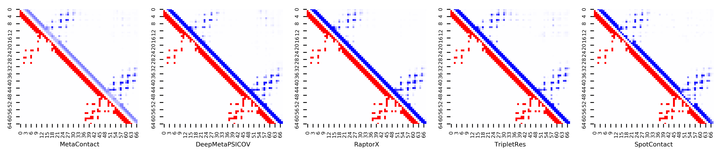

**Figure S62.** Five predicted contact maps (blue) with nature contacts (red) of target protein (1TAF_A)

**Table S69**. Precision of five contact maps (Protein ID: 1TYG_B)

|  |  |  |  |  |  |  |  |  |  |  |  |
| --- | --- | --- | --- | --- | --- | --- | --- | --- | --- | --- | --- |
| ID: 1TYG_B | | MetaContact | | DeepMetaPSICOV | | RaptorX | | SpotContact | | TripletRes | |
| Range | List size | Precision | Count | Precision | Count | Precision | Count | Precision | Count | Precision | Count |
| medium and long | Top-L/5 | 1.000 | 13 | 1.000 | 13 | 0.692 | 13 | 1.000 | 13 | 1.000 | 13 |
| Top-L/2 | 1.000 | 32 | 1.000 | 32 | 0.656 | 32 | 1.000 | 32 | 0.969 | 32 |
| Top-L | 0.892 | 65 | 0.908 | 65 | 0.615 | 65 | 0.908 | 65 | 0.815 | 65 |
| Top-NC | 0.818 | 77 | 0.844 | 77 | 0.558 | 77 | 0.857 | 77 | 0.766 | 77 |
| long | Top-L/5 | 1.000 | 13 | 1.000 | 13 | 0.769 | 13 | 1.000 | 13 | 1.000 | 13 |
| Top-L/2 | 1.000 | 32 | 1.000 | 32 | 0.688 | 32 | 1.000 | 32 | 0.969 | 32 |
| Top-L | 0.815 | 65 | 0.831 | 65 | 0.538 | 65 | 0.831 | 65 | 0.769 | 65 |
| Top-NC | 0.850 | 60 | 0.883 | 60 | 0.533 | 60 | 0.867 | 60 | 0.800 | 60 |

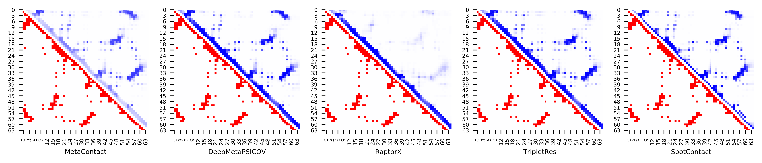

**Figure S63.** Five predicted contact maps (blue) with nature contacts (red) of target protein (1TYG_B)

**Table S70**. Precision of five contact maps (Protein ID: 1UG4_A)

|  |  |  |  |  |  |  |  |  |  |  |  |
| --- | --- | --- | --- | --- | --- | --- | --- | --- | --- | --- | --- |
| ID: 1UG4_A | | MetaContact | | DeepMetaPSICOV | | RaptorX | | SpotContact | | TripletRes | |
| Range | List size | Precision | Count | Precision | Count | Precision | Count | Precision | Count | Precision | Count |
| medium and long | Top-L/5 | 1.000 | 12 | 1.000 | 12 | 1.000 | 12 | 1.000 | 12 | 1.000 | 12 |
| Top-L/2 | 1.000 | 30 | 1.000 | 30 | 1.000 | 30 | 1.000 | 30 | 0.933 | 30 |
| Top-L | 0.900 | 60 | 0.883 | 60 | 0.900 | 60 | 0.900 | 60 | 0.750 | 60 |
| Top-NC | 0.693 | 101 | 0.693 | 101 | 0.733 | 101 | 0.624 | 101 | 0.703 | 101 |
| long | Top-L/5 | 1.000 | 12 | 1.000 | 12 | 1.000 | 12 | 1.000 | 12 | 1.000 | 12 |
| Top-L/2 | 0.867 | 30 | 0.900 | 30 | 0.900 | 30 | 0.867 | 30 | 0.733 | 30 |
| Top-L | 0.583 | 60 | 0.633 | 60 | 0.683 | 60 | 0.533 | 60 | 0.617 | 60 |
| Top-NC | 0.618 | 55 | 0.655 | 55 | 0.709 | 55 | 0.582 | 55 | 0.636 | 55 |

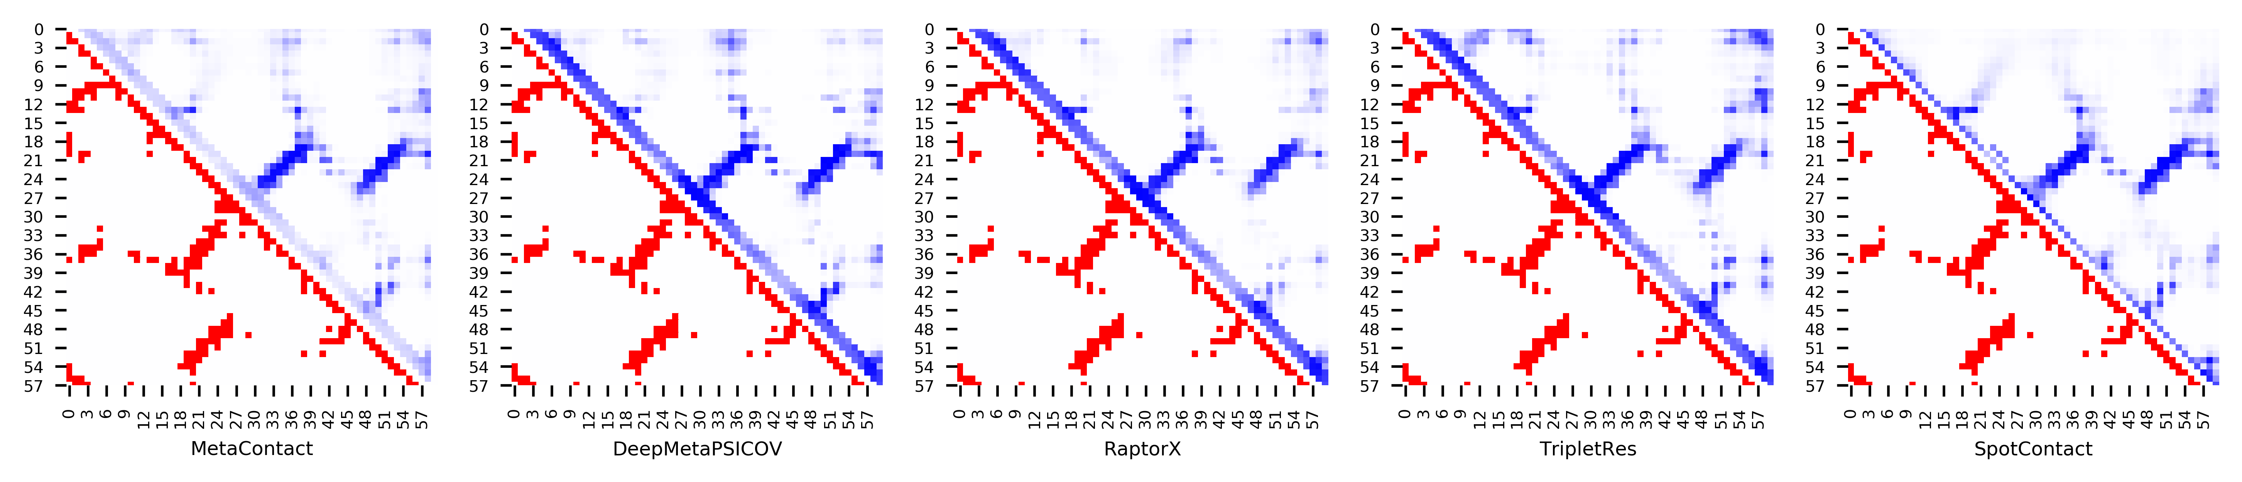

**Figure S64.** Five predicted contact maps (blue) with nature contacts (red) of target protein (1UG4_A)

**Table S71**. Precision of five contact maps (Protein ID: 1VKE_E)

|  |  |  |  |  |  |  |  |  |  |  |  |
| --- | --- | --- | --- | --- | --- | --- | --- | --- | --- | --- | --- |
| ID: 1VKE_E | | MetaContact | | DeepMetaPSICOV | | RaptorX | | SpotContact | | TripletRes | |
| Range | List size | Precision | Count | Precision | Count | Precision | Count | Precision | Count | Precision | Count |
| medium and long | Top-L/5 | 1.000 | 24 | 1.000 | 24 | 0.958 | 24 | 0.958 | 24 | 1.000 | 24 |
| Top-L/2 | 0.883 | 60 | 0.817 | 60 | 0.833 | 60 | 0.900 | 60 | 0.783 | 60 |
| Top-L | 0.580 | 119 | 0.555 | 119 | 0.555 | 119 | 0.588 | 119 | 0.521 | 119 |
| Top-NC | 0.688 | 96 | 0.656 | 96 | 0.646 | 96 | 0.667 | 96 | 0.583 | 96 |
| long | Top-L/5 | 1.000 | 24 | 0.917 | 24 | 1.000 | 24 | 0.917 | 24 | 1.000 | 24 |
| Top-L/2 | 0.767 | 60 | 0.650 | 60 | 0.750 | 60 | 0.767 | 60 | 0.600 | 60 |
| Top-L | 0.462 | 119 | 0.429 | 119 | 0.429 | 119 | 0.471 | 119 | 0.395 | 119 |
| Top-NC | 0.636 | 77 | 0.584 | 77 | 0.610 | 77 | 0.649 | 77 | 0.545 | 77 |

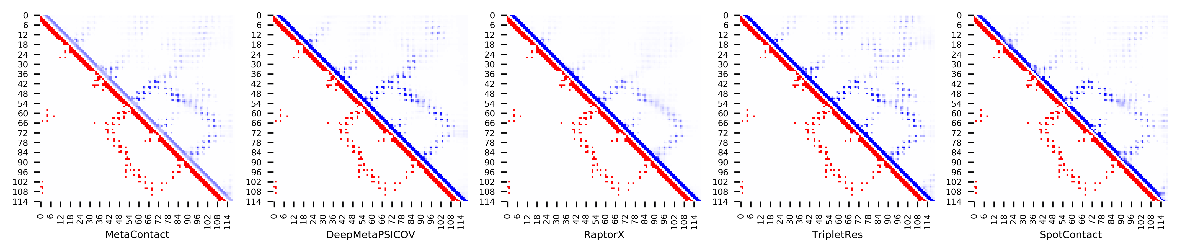

**Figure S65.** Five predicted contact maps (blue) with nature contacts (red) of target protein (1VKE_E)

**Table S72**. Precision of five contact maps (Protein ID: 1W1W_E)

|  |  |  |  |  |  |  |  |  |  |  |  |
| --- | --- | --- | --- | --- | --- | --- | --- | --- | --- | --- | --- |
| ID: 1W1W_E | | MetaContact | | DeepMetaPSICOV | | RaptorX | | SpotContact | | TripletRes | |
| Range | List size | Precision | Count | Precision | Count | Precision | Count | Precision | Count | Precision | Count |
| medium and long | Top-L/5 | 1.000 | 14 | 1.000 | 14 | 1.000 | 14 | 1.000 | 14 | 1.000 | 14 |
| Top-L/2 | 0.943 | 35 | 0.886 | 35 | 0.943 | 35 | 0.943 | 35 | 0.943 | 35 |
| Top-L | 0.757 | 70 | 0.671 | 70 | 0.786 | 70 | 0.829 | 70 | 0.771 | 70 |
| Top-NC | 0.730 | 74 | 0.635 | 74 | 0.757 | 74 | 0.797 | 74 | 0.743 | 74 |
| long | Top-L/5 | 1.000 | 14 | 0.929 | 14 | 0.929 | 14 | 1.000 | 14 | 0.929 | 14 |
| Top-L/2 | 0.829 | 35 | 0.771 | 35 | 0.857 | 35 | 0.857 | 35 | 0.743 | 35 |
| Top-L | 0.600 | 70 | 0.443 | 70 | 0.600 | 70 | 0.600 | 70 | 0.543 | 70 |
| Top-NC | 0.739 | 46 | 0.609 | 46 | 0.739 | 46 | 0.761 | 46 | 0.739 | 46 |

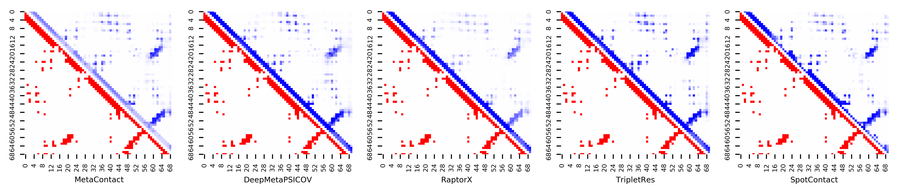

**Figure S66.** Five predicted contact maps (blue) with nature contacts (red) of target protein (1W1W_E)

**Table S73**. Precision of five contact maps (Protein ID: 1WJ8_A)

|  |  |  |  |  |  |  |  |  |  |  |  |
| --- | --- | --- | --- | --- | --- | --- | --- | --- | --- | --- | --- |
| ID: 1WJ8_A | | MetaContact | | DeepMetaPSICOV | | RaptorX | | SpotContact | | TripletRes | |
| Range | List size | Precision | Count | Precision | Count | Precision | Count | Precision | Count | Precision | Count |
| medium and long | Top-L/5 | 1.000 | 23 | 1.000 | 23 | 1.000 | 23 | 1.000 | 23 | 0.826 | 23 |
| Top-L/2 | 0.983 | 58 | 0.948 | 58 | 0.948 | 58 | 0.966 | 58 | 0.897 | 58 |
| Top-L | 0.795 | 117 | 0.786 | 117 | 0.838 | 117 | 0.795 | 117 | 0.701 | 117 |
| Top-NC | 0.779 | 122 | 0.779 | 122 | 0.828 | 122 | 0.770 | 122 | 0.697 | 122 |
| long | Top-L/5 | 1.000 | 23 | 0.957 | 23 | 1.000 | 23 | 1.000 | 23 | 0.826 | 23 |
| Top-L/2 | 0.845 | 58 | 0.793 | 58 | 0.862 | 58 | 0.845 | 58 | 0.741 | 58 |
| Top-L | 0.590 | 117 | 0.564 | 117 | 0.632 | 117 | 0.573 | 117 | 0.479 | 117 |
| Top-NC | 0.734 | 79 | 0.709 | 79 | 0.785 | 79 | 0.722 | 79 | 0.620 | 79 |

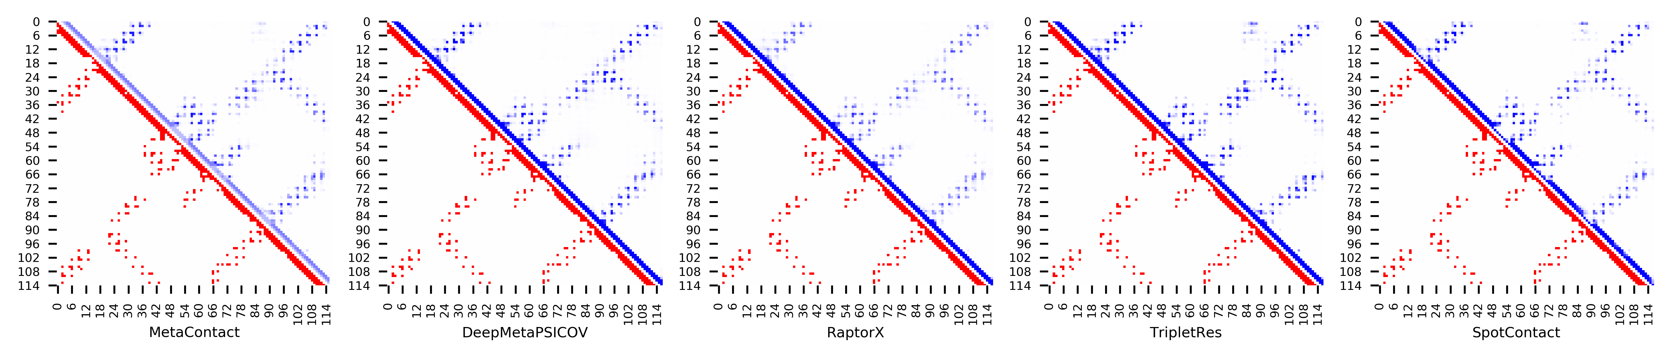

**Figure S67.** Five predicted contact maps (blue) with nature contacts (red) of target protein (1WJ8_A)

**Table S74**. Precision of five contact maps (Protein ID: 1WMH_B)

|  |  |  |  |  |  |  |  |  |  |  |  |
| --- | --- | --- | --- | --- | --- | --- | --- | --- | --- | --- | --- |
| ID: 1WMH_B | | MetaContact | | DeepMetaPSICOV | | RaptorX | | SpotContact | | TripletRes | |
| Range | List size | Precision | Count | Precision | Count | Precision | Count | Precision | Count | Precision | Count |
| medium and long | Top-L/5 | 1.000 | 16 | 1.000 | 16 | 1.000 | 16 | 0.938 | 16 | 0.938 | 16 |
| Top-L/2 | 0.927 | 41 | 0.780 | 41 | 0.902 | 41 | 0.927 | 41 | 0.878 | 41 |
| Top-L | 0.817 | 82 | 0.707 | 82 | 0.866 | 82 | 0.841 | 82 | 0.744 | 82 |
| Top-NC | 0.791 | 110 | 0.664 | 110 | 0.800 | 110 | 0.782 | 110 | 0.655 | 110 |
| long | Top-L/5 | 1.000 | 16 | 1.000 | 16 | 1.000 | 16 | 1.000 | 16 | 0.938 | 16 |
| Top-L/2 | 0.878 | 41 | 0.683 | 41 | 0.951 | 41 | 0.927 | 41 | 0.829 | 41 |
| Top-L | 0.756 | 82 | 0.634 | 82 | 0.768 | 82 | 0.744 | 82 | 0.610 | 82 |
| Top-NC | 0.792 | 72 | 0.667 | 72 | 0.847 | 72 | 0.764 | 72 | 0.667 | 72 |

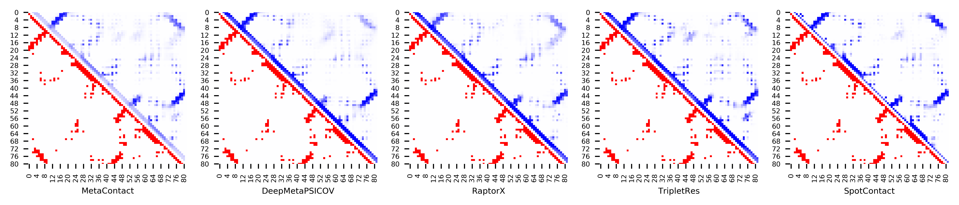

**Figure S68.** Five predicted contact maps (blue) with nature contacts (red) of target protein (1WMH_B)

**Table S75**. Precision of five contact maps (Protein ID: 1Y1X_A)

|  |  |  |  |  |  |  |  |  |  |  |  |
| --- | --- | --- | --- | --- | --- | --- | --- | --- | --- | --- | --- |
| ID: 1Y1X_A | | MetaContact | | DeepMetaPSICOV | | RaptorX | | SpotContact | | TripletRes | |
| Range | List size | Precision | Count | Precision | Count | Precision | Count | Precision | Count | Precision | Count |
| medium and long | Top-L/5 | 1.000 | 36 | 0.972 | 36 | 1.000 | 36 | 1.000 | 36 | 1.000 | 36 |
| Top-L/2 | 0.824 | 91 | 0.747 | 91 | 0.835 | 91 | 0.846 | 91 | 0.747 | 91 |
| Top-L | 0.511 | 182 | 0.445 | 182 | 0.533 | 182 | 0.522 | 182 | 0.478 | 182 |
| Top-NC | 0.514 | 181 | 0.448 | 181 | 0.536 | 181 | 0.519 | 181 | 0.481 | 181 |
| long | Top-L/5 | 0.944 | 36 | 0.861 | 36 | 0.917 | 36 | 0.972 | 36 | 0.917 | 36 |
| Top-L/2 | 0.516 | 91 | 0.462 | 91 | 0.527 | 91 | 0.560 | 91 | 0.495 | 91 |
| Top-L | 0.308 | 182 | 0.258 | 182 | 0.341 | 182 | 0.324 | 182 | 0.275 | 182 |
| Top-NC | 0.395 | 129 | 0.341 | 129 | 0.450 | 129 | 0.419 | 129 | 0.380 | 129 |

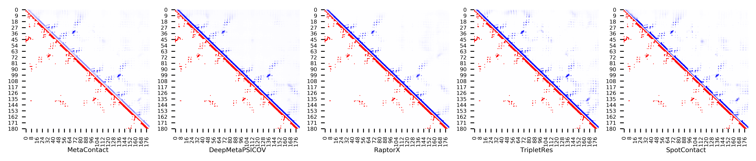

**Figure S69.** Five predicted contact maps (blue) with nature contacts (red) of target protein (1Y1X_A)

**Table S76**. Precision of five contact maps (Protein ID: 2ACY_A)

|  |  |  |  |  |  |  |  |  |  |  |  |
| --- | --- | --- | --- | --- | --- | --- | --- | --- | --- | --- | --- |
| ID: 2ACY_A | | MetaContact | | DeepMetaPSICOV | | RaptorX | | SpotContact | | TripletRes | |
| Range | List size | Precision | Count | Precision | Count | Precision | Count | Precision | Count | Precision | Count |
| medium and long | Top-L/5 | 1.000 | 20 | 1.000 | 20 | 1.000 | 20 | 1.000 | 20 | 1.000 | 20 |
| Top-L/2 | 0.980 | 49 | 0.980 | 49 | 0.918 | 49 | 1.000 | 49 | 0.980 | 49 |
| Top-L | 0.939 | 98 | 0.929 | 98 | 0.847 | 98 | 0.959 | 98 | 0.939 | 98 |
| Top-NC | 0.804 | 204 | 0.784 | 204 | 0.647 | 204 | 0.833 | 204 | 0.779 | 204 |
| long | Top-L/5 | 1.000 | 20 | 1.000 | 20 | 1.000 | 20 | 1.000 | 20 | 1.000 | 20 |
| Top-L/2 | 0.980 | 49 | 0.959 | 49 | 0.918 | 49 | 1.000 | 49 | 0.980 | 49 |
| Top-L | 0.918 | 98 | 0.908 | 98 | 0.816 | 98 | 0.929 | 98 | 0.908 | 98 |
| Top-NC | 0.801 | 176 | 0.767 | 176 | 0.659 | 176 | 0.818 | 176 | 0.784 | 176 |

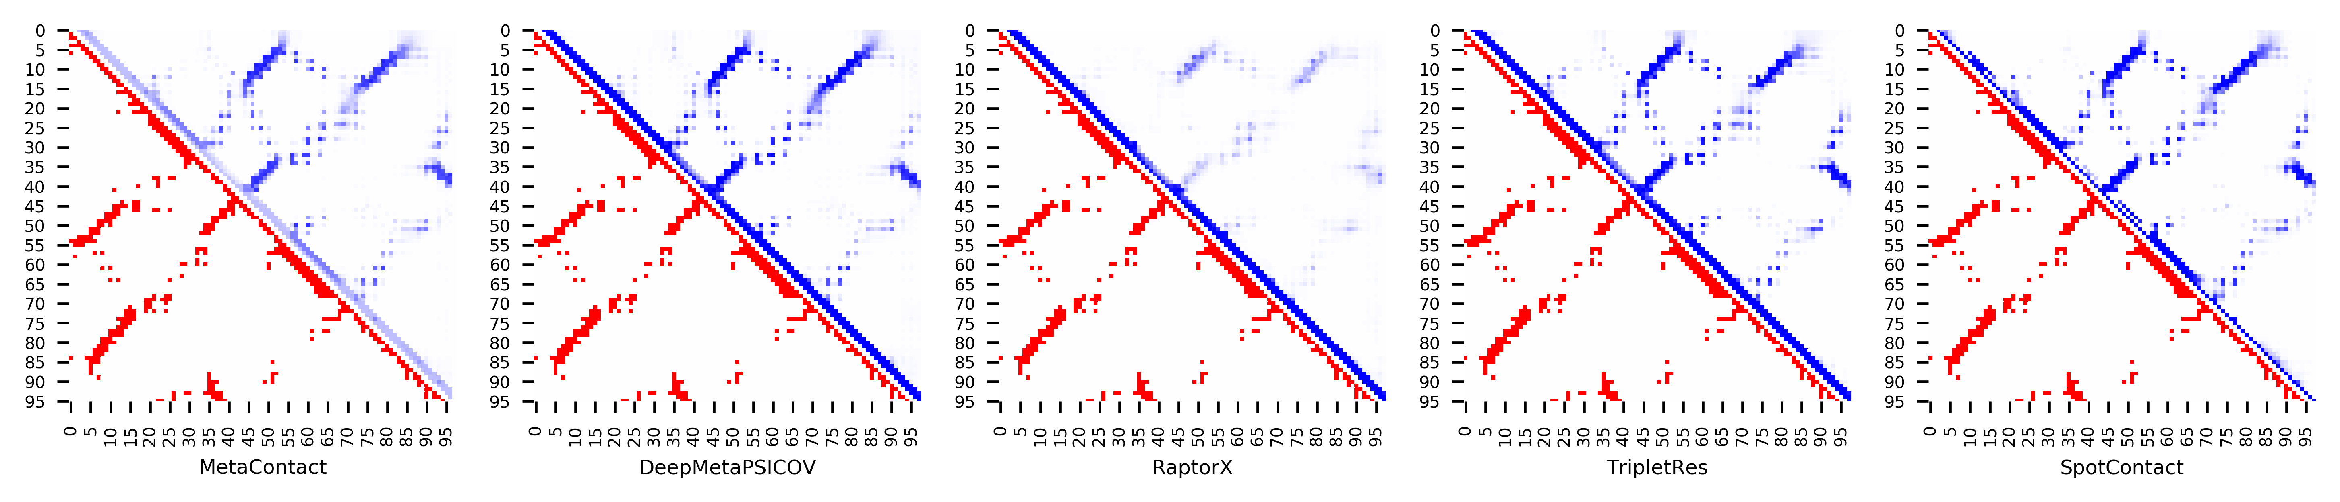

**Figure S70.** Five predicted contact maps (blue) with nature contacts (red) of target protein (2ACY_A)

**Table S77**. Precision of five contact maps (Protein ID: 2APN_A)

|  |  |  |  |  |  |  |  |  |  |  |  |
| --- | --- | --- | --- | --- | --- | --- | --- | --- | --- | --- | --- |
| ID: 2APN_A | | MetaContact | | DeepMetaPSICOV | | RaptorX | | SpotContact | | TripletRes | |
| Range | List size | Precision | Count | Precision | Count | Precision | Count | Precision | Count | Precision | Count |
| medium and long | Top-L/5 | 1.000 | 23 | 1.000 | 23 | 0.957 | 23 | 1.000 | 23 | 1.000 | 23 |
| Top-L/2 | 1.000 | 57 | 1.000 | 57 | 0.807 | 57 | 1.000 | 57 | 1.000 | 57 |
| Top-L | 0.895 | 114 | 0.851 | 114 | 0.711 | 114 | 0.912 | 114 | 0.851 | 114 |
| Top-NC | 0.671 | 210 | 0.633 | 210 | 0.533 | 210 | 0.690 | 210 | 0.657 | 210 |
| long | Top-L/5 | 1.000 | 23 | 1.000 | 23 | 0.609 | 23 | 1.000 | 23 | 1.000 | 23 |
| Top-L/2 | 0.895 | 57 | 0.825 | 57 | 0.649 | 57 | 0.930 | 57 | 0.825 | 57 |
| Top-L | 0.711 | 114 | 0.675 | 114 | 0.482 | 114 | 0.754 | 114 | 0.702 | 114 |
| Top-NC | 0.607 | 150 | 0.580 | 150 | 0.433 | 150 | 0.620 | 150 | 0.600 | 150 |

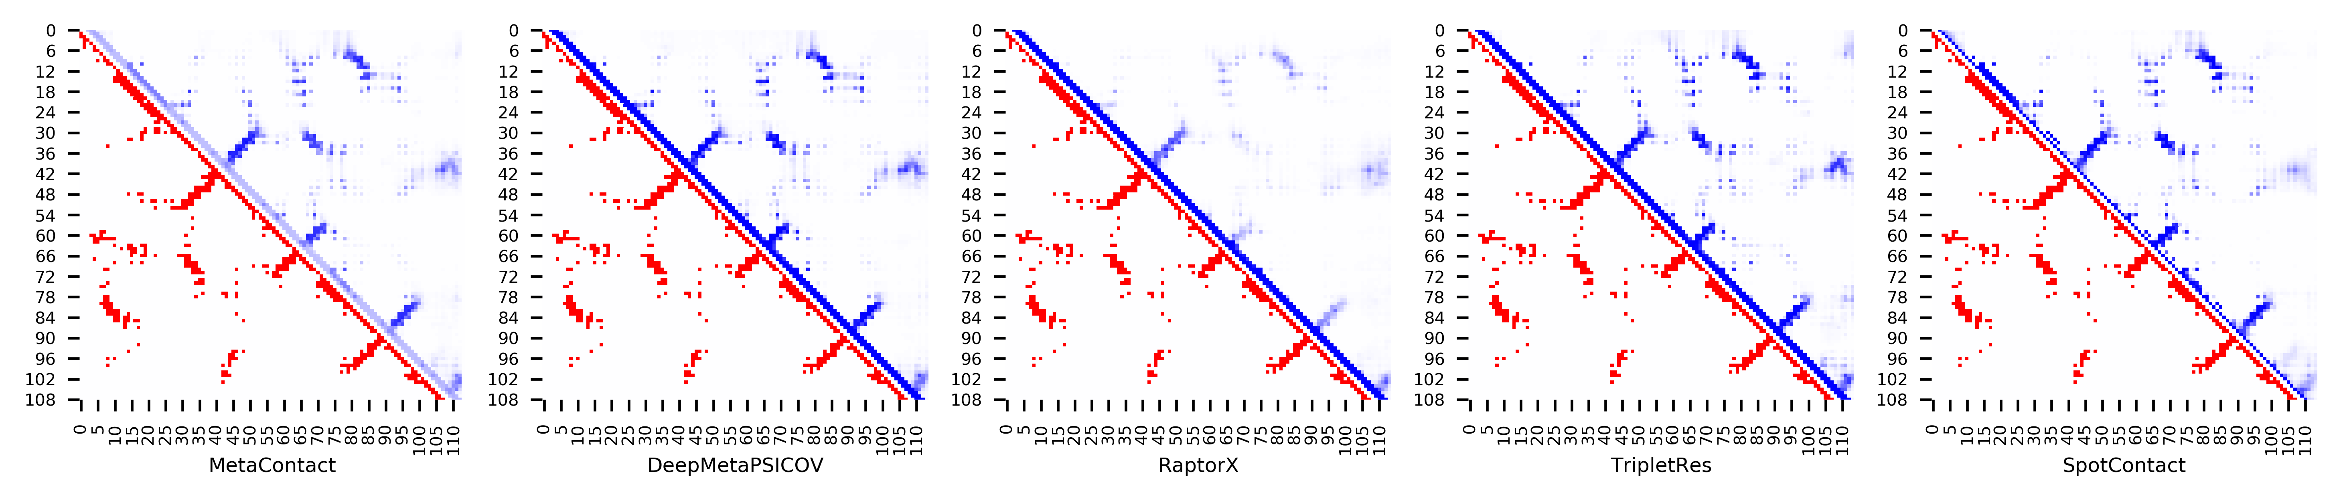

**Figure S71.** Five predicted contact maps (blue) with nature contacts (red) of target protein (2APN_A)

**Table S78**. Precision of five contact maps (Protein ID: 2AQ0_A)

|  |  |  |  |  |  |  |  |  |  |  |  |
| --- | --- | --- | --- | --- | --- | --- | --- | --- | --- | --- | --- |
| ID: 2AQ0_A | | MetaContact | | DeepMetaPSICOV | | RaptorX | | SpotContact | | TripletRes | |
| Range | List size | Precision | Count | Precision | Count | Precision | Count | Precision | Count | Precision | Count |
| medium and long | Top-L/5 | 0.941 | 17 | 0.941 | 17 | 0.941 | 17 | 1.000 | 17 | 0.882 | 17 |
| Top-L/2 | 0.786 | 42 | 0.714 | 42 | 0.762 | 42 | 0.810 | 42 | 0.690 | 42 |
| Top-L | 0.524 | 84 | 0.488 | 84 | 0.536 | 84 | 0.536 | 84 | 0.452 | 84 |
| Top-NC | 0.712 | 52 | 0.673 | 52 | 0.673 | 52 | 0.731 | 52 | 0.615 | 52 |
| long | Top-L/5 | 0.824 | 17 | 0.706 | 17 | 0.706 | 17 | 0.824 | 17 | 0.706 | 17 |
| Top-L/2 | 0.548 | 42 | 0.452 | 42 | 0.524 | 42 | 0.524 | 42 | 0.452 | 42 |
| Top-L | 0.310 | 84 | 0.262 | 84 | 0.298 | 84 | 0.321 | 84 | 0.262 | 84 |
| Top-NC | 0.667 | 30 | 0.567 | 30 | 0.600 | 30 | 0.667 | 30 | 0.533 | 30 |

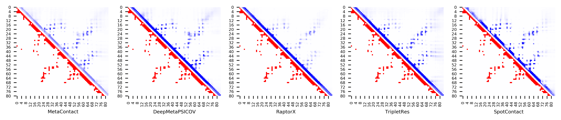

**Figure S72.** Five predicted contact maps (blue) with nature contacts (red) of target protein (2AQ0_A)

**Table S79**. Precision of five contact maps (Protein ID: 2BYK_D)

|  |  |  |  |  |  |  |  |  |  |  |  |
| --- | --- | --- | --- | --- | --- | --- | --- | --- | --- | --- | --- |
| ID: 2BYK_D | | MetaContact | | DeepMetaPSICOV | | RaptorX | | SpotContact | | TripletRes | |
| Range | List size | Precision | Count | Precision | Count | Precision | Count | Precision | Count | Precision | Count |
| medium and long | Top-L/5 | 1.000 | 18 | 1.000 | 18 | 1.000 | 18 | 1.000 | 18 | 1.000 | 18 |
| Top-L/2 | 0.804 | 46 | 0.739 | 46 | 0.826 | 46 | 0.739 | 46 | 0.739 | 46 |
| Top-L | 0.424 | 92 | 0.413 | 92 | 0.446 | 92 | 0.424 | 92 | 0.413 | 92 |
| Top-NC | 0.841 | 44 | 0.750 | 44 | 0.841 | 44 | 0.773 | 44 | 0.750 | 44 |
| long | Top-L/5 | 0.667 | 18 | 0.556 | 18 | 0.722 | 18 | 0.500 | 18 | 0.611 | 18 |
| Top-L/2 | 0.304 | 46 | 0.283 | 46 | 0.348 | 46 | 0.304 | 46 | 0.261 | 46 |
| Top-L | 0.174 | 92 | 0.163 | 92 | 0.207 | 92 | 0.185 | 92 | 0.141 | 92 |
| Top-NC | 0.632 | 19 | 0.526 | 19 | 0.684 | 19 | 0.474 | 19 | 0.632 | 19 |

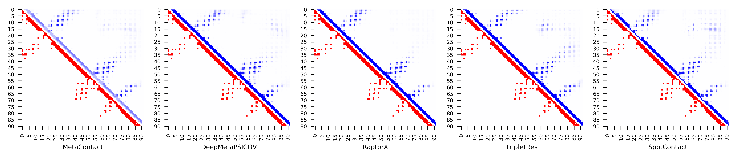

**Figure S73.** Five predicted contact maps (blue) with nature contacts (red) of target protein (2BYK_D)

**Table S80**. Precision of five contact maps (Protein ID: 2CMX_A)

|  |  |  |  |  |  |  |  |  |  |  |  |
| --- | --- | --- | --- | --- | --- | --- | --- | --- | --- | --- | --- |
| ID: 2CMX_A | | MetaContact | | DeepMetaPSICOV | | RaptorX | | SpotContact | | TripletRes | |
| Range | List size | Precision | Count | Precision | Count | Precision | Count | Precision | Count | Precision | Count |
| medium and long | Top-L/5 | 0.929 | 14 | 1.000 | 14 | 0.857 | 14 | 1.000 | 14 | 0.714 | 14 |
| Top-L/2 | 0.857 | 35 | 0.886 | 35 | 0.829 | 35 | 0.914 | 35 | 0.600 | 35 |
| Top-L | 0.757 | 70 | 0.757 | 70 | 0.743 | 70 | 0.714 | 70 | 0.429 | 70 |
| Top-NC | 0.737 | 76 | 0.724 | 76 | 0.724 | 76 | 0.724 | 76 | 0.395 | 76 |
| long | Top-L/5 | 1.000 | 14 | 0.929 | 14 | 0.929 | 14 | 0.929 | 14 | 0.714 | 14 |
| Top-L/2 | 0.800 | 35 | 0.771 | 35 | 0.829 | 35 | 0.829 | 35 | 0.571 | 35 |
| Top-L | 0.557 | 70 | 0.543 | 70 | 0.557 | 70 | 0.557 | 70 | 0.400 | 70 |
| Top-NC | 0.733 | 45 | 0.689 | 45 | 0.733 | 45 | 0.733 | 45 | 0.533 | 45 |

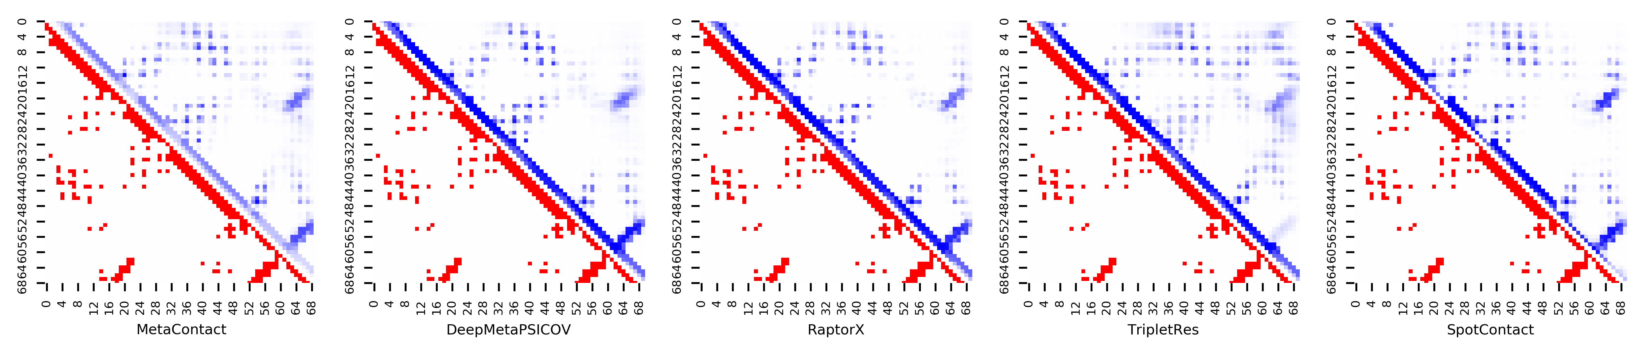

**Figure S74.** Five predicted contact maps (blue) with nature contacts (red) of target protein (2CMX_A)

**Table S81**. Precision of five contact maps (Protein ID: 2CWP_A)

|  |  |  |  |  |  |  |  |  |  |  |  |
| --- | --- | --- | --- | --- | --- | --- | --- | --- | --- | --- | --- |
| ID: 2CWP_A | | MetaContact | | DeepMetaPSICOV | | RaptorX | | SpotContact | | TripletRes | |
| Range | List size | Precision | Count | Precision | Count | Precision | Count | Precision | Count | Precision | Count |
| medium and long | Top-L/5 | 1.000 | 22 | 1.000 | 22 | 1.000 | 22 | 1.000 | 22 | 1.000 | 22 |
| Top-L/2 | 1.000 | 54 | 1.000 | 54 | 0.889 | 54 | 1.000 | 54 | 1.000 | 54 |
| Top-L | 0.972 | 109 | 0.927 | 109 | 0.798 | 109 | 0.963 | 109 | 0.936 | 109 |
| Top-NC | 0.791 | 196 | 0.760 | 196 | 0.699 | 196 | 0.816 | 196 | 0.760 | 196 |
| long | Top-L/5 | 1.000 | 22 | 1.000 | 22 | 1.000 | 22 | 1.000 | 22 | 1.000 | 22 |
| Top-L/2 | 1.000 | 54 | 0.963 | 54 | 0.907 | 54 | 1.000 | 54 | 0.963 | 54 |
| Top-L | 0.862 | 109 | 0.826 | 109 | 0.734 | 109 | 0.881 | 109 | 0.817 | 109 |
| Top-NC | 0.795 | 132 | 0.750 | 132 | 0.682 | 132 | 0.803 | 132 | 0.742 | 132 |

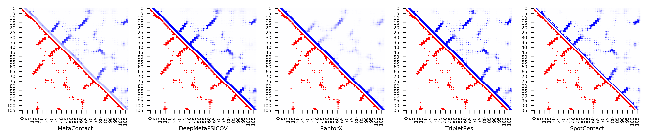

**Figure S75.** Five predicted contact maps (blue) with nature contacts (red) of target protein (2CWP_A)

**Table S82**. Precision of five contact maps (Protein ID: 2EWC_B)

|  |  |  |  |  |  |  |  |  |  |  |  |
| --- | --- | --- | --- | --- | --- | --- | --- | --- | --- | --- | --- |
| ID: 2EWC_B | | MetaContact | | DeepMetaPSICOV | | RaptorX | | SpotContact | | TripletRes | |
| Range | List size | Precision | Count | Precision | Count | Precision | Count | Precision | Count | Precision | Count |
| medium and long | Top-L/5 | 1.000 | 24 | 1.000 | 24 | 0.833 | 24 | 1.000 | 24 | 1.000 | 24 |
| Top-L/2 | 1.000 | 61 | 1.000 | 61 | 0.721 | 61 | 1.000 | 61 | 0.984 | 61 |
| Top-L | 0.943 | 122 | 0.918 | 122 | 0.574 | 122 | 0.975 | 122 | 0.910 | 122 |
| Top-NC | 0.785 | 200 | 0.760 | 200 | 0.480 | 200 | 0.800 | 200 | 0.730 | 200 |
| long | Top-L/5 | 1.000 | 24 | 1.000 | 24 | 0.833 | 24 | 1.000 | 24 | 1.000 | 24 |
| Top-L/2 | 1.000 | 61 | 1.000 | 61 | 0.689 | 61 | 1.000 | 61 | 0.984 | 61 |
| Top-L | 0.934 | 122 | 0.902 | 122 | 0.541 | 122 | 0.926 | 122 | 0.885 | 122 |
| Top-NC | 0.798 | 163 | 0.785 | 163 | 0.479 | 163 | 0.810 | 163 | 0.785 | 163 |

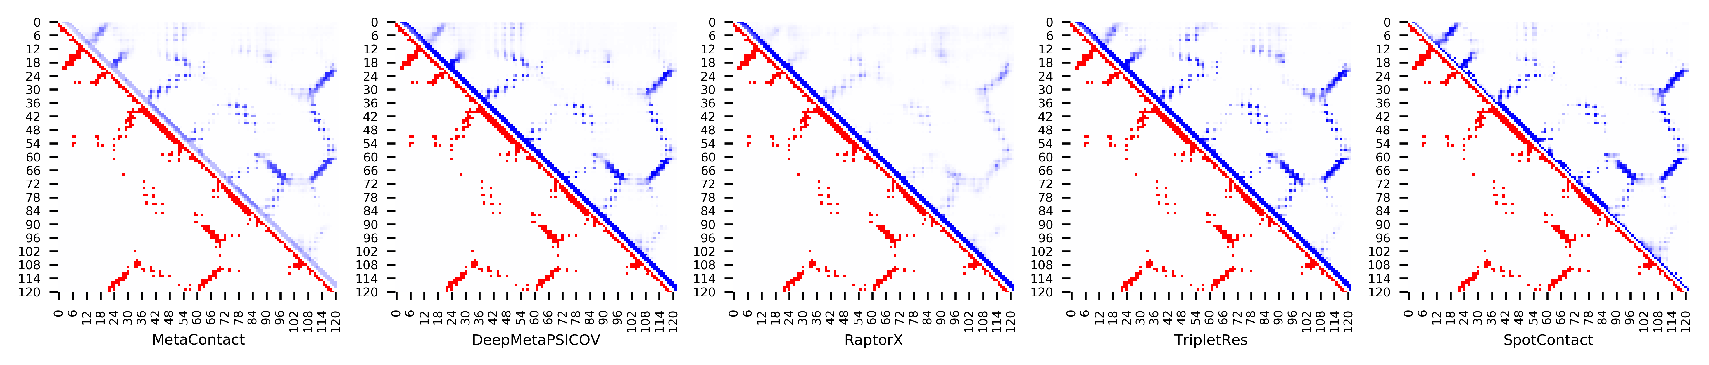

**Figure S76.** Five predicted contact maps (blue) with nature contacts (red) of target protein (2EWC_B)

**Table S83**. Precision of five contact maps (Protein ID: 2F22_B)

|  |  |  |  |  |  |  |  |  |  |  |  |
| --- | --- | --- | --- | --- | --- | --- | --- | --- | --- | --- | --- |
| ID: 2F22_B | | MetaContact | | DeepMetaPSICOV | | RaptorX | | SpotContact | | TripletRes | |
| Range | List size | Precision | Count | Precision | Count | Precision | Count | Precision | Count | Precision | Count |
| medium and long | Top-L/5 | 0.862 | 29 | 0.828 | 29 | 0.621 | 29 | 0.897 | 29 | 0.828 | 29 |
| Top-L/2 | 0.778 | 72 | 0.611 | 72 | 0.583 | 72 | 0.778 | 72 | 0.778 | 72 |
| Top-L | 0.664 | 143 | 0.531 | 143 | 0.462 | 143 | 0.664 | 143 | 0.594 | 143 |
| Top-NC | 0.601 | 168 | 0.476 | 168 | 0.423 | 168 | 0.643 | 168 | 0.565 | 168 |
| long | Top-L/5 | 0.828 | 29 | 0.793 | 29 | 0.621 | 29 | 0.828 | 29 | 0.793 | 29 |
| Top-L/2 | 0.736 | 72 | 0.583 | 72 | 0.583 | 72 | 0.750 | 72 | 0.736 | 72 |
| Top-L | 0.608 | 143 | 0.497 | 143 | 0.441 | 143 | 0.622 | 143 | 0.566 | 143 |
| Top-NC | 0.617 | 141 | 0.504 | 141 | 0.440 | 141 | 0.617 | 141 | 0.560 | 141 |

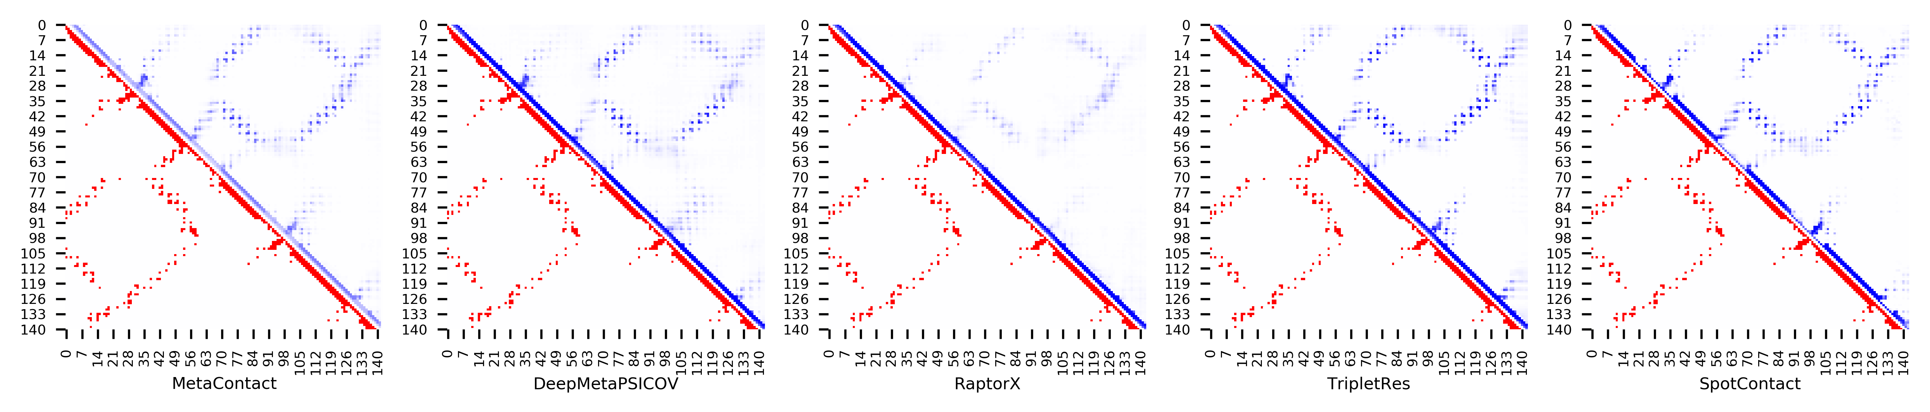

**Figure S77.** Five predicted contact maps (blue) with nature contacts (red) of target protein (2F22_B)

**Table S84**. Precision of five contact maps (Protein ID: 2FA5_B)

|  |  |  |  |  |  |  |  |  |  |  |  |
| --- | --- | --- | --- | --- | --- | --- | --- | --- | --- | --- | --- |
| ID: 2FA5_B | | MetaContact | | DeepMetaPSICOV | | RaptorX | | SpotContact | | TripletRes | |
| Range | List size | Precision | Count | Precision | Count | Precision | Count | Precision | Count | Precision | Count |
| medium and long | Top-L/5 | 0.964 | 28 | 0.893 | 28 | 0.750 | 28 | 1.000 | 28 | 0.893 | 28 |
| Top-L/2 | 0.859 | 71 | 0.803 | 71 | 0.577 | 71 | 0.887 | 71 | 0.775 | 71 |
| Top-L | 0.570 | 142 | 0.549 | 142 | 0.373 | 142 | 0.606 | 142 | 0.493 | 142 |
| Top-NC | 0.730 | 89 | 0.697 | 89 | 0.528 | 89 | 0.843 | 89 | 0.674 | 89 |
| long | Top-L/5 | 0.964 | 28 | 0.821 | 28 | 0.571 | 28 | 1.000 | 28 | 0.786 | 28 |
| Top-L/2 | 0.676 | 71 | 0.648 | 71 | 0.563 | 71 | 0.775 | 71 | 0.634 | 71 |
| Top-L | 0.437 | 142 | 0.430 | 142 | 0.331 | 142 | 0.444 | 142 | 0.387 | 142 |
| Top-NC | 0.723 | 65 | 0.677 | 65 | 0.569 | 65 | 0.831 | 65 | 0.677 | 65 |

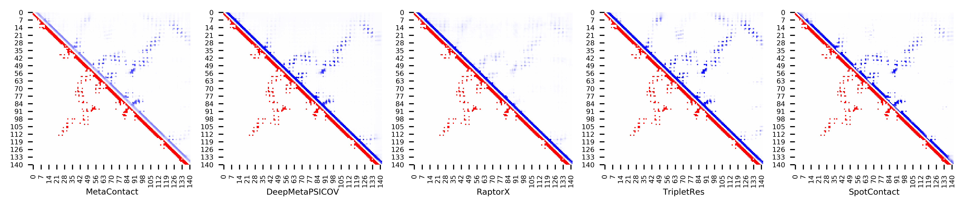

**Figure S78.** Five predicted contact maps (blue) with nature contacts (red) of target protein (2FA5_B)

**Table S85**. Precision of five contact maps (Protein ID: 2FKB_C)

|  |  |  |  |  |  |  |  |  |  |  |  |
| --- | --- | --- | --- | --- | --- | --- | --- | --- | --- | --- | --- |
| ID: 2FKB_C | | MetaContact | | DeepMetaPSICOV | | RaptorX | | SpotContact | | TripletRes | |
| Range | List size | Precision | Count | Precision | Count | Precision | Count | Precision | Count | Precision | Count |
| medium and long | Top-L/5 | 1.000 | 33 | 1.000 | 33 | 0.879 | 33 | 1.000 | 33 | 0.970 | 33 |
| Top-L/2 | 0.988 | 84 | 0.976 | 84 | 0.857 | 84 | 1.000 | 84 | 0.940 | 84 |
| Top-L | 0.922 | 167 | 0.880 | 167 | 0.778 | 167 | 0.964 | 167 | 0.898 | 167 |
| Top-NC | 0.751 | 309 | 0.689 | 309 | 0.608 | 309 | 0.783 | 309 | 0.702 | 309 |
| long | Top-L/5 | 1.000 | 33 | 0.970 | 33 | 0.909 | 33 | 1.000 | 33 | 0.939 | 33 |
| Top-L/2 | 0.964 | 84 | 0.940 | 84 | 0.774 | 84 | 0.988 | 84 | 0.917 | 84 |
| Top-L | 0.826 | 167 | 0.784 | 167 | 0.665 | 167 | 0.850 | 167 | 0.796 | 167 |
| Top-NC | 0.733 | 236 | 0.682 | 236 | 0.576 | 236 | 0.758 | 236 | 0.669 | 236 |

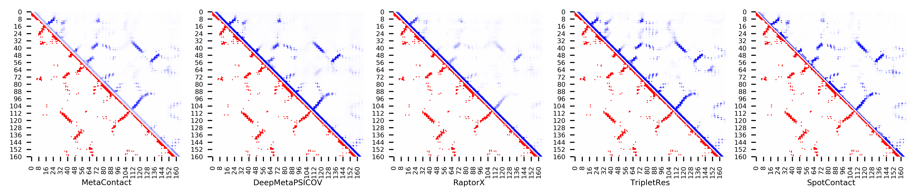

**Figure S79.** Five predicted contact maps (blue) with nature contacts (red) of target protein (2FKB_C)

**Table S86**. Precision of five contact maps (Protein ID: 2GBJ_B)

|  |  |  |  |  |  |  |  |  |  |  |  |
| --- | --- | --- | --- | --- | --- | --- | --- | --- | --- | --- | --- |
| ID: 2GBJ_B | | MetaContact | | DeepMetaPSICOV | | RaptorX | | SpotContact | | TripletRes | |
| Range | List size | Precision | Count | Precision | Count | Precision | Count | Precision | Count | Precision | Count |
| medium and long | Top-L/5 | 1.000 | 17 | 1.000 | 17 | 1.000 | 17 | 1.000 | 17 | 1.000 | 17 |
| Top-L/2 | 1.000 | 42 | 1.000 | 42 | 1.000 | 42 | 1.000 | 42 | 1.000 | 42 |
| Top-L | 1.000 | 84 | 0.964 | 84 | 0.857 | 84 | 1.000 | 84 | 0.988 | 84 |
| Top-NC | 0.886 | 132 | 0.826 | 132 | 0.689 | 132 | 0.864 | 132 | 0.894 | 132 |
| long | Top-L/5 | 1.000 | 17 | 1.000 | 17 | 1.000 | 17 | 1.000 | 17 | 1.000 | 17 |
| Top-L/2 | 1.000 | 42 | 1.000 | 42 | 0.952 | 42 | 1.000 | 42 | 1.000 | 42 |
| Top-L | 0.940 | 84 | 0.833 | 84 | 0.738 | 84 | 0.905 | 84 | 0.940 | 84 |
| Top-NC | 0.911 | 90 | 0.822 | 90 | 0.711 | 90 | 0.878 | 90 | 0.900 | 90 |

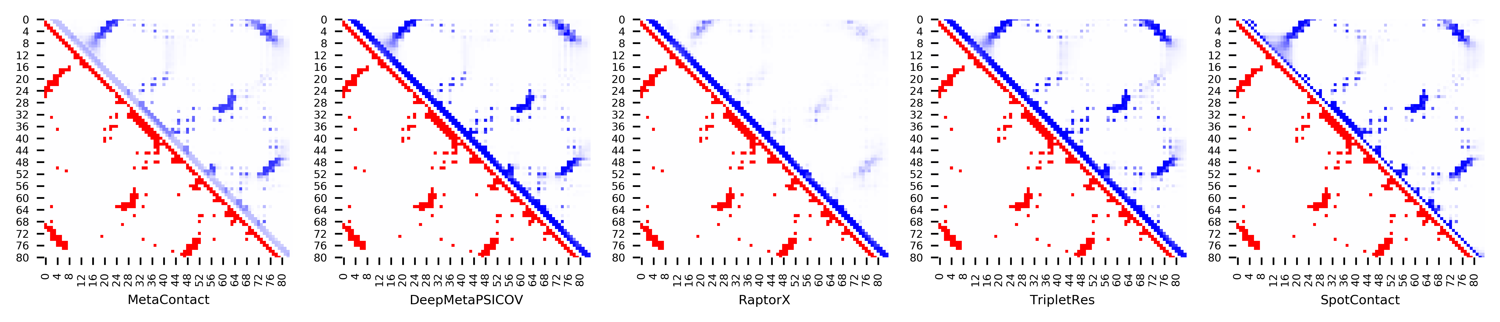

**Figure S80.** Five predicted contact maps (blue) with nature contacts (red) of target protein (2GBJ_B)

**Table S87**. Precision of five contact maps (Protein ID: 2GJ3_A)

|  |  |  |  |  |  |  |  |  |  |  |  |
| --- | --- | --- | --- | --- | --- | --- | --- | --- | --- | --- | --- |
| ID: 2GJ3_A | | MetaContact | | DeepMetaPSICOV | | RaptorX | | SpotContact | | TripletRes | |
| Range | List size | Precision | Count | Precision | Count | Precision | Count | Precision | Count | Precision | Count |
| medium and long | Top-L/5 | 1.000 | 24 | 1.000 | 24 | 0.958 | 24 | 1.000 | 24 | 1.000 | 24 |
| Top-L/2 | 1.000 | 60 | 0.967 | 60 | 0.783 | 60 | 1.000 | 60 | 1.000 | 60 |
| Top-L | 0.924 | 119 | 0.882 | 119 | 0.672 | 119 | 0.916 | 119 | 0.874 | 119 |
| Top-NC | 0.812 | 170 | 0.782 | 170 | 0.571 | 170 | 0.829 | 170 | 0.771 | 170 |
| long | Top-L/5 | 0.875 | 24 | 0.875 | 24 | 0.708 | 24 | 0.958 | 24 | 1.000 | 24 |
| Top-L/2 | 0.850 | 60 | 0.817 | 60 | 0.600 | 60 | 0.850 | 60 | 0.700 | 60 |
| Top-L | 0.597 | 119 | 0.546 | 119 | 0.471 | 119 | 0.580 | 119 | 0.563 | 119 |
| Top-NC | 0.729 | 85 | 0.682 | 85 | 0.518 | 85 | 0.741 | 85 | 0.647 | 85 |

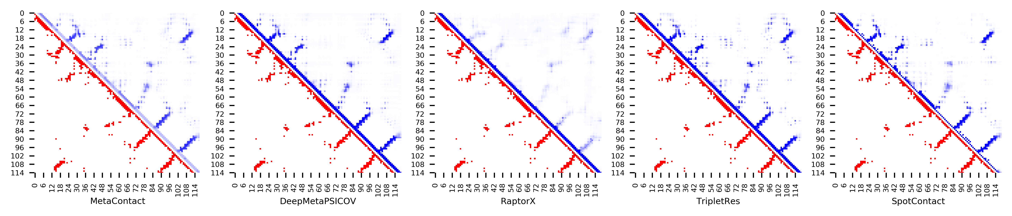

**Figure S81.** Five predicted contact maps (blue) with nature contacts (red) of target protein (2GJ3_A)

**Table S88**. Precision of five contact maps (Protein ID: 2GKC_A)

|  |  |  |  |  |  |  |  |  |  |  |  |
| --- | --- | --- | --- | --- | --- | --- | --- | --- | --- | --- | --- |
| ID: 2GKC_A | | MetaContact | | DeepMetaPSICOV | | RaptorX | | SpotContact | | TripletRes | |
| Range | List size | Precision | Count | Precision | Count | Precision | Count | Precision | Count | Precision | Count |
| medium and long | Top-L/5 | 0.871 | 31 | 0.903 | 31 | 0.710 | 31 | 0.903 | 31 | 0.839 | 31 |
| Top-L/2 | 0.846 | 78 | 0.846 | 78 | 0.641 | 78 | 0.859 | 78 | 0.821 | 78 |
| Top-L | 0.671 | 155 | 0.632 | 155 | 0.529 | 155 | 0.658 | 155 | 0.671 | 155 |
| Top-NC | 0.577 | 201 | 0.552 | 201 | 0.463 | 201 | 0.562 | 201 | 0.572 | 201 |
| long | Top-L/5 | 0.903 | 31 | 0.903 | 31 | 0.645 | 31 | 0.935 | 31 | 0.935 | 31 |
| Top-L/2 | 0.654 | 78 | 0.590 | 78 | 0.564 | 78 | 0.628 | 78 | 0.667 | 78 |
| Top-L | 0.458 | 155 | 0.419 | 155 | 0.355 | 155 | 0.490 | 155 | 0.413 | 155 |
| Top-NC | 0.521 | 117 | 0.479 | 117 | 0.410 | 117 | 0.547 | 117 | 0.513 | 117 |

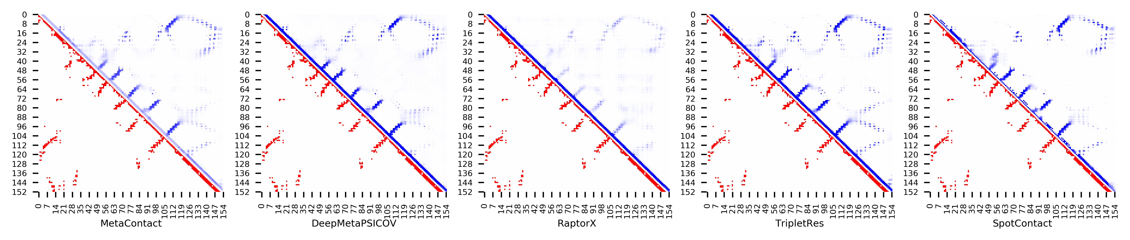

**Figure S82.** Five predicted contact maps (blue) with nature contacts (red) of target protein (2GKC_A)

**Table S89**. Precision of five contact maps (Protein ID: 2H30_A)

|  |  |  |  |  |  |  |  |  |  |  |  |
| --- | --- | --- | --- | --- | --- | --- | --- | --- | --- | --- | --- |
| ID: 2H30_A | | MetaContact | | DeepMetaPSICOV | | RaptorX | | SpotContact | | TripletRes | |
| Range | List size | Precision | Count | Precision | Count | Precision | Count | Precision | Count | Precision | Count |
| medium and long | Top-L/5 | 1.000 | 30 | 1.000 | 30 | 0.967 | 30 | 1.000 | 30 | 1.000 | 30 |
| Top-L/2 | 0.961 | 76 | 0.921 | 76 | 0.776 | 76 | 0.987 | 76 | 0.921 | 76 |
| Top-L | 0.821 | 151 | 0.781 | 151 | 0.656 | 151 | 0.881 | 151 | 0.795 | 151 |
| Top-NC | 0.668 | 265 | 0.592 | 265 | 0.555 | 265 | 0.683 | 265 | 0.642 | 265 |
| long | Top-L/5 | 1.000 | 30 | 1.000 | 30 | 0.967 | 30 | 1.000 | 30 | 1.000 | 30 |
| Top-L/2 | 0.974 | 76 | 0.934 | 76 | 0.789 | 76 | 0.987 | 76 | 0.934 | 76 |
| Top-L | 0.821 | 151 | 0.748 | 151 | 0.656 | 151 | 0.848 | 151 | 0.768 | 151 |
| Top-NC | 0.684 | 212 | 0.623 | 212 | 0.585 | 212 | 0.698 | 212 | 0.665 | 212 |

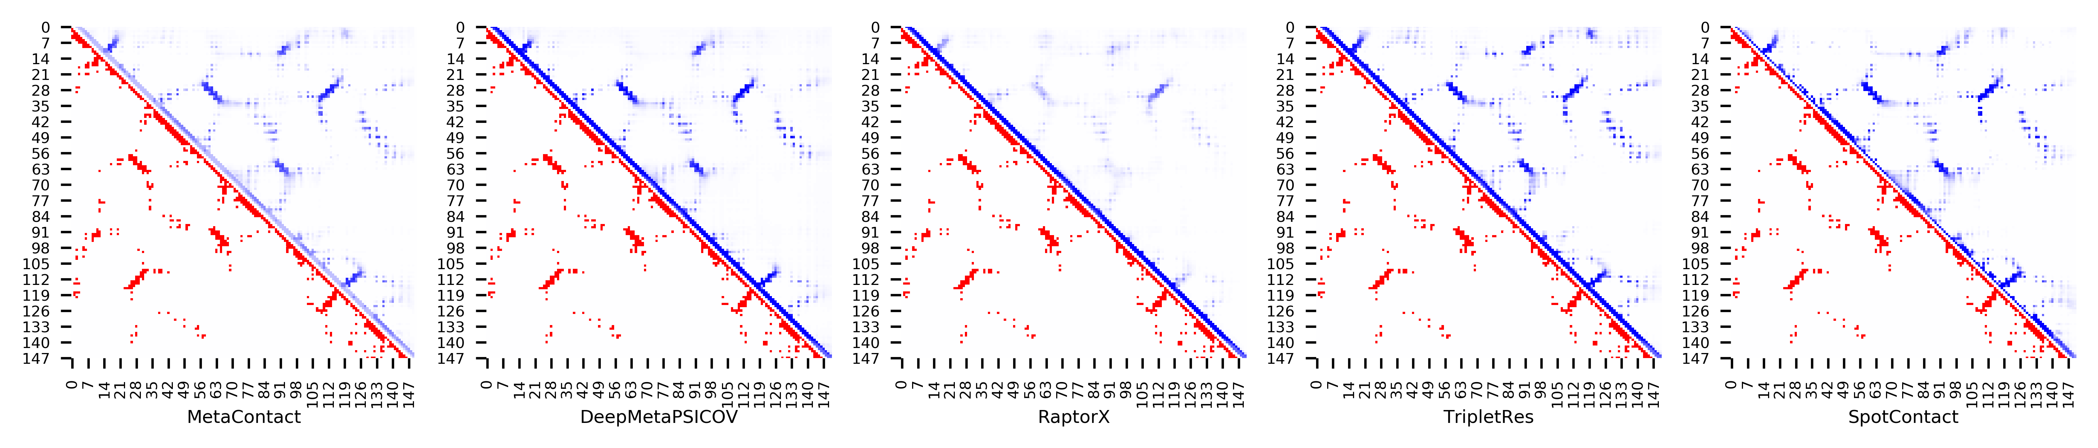

**Figure S83.** Five predicted contact maps (blue) with nature contacts (red) of target protein (2H30_A)

**Table S90**. Precision of five contact maps (Protein ID: 2HQ7_B)

|  |  |  |  |  |  |  |  |  |  |  |  |
| --- | --- | --- | --- | --- | --- | --- | --- | --- | --- | --- | --- |
| ID: 2HQ7_B | | MetaContact | | DeepMetaPSICOV | | RaptorX | | SpotContact | | TripletRes | |
| Range | List size | Precision | Count | Precision | Count | Precision | Count | Precision | Count | Precision | Count |
| medium and long | Top-L/5 | 1.000 | 28 | 1.000 | 28 | 0.893 | 28 | 1.000 | 28 | 1.000 | 28 |
| Top-L/2 | 0.986 | 71 | 0.972 | 71 | 0.803 | 71 | 1.000 | 71 | 0.972 | 71 |
| Top-L | 0.930 | 142 | 0.901 | 142 | 0.690 | 142 | 0.965 | 142 | 0.887 | 142 |
| Top-NC | 0.789 | 237 | 0.776 | 237 | 0.587 | 237 | 0.802 | 237 | 0.726 | 237 |
| long | Top-L/5 | 1.000 | 28 | 1.000 | 28 | 0.786 | 28 | 1.000 | 28 | 1.000 | 28 |
| Top-L/2 | 0.972 | 71 | 0.944 | 71 | 0.676 | 71 | 0.986 | 71 | 0.972 | 71 |
| Top-L | 0.845 | 142 | 0.803 | 142 | 0.620 | 142 | 0.824 | 142 | 0.782 | 142 |
| Top-NC | 0.739 | 176 | 0.722 | 176 | 0.580 | 176 | 0.756 | 176 | 0.699 | 176 |

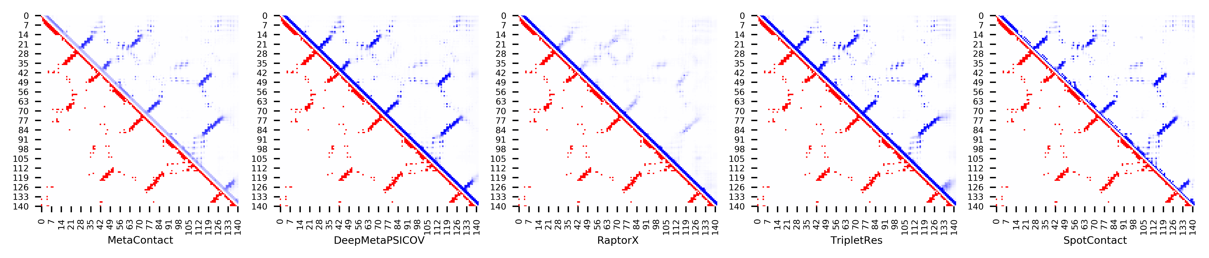

**Figure S84.** Five predicted contact maps (blue) with nature contacts (red) of target protein (2HQ7_B)

**Table S91**. Precision of five contact maps (Protein ID: 2ICT_A)

|  |  |  |  |  |  |  |  |  |  |  |  |
| --- | --- | --- | --- | --- | --- | --- | --- | --- | --- | --- | --- |
| ID: 2ICT_A | | MetaContact | | DeepMetaPSICOV | | RaptorX | | SpotContact | | TripletRes | |
| Range | List size | Precision | Count | Precision | Count | Precision | Count | Precision | Count | Precision | Count |
| medium and long | Top-L/5 | 0.895 | 19 | 0.842 | 19 | 0.632 | 19 | 0.947 | 19 | 0.842 | 19 |
| Top-L/2 | 0.702 | 47 | 0.723 | 47 | 0.447 | 47 | 0.723 | 47 | 0.553 | 47 |
| Top-L | 0.489 | 94 | 0.468 | 94 | 0.298 | 94 | 0.553 | 94 | 0.351 | 94 |
| Top-NC | 0.629 | 62 | 0.629 | 62 | 0.387 | 62 | 0.677 | 62 | 0.468 | 62 |
| long | Top-L/5 | 0.842 | 19 | 0.789 | 19 | 0.526 | 19 | 0.895 | 19 | 0.842 | 19 |
| Top-L/2 | 0.596 | 47 | 0.574 | 47 | 0.426 | 47 | 0.660 | 47 | 0.489 | 47 |
| Top-L | 0.351 | 94 | 0.330 | 94 | 0.266 | 94 | 0.404 | 94 | 0.298 | 94 |
| Top-NC | 0.651 | 43 | 0.605 | 43 | 0.419 | 43 | 0.674 | 43 | 0.512 | 43 |

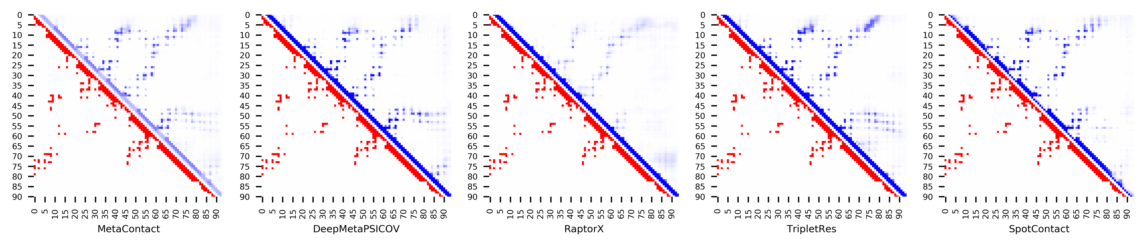

**Figure S85.** Five predicted contact maps (blue) with nature contacts (red) of target protein (2ICT_A)

**Table S92**. Precision of five contact maps (Protein ID: 2L74_A)

|  |  |  |  |  |  |  |  |  |  |  |  |
| --- | --- | --- | --- | --- | --- | --- | --- | --- | --- | --- | --- |
| ID: 2L74_A | | MetaContact | | DeepMetaPSICOV | | RaptorX | | SpotContact | | TripletRes | |
| Range | List size | Precision | Count | Precision | Count | Precision | Count | Precision | Count | Precision | Count |
| medium and long | Top-L/5 | 1.000 | 25 | 1.000 | 25 | 0.840 | 25 | 1.000 | 25 | 1.000 | 25 |
| Top-L/2 | 0.935 | 62 | 0.952 | 62 | 0.839 | 62 | 1.000 | 62 | 0.968 | 62 |
| Top-L | 0.840 | 125 | 0.832 | 125 | 0.720 | 125 | 0.824 | 125 | 0.816 | 125 |
| Top-NC | 0.795 | 161 | 0.752 | 161 | 0.677 | 161 | 0.789 | 161 | 0.739 | 161 |
| long | Top-L/5 | 1.000 | 25 | 1.000 | 25 | 0.720 | 25 | 1.000 | 25 | 1.000 | 25 |
| Top-L/2 | 0.855 | 62 | 0.871 | 62 | 0.726 | 62 | 0.855 | 62 | 0.823 | 62 |
| Top-L | 0.616 | 125 | 0.592 | 125 | 0.520 | 125 | 0.624 | 125 | 0.560 | 125 |
| Top-NC | 0.753 | 93 | 0.720 | 93 | 0.634 | 93 | 0.753 | 93 | 0.688 | 93 |

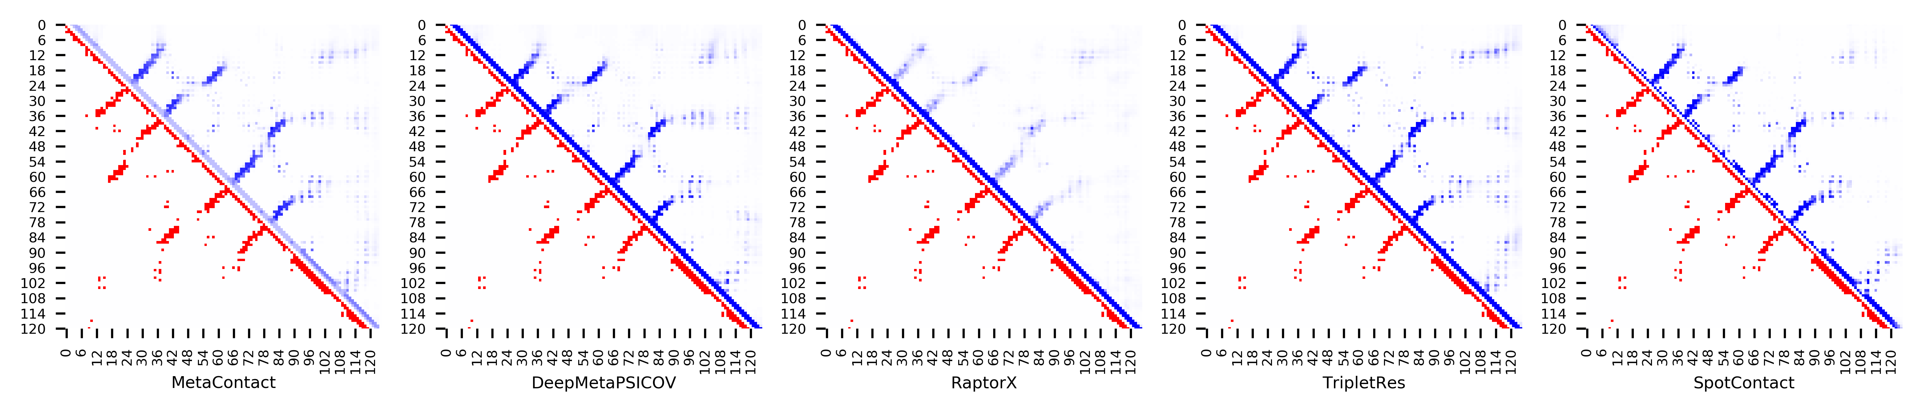

**Figure S86.** Five predicted contact maps (blue) with nature contacts (red) of target protein (2L74_A)

**Table S93**. Precision of five contact maps (Protein ID: 2NCM_A)

|  |  |  |  |  |  |  |  |  |  |  |  |
| --- | --- | --- | --- | --- | --- | --- | --- | --- | --- | --- | --- |
| ID: 2NCM_A | | MetaContact | | DeepMetaPSICOV | | RaptorX | | SpotContact | | TripletRes | |
| Range | List size | Precision | Count | Precision | Count | Precision | Count | Precision | Count | Precision | Count |
| medium and long | Top-L/5 | 1.000 | 20 | 1.000 | 20 | 0.950 | 20 | 1.000 | 20 | 1.000 | 20 |
| Top-L/2 | 0.980 | 50 | 0.940 | 50 | 0.900 | 50 | 1.000 | 50 | 1.000 | 50 |
| Top-L | 0.949 | 99 | 0.818 | 99 | 0.778 | 99 | 1.000 | 99 | 0.960 | 99 |
| Top-NC | 0.806 | 217 | 0.668 | 217 | 0.590 | 217 | 0.816 | 217 | 0.793 | 217 |
| long | Top-L/5 | 1.000 | 20 | 1.000 | 20 | 1.000 | 20 | 1.000 | 20 | 1.000 | 20 |
| Top-L/2 | 0.940 | 50 | 0.880 | 50 | 0.880 | 50 | 1.000 | 50 | 1.000 | 50 |
| Top-L | 0.919 | 99 | 0.737 | 99 | 0.727 | 99 | 0.909 | 99 | 0.909 | 99 |
| Top-NC | 0.783 | 157 | 0.643 | 157 | 0.580 | 157 | 0.809 | 157 | 0.758 | 157 |

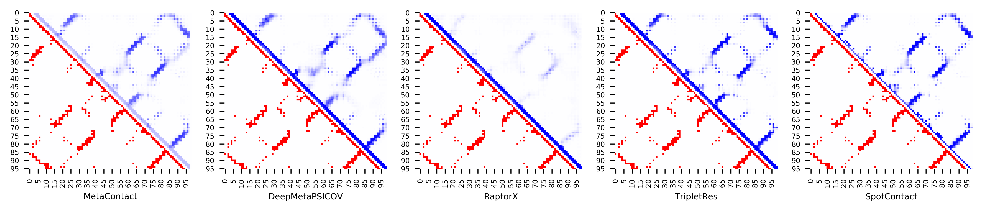

**Figure S87.** Five predicted contact maps (blue) with nature contacts (red) of target protein (2NCM_A)

**Table S94**. Precision of five contact maps (Protein ID: 2PYB_A)

|  |  |  |  |  |  |  |  |  |  |  |  |
| --- | --- | --- | --- | --- | --- | --- | --- | --- | --- | --- | --- |
| ID: 2PYB_A | | MetaContact | | DeepMetaPSICOV | | RaptorX | | SpotContact | | TripletRes | |
| Range | List size | Precision | Count | Precision | Count | Precision | Count | Precision | Count | Precision | Count |
| medium and long | Top-L/5 | 1.000 | 30 | 0.967 | 30 | 0.967 | 30 | 1.000 | 30 | 0.933 | 30 |
| Top-L/2 | 0.947 | 76 | 0.908 | 76 | 0.921 | 76 | 0.961 | 76 | 0.895 | 76 |
| Top-L | 0.755 | 151 | 0.715 | 151 | 0.781 | 151 | 0.755 | 151 | 0.715 | 151 |
| Top-NC | 0.711 | 166 | 0.681 | 166 | 0.729 | 166 | 0.705 | 166 | 0.681 | 166 |
| long | Top-L/5 | 0.967 | 30 | 0.967 | 30 | 0.933 | 30 | 1.000 | 30 | 0.867 | 30 |
| Top-L/2 | 0.895 | 76 | 0.842 | 76 | 0.908 | 76 | 0.908 | 76 | 0.855 | 76 |
| Top-L | 0.669 | 151 | 0.616 | 151 | 0.682 | 151 | 0.662 | 151 | 0.623 | 151 |
| Top-NC | 0.683 | 142 | 0.648 | 142 | 0.697 | 142 | 0.676 | 142 | 0.641 | 142 |

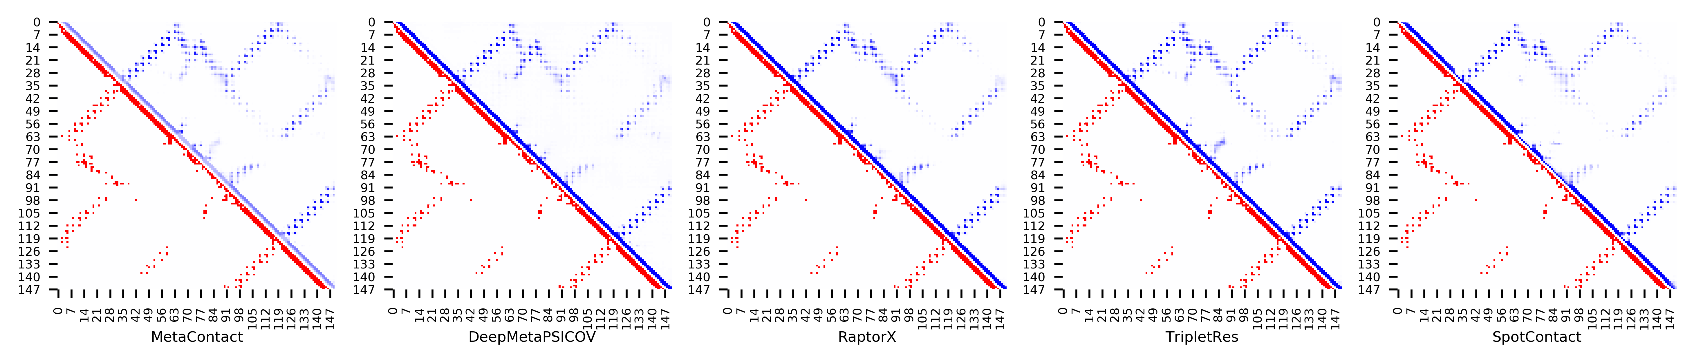

**Figure S88.** Five predicted contact maps (blue) with nature contacts (red) of target protein (2PYB_A)

**Table S95**. Precision of five contact maps (Protein ID: 2QVG_A)

|  |  |  |  |  |  |  |  |  |  |  |  |
| --- | --- | --- | --- | --- | --- | --- | --- | --- | --- | --- | --- |
| ID: 2QVG_A | | MetaContact | | DeepMetaPSICOV | | RaptorX | | SpotContact | | TripletRes | |
| Range | List size | Precision | Count | Precision | Count | Precision | Count | Precision | Count | Precision | Count |
| medium and long | Top-L/5 | 1.000 | 26 | 1.000 | 26 | 0.808 | 26 | 1.000 | 26 | 1.000 | 26 |
| Top-L/2 | 0.969 | 64 | 0.969 | 64 | 0.703 | 64 | 1.000 | 64 | 1.000 | 64 |
| Top-L | 0.899 | 129 | 0.876 | 129 | 0.620 | 129 | 0.868 | 129 | 0.868 | 129 |
| Top-NC | 0.737 | 198 | 0.727 | 198 | 0.556 | 198 | 0.707 | 198 | 0.742 | 198 |
| long | Top-L/5 | 1.000 | 26 | 1.000 | 26 | 0.769 | 26 | 1.000 | 26 | 1.000 | 26 |
| Top-L/2 | 0.922 | 64 | 0.938 | 64 | 0.688 | 64 | 0.938 | 64 | 0.953 | 64 |
| Top-L | 0.806 | 129 | 0.783 | 129 | 0.643 | 129 | 0.767 | 129 | 0.822 | 129 |
| Top-NC | 0.722 | 158 | 0.696 | 158 | 0.563 | 158 | 0.684 | 158 | 0.709 | 158 |

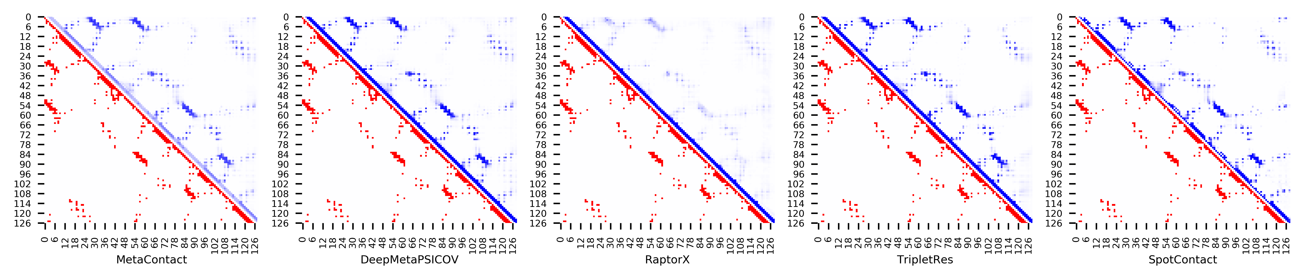

**Figure S89.** Five predicted contact maps (blue) with nature contacts (red) of target protein (2QVG_A)

**Table S96**. Precision of five contact maps (Protein ID: 2QZJ_A)

|  |  |  |  |  |  |  |  |  |  |  |  |
| --- | --- | --- | --- | --- | --- | --- | --- | --- | --- | --- | --- |
| ID: 2QZJ_A | | MetaContact | | DeepMetaPSICOV | | RaptorX | | SpotContact | | TripletRes | |
| Range | List size | Precision | Count | Precision | Count | Precision | Count | Precision | Count | Precision | Count |
| medium and long | Top-L/5 | 1.000 | 24 | 1.000 | 24 | 0.917 | 24 | 1.000 | 24 | 1.000 | 24 |
| Top-L/2 | 1.000 | 60 | 1.000 | 60 | 0.717 | 60 | 1.000 | 60 | 1.000 | 60 |
| Top-L | 0.975 | 121 | 0.942 | 121 | 0.620 | 121 | 0.967 | 121 | 0.959 | 121 |
| Top-NC | 0.858 | 204 | 0.828 | 204 | 0.544 | 204 | 0.877 | 204 | 0.838 | 204 |
| long | Top-L/5 | 1.000 | 24 | 1.000 | 24 | 0.833 | 24 | 1.000 | 24 | 1.000 | 24 |
| Top-L/2 | 1.000 | 60 | 0.983 | 60 | 0.717 | 60 | 1.000 | 60 | 1.000 | 60 |
| Top-L | 0.909 | 121 | 0.893 | 121 | 0.587 | 121 | 0.917 | 121 | 0.901 | 121 |
| Top-NC | 0.850 | 147 | 0.803 | 147 | 0.558 | 147 | 0.871 | 147 | 0.837 | 147 |

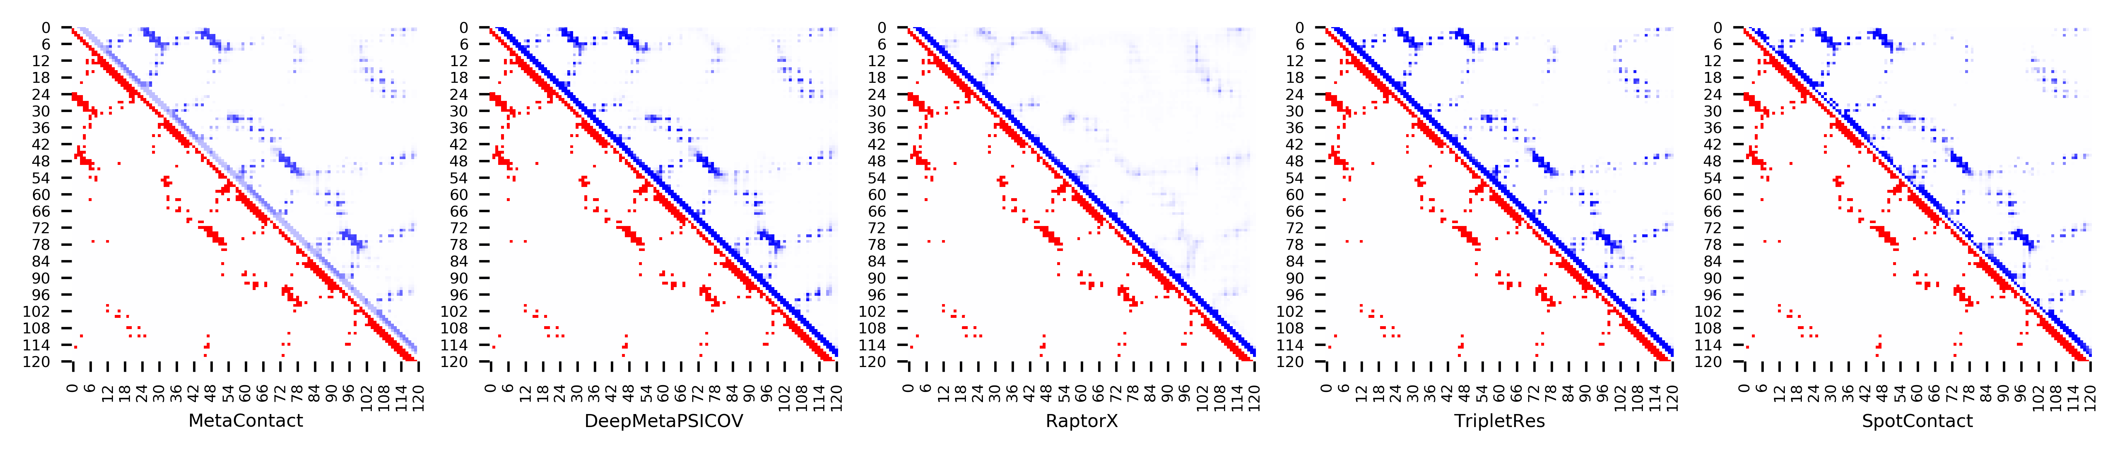

**Figure S90.** Five predicted contact maps (blue) with nature contacts (red) of target protein (2QZJ_A)

**Table S97**. Precision of five contact maps (Protein ID: 2RLD_C)

|  |  |  |  |  |  |  |  |  |  |  |  |
| --- | --- | --- | --- | --- | --- | --- | --- | --- | --- | --- | --- |
| ID: 2RLD_C | | MetaContact | | DeepMetaPSICOV | | RaptorX | | SpotContact | | TripletRes | |
| Range | List size | Precision | Count | Precision | Count | Precision | Count | Precision | Count | Precision | Count |
| medium and long | Top-L/5 | 1.000 | 23 | 0.957 | 23 | 0.696 | 23 | 1.000 | 23 | 1.000 | 23 |
| Top-L/2 | 1.000 | 58 | 0.845 | 58 | 0.776 | 58 | 1.000 | 58 | 0.983 | 58 |
| Top-L | 0.836 | 116 | 0.750 | 116 | 0.543 | 116 | 0.905 | 116 | 0.784 | 116 |
| Top-NC | 0.752 | 137 | 0.686 | 137 | 0.489 | 137 | 0.825 | 137 | 0.737 | 137 |
| long | Top-L/5 | 1.000 | 23 | 0.957 | 23 | 0.696 | 23 | 1.000 | 23 | 0.957 | 23 |
| Top-L/2 | 0.983 | 58 | 0.793 | 58 | 0.707 | 58 | 0.966 | 58 | 0.879 | 58 |
| Top-L | 0.707 | 116 | 0.629 | 116 | 0.491 | 116 | 0.759 | 116 | 0.672 | 116 |
| Top-NC | 0.708 | 106 | 0.670 | 106 | 0.519 | 106 | 0.811 | 106 | 0.679 | 106 |

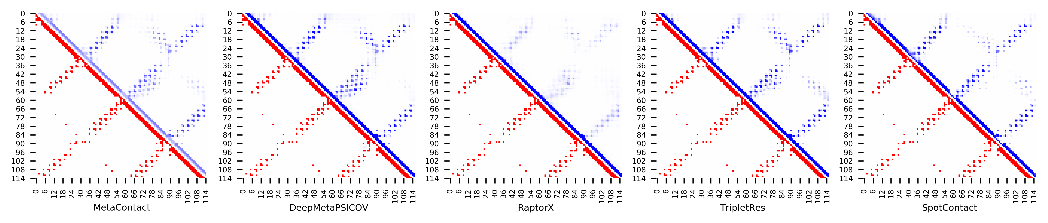

**Figure S91.** Five predicted contact maps (blue) with nature contacts (red) of target protein (2RLD_C)

**Table S98**. Precision of five contact maps (Protein ID: 2WGP_A)

|  |  |  |  |  |  |  |  |  |  |  |  |
| --- | --- | --- | --- | --- | --- | --- | --- | --- | --- | --- | --- |
| ID: 2WGP_A | | MetaContact | | DeepMetaPSICOV | | RaptorX | | SpotContact | | TripletRes | |
| Range | List size | Precision | Count | Precision | Count | Precision | Count | Precision | Count | Precision | Count |
| medium and long | Top-L/5 | 1.000 | 34 | 1.000 | 34 | 1.000 | 34 | 1.000 | 34 | 1.000 | 34 |
| Top-L/2 | 1.000 | 84 | 1.000 | 84 | 0.964 | 84 | 1.000 | 84 | 0.988 | 84 |
| Top-L | 0.893 | 168 | 0.833 | 168 | 0.881 | 168 | 0.911 | 168 | 0.839 | 168 |
| Top-NC | 0.749 | 299 | 0.689 | 299 | 0.692 | 299 | 0.759 | 299 | 0.676 | 299 |
| long | Top-L/5 | 1.000 | 34 | 1.000 | 34 | 1.000 | 34 | 1.000 | 34 | 1.000 | 34 |
| Top-L/2 | 0.952 | 84 | 0.940 | 84 | 0.952 | 84 | 1.000 | 84 | 0.952 | 84 |
| Top-L | 0.875 | 168 | 0.786 | 168 | 0.815 | 168 | 0.881 | 168 | 0.786 | 168 |
| Top-NC | 0.759 | 220 | 0.695 | 220 | 0.700 | 220 | 0.786 | 220 | 0.673 | 220 |

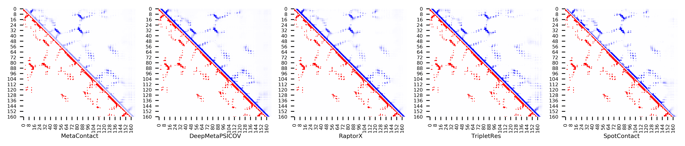

**Figure S92.** Five predicted contact maps (blue) with nature contacts (red) of target protein (2WGP_A)

**Table S99**. Precision of five contact maps (Protein ID: 3BDB_A)

|  |  |  |  |  |  |  |  |  |  |  |  |
| --- | --- | --- | --- | --- | --- | --- | --- | --- | --- | --- | --- |
| ID: 3BDB_A | | MetaContact | | DeepMetaPSICOV | | RaptorX | | SpotContact | | TripletRes | |
| Range | List size | Precision | Count | Precision | Count | Precision | Count | Precision | Count | Precision | Count |
| medium and long | Top-L/5 | 1.000 | 25 | 1.000 | 25 | 0.880 | 25 | 1.000 | 25 | 1.000 | 25 |
| Top-L/2 | 0.984 | 63 | 0.968 | 63 | 0.810 | 63 | 0.984 | 63 | 0.968 | 63 |
| Top-L | 0.881 | 126 | 0.849 | 126 | 0.762 | 126 | 0.881 | 126 | 0.865 | 126 |
| Top-NC | 0.756 | 205 | 0.722 | 205 | 0.663 | 205 | 0.746 | 205 | 0.717 | 205 |
| long | Top-L/5 | 1.000 | 25 | 1.000 | 25 | 0.880 | 25 | 1.000 | 25 | 1.000 | 25 |
| Top-L/2 | 0.905 | 63 | 0.921 | 63 | 0.810 | 63 | 0.952 | 63 | 0.889 | 63 |
| Top-L | 0.794 | 126 | 0.730 | 126 | 0.683 | 126 | 0.802 | 126 | 0.778 | 126 |
| Top-NC | 0.766 | 137 | 0.701 | 137 | 0.664 | 137 | 0.766 | 137 | 0.737 | 137 |

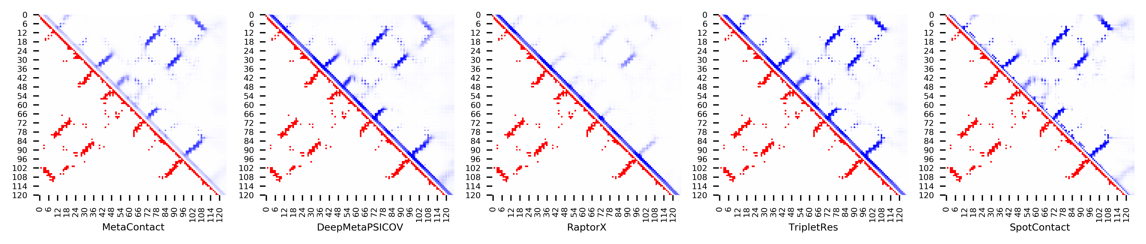

**Figure S93.** Five predicted contact maps (blue) with nature contacts (red) of target protein (3BDB_A)

**Table S100**. Precision of five contact maps (Protein ID: 3CG4_A)

|  |  |  |  |  |  |  |  |  |  |  |  |
| --- | --- | --- | --- | --- | --- | --- | --- | --- | --- | --- | --- |
| ID: 3CG4_A | | MetaContact | | DeepMetaPSICOV | | RaptorX | | SpotContact | | TripletRes | |
| Range | List size | Precision | Count | Precision | Count | Precision | Count | Precision | Count | Precision | Count |
| medium and long | Top-L/5 | 1.000 | 25 | 1.000 | 25 | 0.680 | 25 | 1.000 | 25 | 1.000 | 25 |
| Top-L/2 | 1.000 | 63 | 1.000 | 63 | 0.683 | 63 | 0.968 | 63 | 0.968 | 63 |
| Top-L | 0.889 | 126 | 0.857 | 126 | 0.635 | 126 | 0.937 | 126 | 0.873 | 126 |
| Top-NC | 0.757 | 230 | 0.709 | 230 | 0.513 | 230 | 0.791 | 230 | 0.730 | 230 |
| long | Top-L/5 | 1.000 | 25 | 1.000 | 25 | 0.760 | 25 | 1.000 | 25 | 1.000 | 25 |
| Top-L/2 | 0.968 | 63 | 0.937 | 63 | 0.698 | 63 | 0.952 | 63 | 0.937 | 63 |
| Top-L | 0.817 | 126 | 0.778 | 126 | 0.579 | 126 | 0.849 | 126 | 0.802 | 126 |
| Top-NC | 0.743 | 171 | 0.684 | 171 | 0.515 | 171 | 0.772 | 171 | 0.708 | 171 |

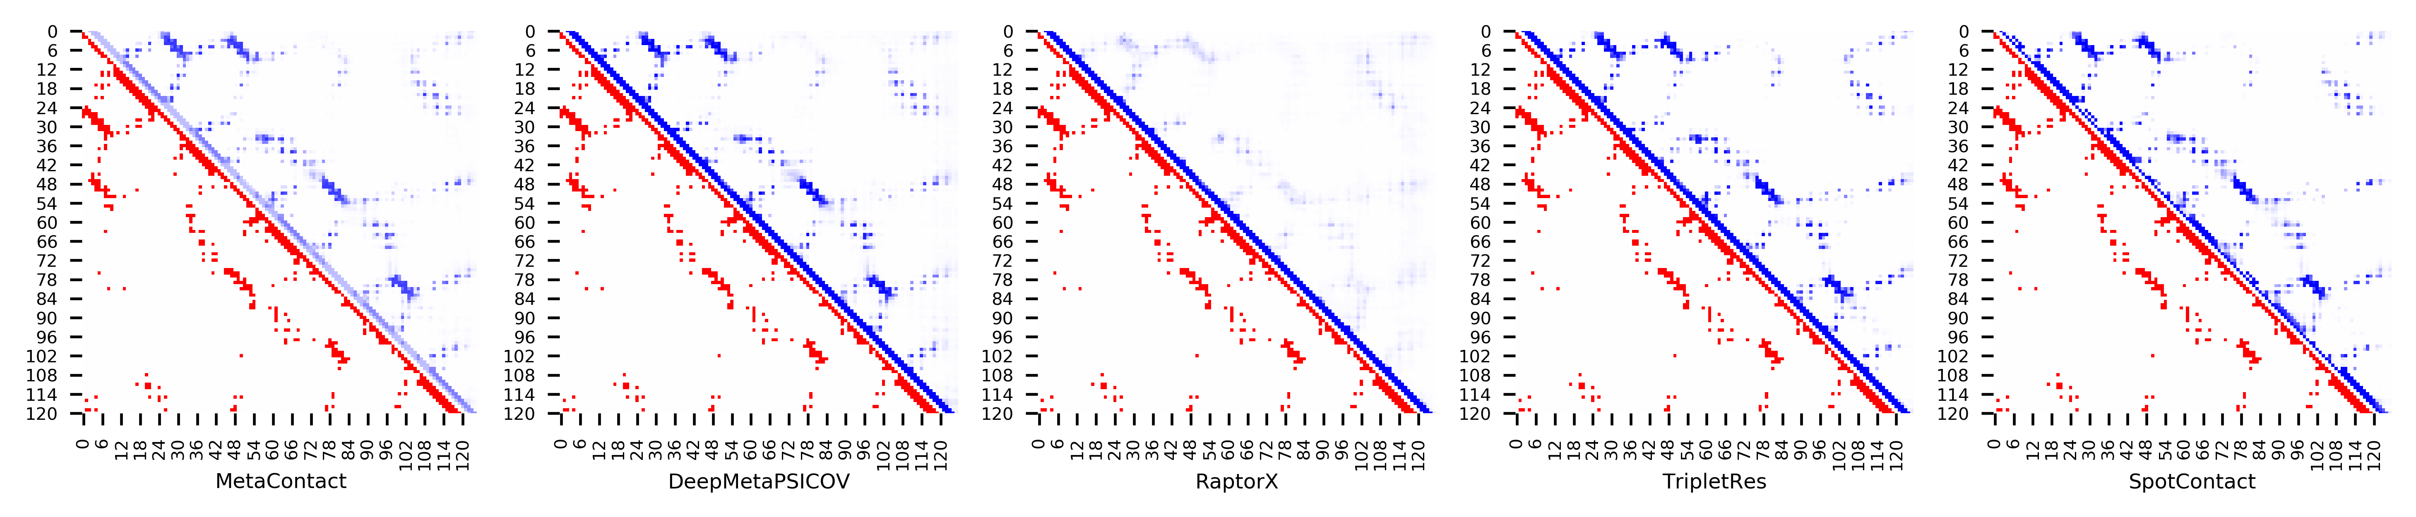

**Figure S94.** Five predicted contact maps (blue) with nature contacts (red) of target protein (3CG4_A)

**Table S101**. Precision of five contact maps (Protein ID: 3E9T_D)

|  |  |  |  |  |  |  |  |  |  |  |  |
| --- | --- | --- | --- | --- | --- | --- | --- | --- | --- | --- | --- |
| ID: 3E9T_D | | MetaContact | | DeepMetaPSICOV | | RaptorX | | SpotContact | | TripletRes | |
| Range | List size | Precision | Count | Precision | Count | Precision | Count | Precision | Count | Precision | Count |
| medium and long | Top-L/5 | 1.000 | 20 | 1.000 | 20 | 1.000 | 20 | 1.000 | 20 | 1.000 | 20 |
| Top-L/2 | 0.980 | 51 | 1.000 | 51 | 0.961 | 51 | 1.000 | 51 | 1.000 | 51 |
| Top-L | 0.980 | 102 | 0.990 | 102 | 0.961 | 102 | 0.980 | 102 | 0.980 | 102 |
| Top-NC | 0.843 | 254 | 0.835 | 254 | 0.764 | 254 | 0.854 | 254 | 0.835 | 254 |
| long | Top-L/5 | 0.950 | 20 | 1.000 | 20 | 0.950 | 20 | 1.000 | 20 | 1.000 | 20 |
| Top-L/2 | 0.980 | 51 | 0.980 | 51 | 0.961 | 51 | 0.980 | 51 | 0.980 | 51 |
| Top-L | 0.971 | 102 | 0.951 | 102 | 0.863 | 102 | 0.980 | 102 | 0.961 | 102 |
| Top-NC | 0.824 | 187 | 0.802 | 187 | 0.706 | 187 | 0.840 | 187 | 0.818 | 187 |

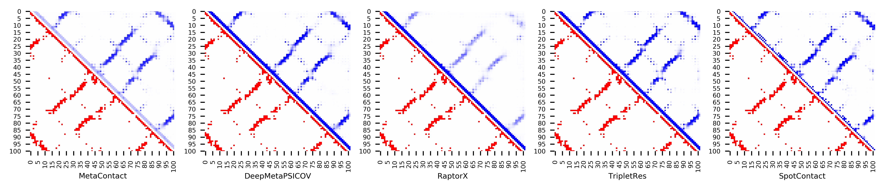

**Figure S95.** Five predicted contact maps (blue) with nature contacts (red) of target protein (3E9T_D)

**Table S102**. Precision of five contact maps (Protein ID: 3EOD_A)

|  |  |  |  |  |  |  |  |  |  |  |  |
| --- | --- | --- | --- | --- | --- | --- | --- | --- | --- | --- | --- |
| ID: 3EOD_A | | MetaContact | | DeepMetaPSICOV | | RaptorX | | SpotContact | | TripletRes | |
| Range | List size | Precision | Count | Precision | Count | Precision | Count | Precision | Count | Precision | Count |
| medium and long | Top-L/5 | 1.000 | 23 | 1.000 | 23 | 0.957 | 23 | 1.000 | 23 | 1.000 | 23 |
| Top-L/2 | 1.000 | 58 | 1.000 | 58 | 0.793 | 58 | 1.000 | 58 | 1.000 | 58 |
| Top-L | 0.965 | 115 | 0.904 | 115 | 0.652 | 115 | 0.965 | 115 | 0.948 | 115 |
| Top-NC | 0.813 | 198 | 0.732 | 198 | 0.525 | 198 | 0.833 | 198 | 0.813 | 198 |
| long | Top-L/5 | 1.000 | 23 | 1.000 | 23 | 0.826 | 23 | 1.000 | 23 | 1.000 | 23 |
| Top-L/2 | 0.983 | 58 | 0.914 | 58 | 0.707 | 58 | 0.983 | 58 | 0.948 | 58 |
| Top-L | 0.774 | 115 | 0.670 | 115 | 0.487 | 115 | 0.791 | 115 | 0.757 | 115 |
| Top-NC | 0.791 | 110 | 0.664 | 110 | 0.500 | 110 | 0.818 | 110 | 0.764 | 110 |

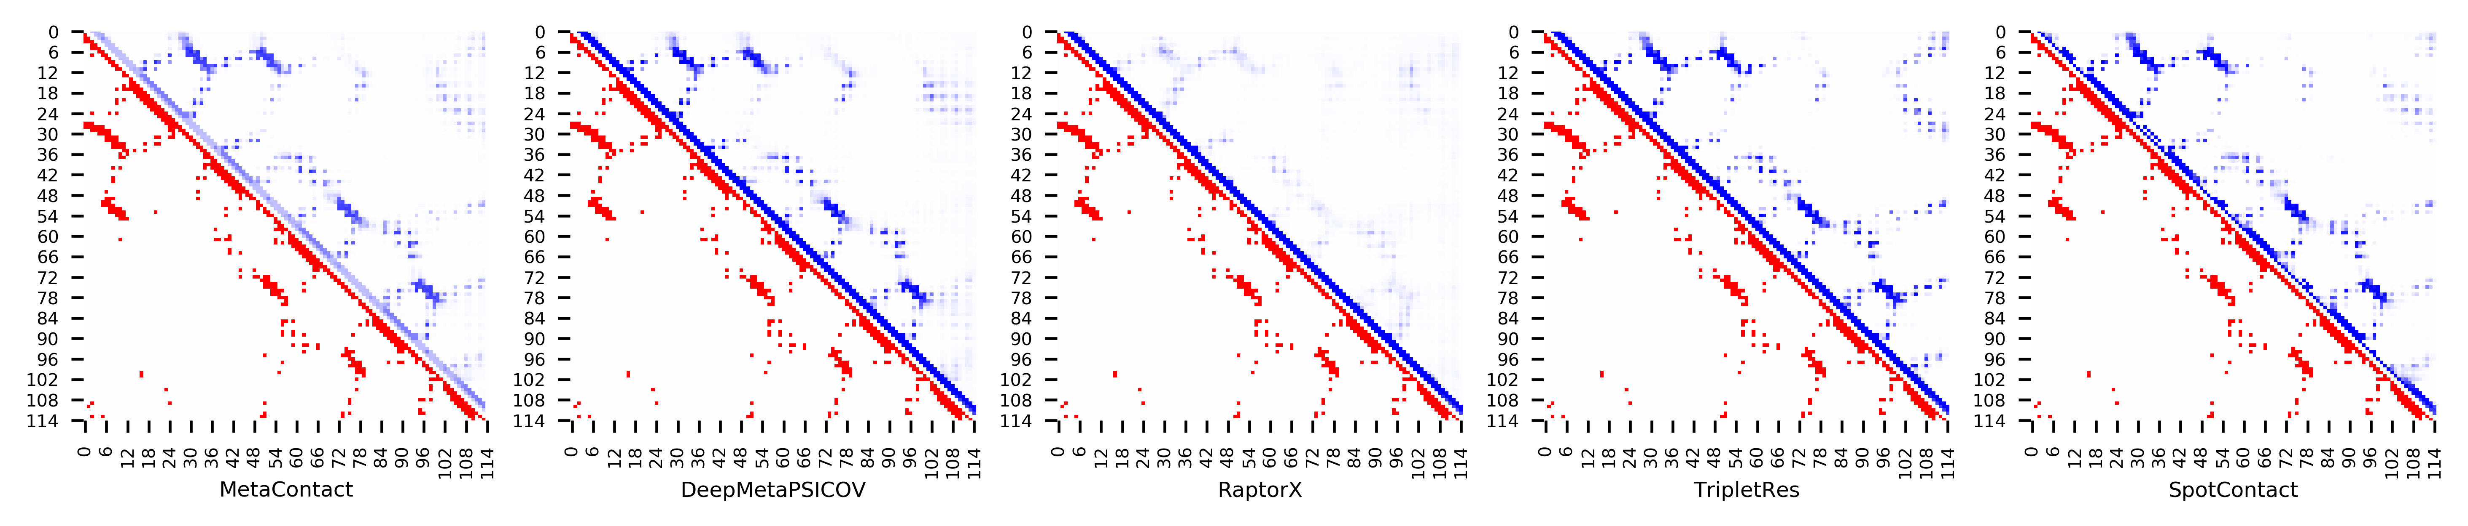

**Figure S96.** Five predicted contact maps (blue) with nature contacts (red) of target protein (3EOD_A)

**Table S103**. Precision of five contact maps (Protein ID: 3F8L_A)

|  |  |  |  |  |  |  |  |  |  |  |  |
| --- | --- | --- | --- | --- | --- | --- | --- | --- | --- | --- | --- |
| ID: 3F8L_A | | MetaContact | | DeepMetaPSICOV | | RaptorX | | SpotContact | | TripletRes | |
| Range | List size | Precision | Count | Precision | Count | Precision | Count | Precision | Count | Precision | Count |
| medium and long | Top-L/5 | 1.000 | 32 | 1.000 | 32 | 0.875 | 32 | 1.000 | 32 | 1.000 | 32 |
| Top-L/2 | 0.988 | 81 | 1.000 | 81 | 0.889 | 81 | 1.000 | 81 | 0.988 | 81 |
| Top-L | 0.969 | 162 | 0.889 | 162 | 0.846 | 162 | 0.981 | 162 | 0.901 | 162 |
| Top-NC | 0.756 | 312 | 0.731 | 312 | 0.654 | 312 | 0.788 | 312 | 0.731 | 312 |
| long | Top-L/5 | 0.969 | 32 | 1.000 | 32 | 0.781 | 32 | 1.000 | 32 | 1.000 | 32 |
| Top-L/2 | 0.963 | 81 | 0.827 | 81 | 0.827 | 81 | 0.975 | 81 | 0.877 | 81 |
| Top-L | 0.821 | 162 | 0.722 | 162 | 0.673 | 162 | 0.846 | 162 | 0.728 | 162 |
| Top-NC | 0.684 | 212 | 0.642 | 212 | 0.557 | 212 | 0.736 | 212 | 0.660 | 212 |

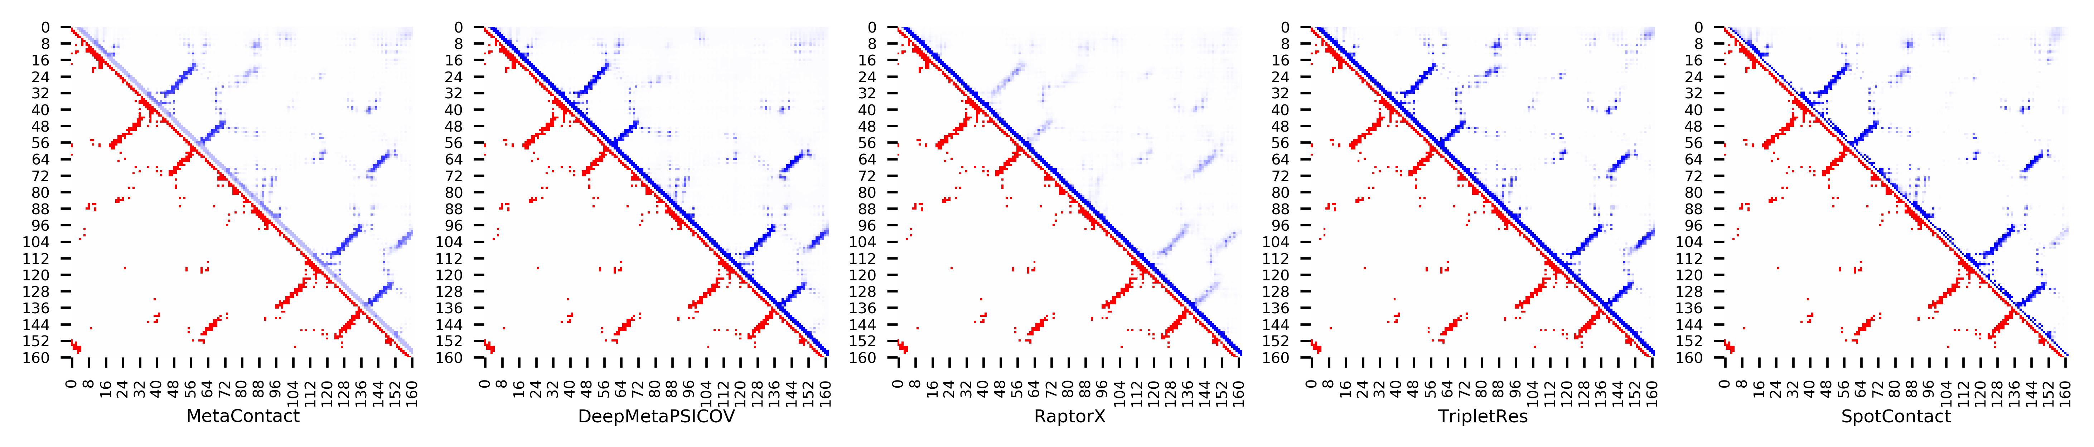

**Figure S97.** Five predicted contact maps (blue) with nature contacts (red) of target protein (3F8L_A)

**Table S104**. Precision of five contact maps (Protein ID: 3LQV_B)

|  |  |  |  |  |  |  |  |  |  |  |  |
| --- | --- | --- | --- | --- | --- | --- | --- | --- | --- | --- | --- |
| ID: 3LQV_B | | MetaContact | | DeepMetaPSICOV | | RaptorX | | SpotContact | | TripletRes | |
| Range | List size | Precision | Count | Precision | Count | Precision | Count | Precision | Count | Precision | Count |
| medium and long | Top-L/5 | 1.000 | 23 | 1.000 | 23 | 0.826 | 23 | 1.000 | 23 | 1.000 | 23 |
| Top-L/2 | 1.000 | 58 | 1.000 | 58 | 0.862 | 58 | 1.000 | 58 | 0.983 | 58 |
| Top-L | 0.939 | 115 | 0.904 | 115 | 0.783 | 115 | 0.965 | 115 | 0.843 | 115 |
| Top-NC | 0.784 | 162 | 0.753 | 162 | 0.660 | 162 | 0.796 | 162 | 0.716 | 162 |
| long | Top-L/5 | 1.000 | 23 | 1.000 | 23 | 0.826 | 23 | 1.000 | 23 | 1.000 | 23 |
| Top-L/2 | 0.983 | 58 | 0.983 | 58 | 0.845 | 58 | 0.966 | 58 | 0.948 | 58 |
| Top-L | 0.774 | 115 | 0.748 | 115 | 0.670 | 115 | 0.800 | 115 | 0.687 | 115 |
| Top-NC | 0.754 | 122 | 0.705 | 122 | 0.631 | 122 | 0.762 | 122 | 0.664 | 122 |

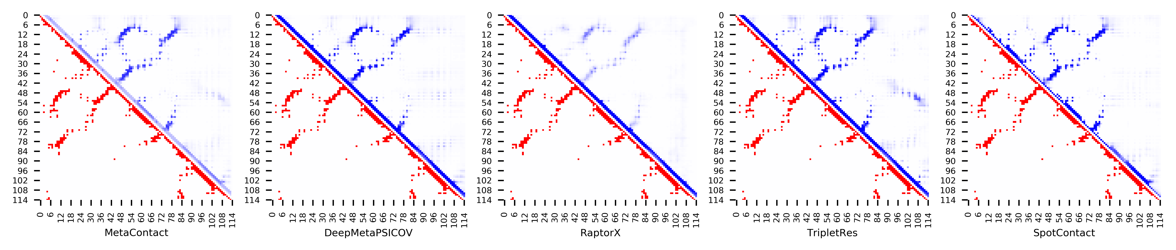

**Figure S98.** Five predicted contact maps (blue) with nature contacts (red) of target protein (3LQV_B)

**Table S105**. Precision of five contact maps (Protein ID: 3MQK_C)

|  |  |  |  |  |  |  |  |  |  |  |  |
| --- | --- | --- | --- | --- | --- | --- | --- | --- | --- | --- | --- |
| ID: 3MQK_C | | MetaContact | | DeepMetaPSICOV | | RaptorX | | SpotContact | | TripletRes | |
| Range | List size | Precision | Count | Precision | Count | Precision | Count | Precision | Count | Precision | Count |
| medium and long | Top-L/5 | 1.000 | 15 | 1.000 | 15 | 1.000 | 15 | 1.000 | 15 | 1.000 | 15 |
| Top-L/2 | 1.000 | 38 | 1.000 | 38 | 0.974 | 38 | 1.000 | 38 | 0.974 | 38 |
| Top-L | 0.960 | 75 | 0.987 | 75 | 0.960 | 75 | 0.960 | 75 | 0.933 | 75 |
| Top-NC | 0.833 | 144 | 0.792 | 144 | 0.833 | 144 | 0.861 | 144 | 0.778 | 144 |
| long | Top-L/5 | 1.000 | 15 | 1.000 | 15 | 1.000 | 15 | 1.000 | 15 | 1.000 | 15 |
| Top-L/2 | 1.000 | 38 | 1.000 | 38 | 0.974 | 38 | 0.974 | 38 | 0.974 | 38 |
| Top-L | 0.933 | 75 | 0.933 | 75 | 0.920 | 75 | 0.920 | 75 | 0.907 | 75 |
| Top-NC | 0.850 | 100 | 0.790 | 100 | 0.860 | 100 | 0.870 | 100 | 0.830 | 100 |

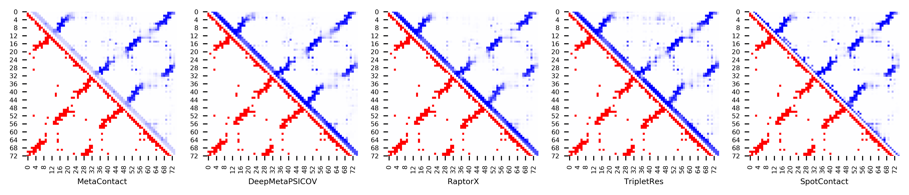

**Figure S99.** Five predicted contact maps (blue) with nature contacts (red) of target protein (3MQK_C)

**Table S106**. Precision of five contact maps (Protein ID: 3N1G_C)

|  |  |  |  |  |  |  |  |  |  |  |  |
| --- | --- | --- | --- | --- | --- | --- | --- | --- | --- | --- | --- |
| ID: 3N1G_C | | MetaContact | | DeepMetaPSICOV | | RaptorX | | SpotContact | | TripletRes | |
| Range | List size | Precision | Count | Precision | Count | Precision | Count | Precision | Count | Precision | Count |
| medium and long | Top-L/5 | 1.000 | 21 | 1.000 | 21 | 0.952 | 21 | 1.000 | 21 | 1.000 | 21 |
| Top-L/2 | 0.981 | 52 | 1.000 | 52 | 0.904 | 52 | 1.000 | 52 | 0.962 | 52 |
| Top-L | 0.971 | 104 | 0.952 | 104 | 0.808 | 104 | 0.981 | 104 | 0.962 | 104 |
| Top-NC | 0.797 | 241 | 0.718 | 241 | 0.581 | 241 | 0.817 | 241 | 0.763 | 241 |
| long | Top-L/5 | 1.000 | 21 | 1.000 | 21 | 1.000 | 21 | 1.000 | 21 | 1.000 | 21 |
| Top-L/2 | 1.000 | 52 | 0.981 | 52 | 0.827 | 52 | 1.000 | 52 | 0.981 | 52 |
| Top-L | 0.933 | 104 | 0.856 | 104 | 0.702 | 104 | 0.952 | 104 | 0.904 | 104 |
| Top-NC | 0.768 | 181 | 0.652 | 181 | 0.586 | 181 | 0.796 | 181 | 0.757 | 181 |

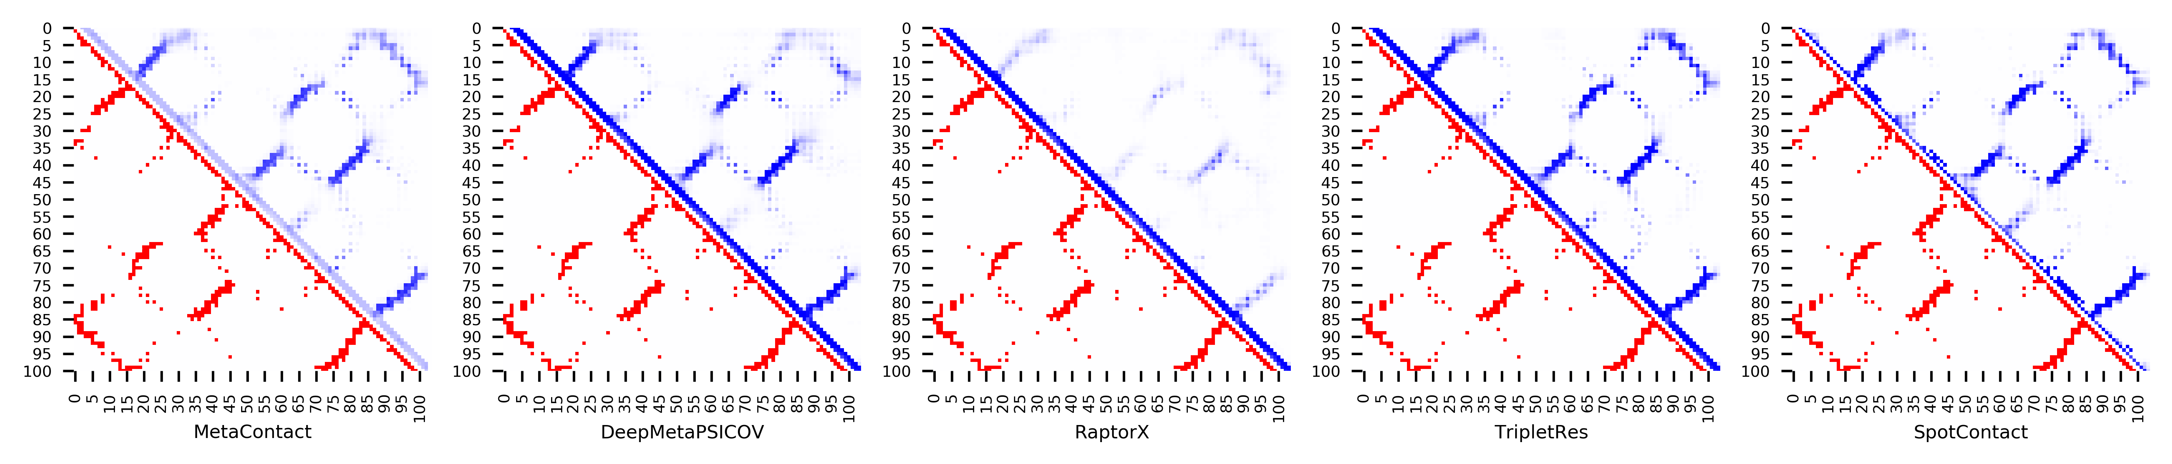

**Figure S100.** Five predicted contact maps (blue) with nature contacts (red) of target protein (3N1G_C)

**Table S107**. Precision of five contact maps (Protein ID: 3N9U_C)

|  |  |  |  |  |  |  |  |  |  |  |  |
| --- | --- | --- | --- | --- | --- | --- | --- | --- | --- | --- | --- |
| ID: 3N9U_C | | MetaContact | | DeepMetaPSICOV | | RaptorX | | SpotContact | | TripletRes | |
| Range | List size | Precision | Count | Precision | Count | Precision | Count | Precision | Count | Precision | Count |
| medium and long | Top-L/5 | 1.000 | 19 | 1.000 | 19 | 1.000 | 19 | 1.000 | 19 | 1.000 | 19 |
| Top-L/2 | 1.000 | 48 | 1.000 | 48 | 0.979 | 48 | 0.979 | 48 | 1.000 | 48 |
| Top-L | 0.938 | 96 | 0.927 | 96 | 0.854 | 96 | 0.979 | 96 | 0.906 | 96 |
| Top-NC | 0.774 | 155 | 0.774 | 155 | 0.684 | 155 | 0.819 | 155 | 0.742 | 155 |
| long | Top-L/5 | 1.000 | 19 | 1.000 | 19 | 1.000 | 19 | 1.000 | 19 | 1.000 | 19 |
| Top-L/2 | 0.979 | 48 | 0.938 | 48 | 0.938 | 48 | 0.979 | 48 | 0.979 | 48 |
| Top-L | 0.854 | 96 | 0.833 | 96 | 0.750 | 96 | 0.885 | 96 | 0.781 | 96 |
| Top-NC | 0.756 | 123 | 0.732 | 123 | 0.626 | 123 | 0.805 | 123 | 0.715 | 123 |

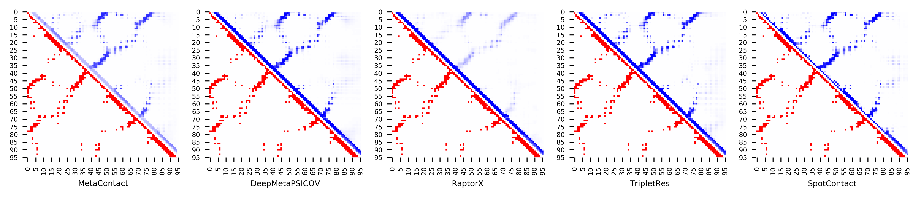

**Figure S101.** Five predicted contact maps (blue) with nature contacts (red) of target protein (3N9U_C)

**Table S108**. Precision of five contact maps (Protein ID: 3UE6_E)

|  |  |  |  |  |  |  |  |  |  |  |  |
| --- | --- | --- | --- | --- | --- | --- | --- | --- | --- | --- | --- |
| ID: 3UE6_E | | MetaContact | | DeepMetaPSICOV | | RaptorX | | SpotContact | | TripletRes | |
| Range | List size | Precision | Count | Precision | Count | Precision | Count | Precision | Count | Precision | Count |
| medium and long | Top-L/5 | 0.964 | 28 | 1.000 | 28 | 0.857 | 28 | 1.000 | 28 | 1.000 | 28 |
| Top-L/2 | 0.971 | 69 | 0.928 | 69 | 0.812 | 69 | 0.986 | 69 | 0.971 | 69 |
| Top-L | 0.870 | 138 | 0.870 | 138 | 0.703 | 138 | 0.833 | 138 | 0.848 | 138 |
| Top-NC | 0.726 | 201 | 0.731 | 201 | 0.587 | 201 | 0.716 | 201 | 0.721 | 201 |
| long | Top-L/5 | 0.821 | 28 | 0.857 | 28 | 0.714 | 28 | 0.821 | 28 | 0.857 | 28 |
| Top-L/2 | 0.812 | 69 | 0.812 | 69 | 0.623 | 69 | 0.739 | 69 | 0.754 | 69 |
| Top-L | 0.565 | 138 | 0.529 | 138 | 0.449 | 138 | 0.551 | 138 | 0.536 | 138 |
| Top-NC | 0.626 | 115 | 0.626 | 115 | 0.487 | 115 | 0.609 | 115 | 0.600 | 115 |

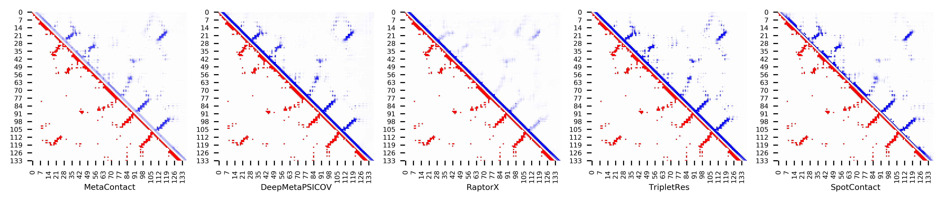

**Figure S102.** Five predicted contact maps (blue) with nature contacts (red) of target protein (3UE6_E)

**Table S109**. Precision of five contact maps (Protein ID: 3V1O_A)

|  |  |  |  |  |  |  |  |  |  |  |  |
| --- | --- | --- | --- | --- | --- | --- | --- | --- | --- | --- | --- |
| ID: 3V1O_A | | MetaContact | | DeepMetaPSICOV | | RaptorX | | SpotContact | | TripletRes | |
| Range | List size | Precision | Count | Precision | Count | Precision | Count | Precision | Count | Precision | Count |
| medium and long | Top-L/5 | 0.909 | 33 | 0.879 | 33 | 0.576 | 33 | 1.000 | 33 | 0.939 | 33 |
| Top-L/2 | 0.841 | 82 | 0.768 | 82 | 0.671 | 82 | 1.000 | 82 | 0.805 | 82 |
| Top-L | 0.806 | 165 | 0.745 | 165 | 0.624 | 165 | 0.891 | 165 | 0.782 | 165 |
| Top-NC | 0.668 | 349 | 0.585 | 349 | 0.507 | 349 | 0.719 | 349 | 0.610 | 349 |
| long | Top-L/5 | 1.000 | 33 | 0.939 | 33 | 0.788 | 33 | 1.000 | 33 | 0.939 | 33 |
| Top-L/2 | 0.927 | 82 | 0.890 | 82 | 0.720 | 82 | 0.976 | 82 | 0.890 | 82 |
| Top-L | 0.806 | 165 | 0.745 | 165 | 0.630 | 165 | 0.867 | 165 | 0.812 | 165 |
| Top-NC | 0.678 | 276 | 0.601 | 276 | 0.525 | 276 | 0.743 | 276 | 0.616 | 276 |

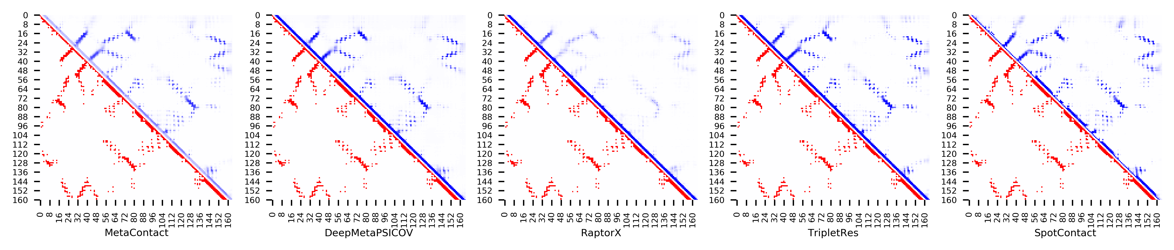

**Figure S103.** Five predicted contact maps (blue) with nature contacts (red) of target protein (3V1O_A)

**Table S110**. Precision of five contact maps (Protein ID: 3W1Z_D)

|  |  |  |  |  |  |  |  |  |  |  |  |
| --- | --- | --- | --- | --- | --- | --- | --- | --- | --- | --- | --- |
| ID: 3W1Z_D | | MetaContact | | DeepMetaPSICOV | | RaptorX | | SpotContact | | TripletRes | |
| Range | List size | Precision | Count | Precision | Count | Precision | Count | Precision | Count | Precision | Count |
| medium and long | Top-L/5 | 1.000 | 22 | 1.000 | 22 | 0.864 | 22 | 1.000 | 22 | 1.000 | 22 |
| Top-L/2 | 1.000 | 55 | 1.000 | 55 | 0.727 | 55 | 1.000 | 55 | 0.873 | 55 |
| Top-L | 0.900 | 110 | 0.855 | 110 | 0.645 | 110 | 0.927 | 110 | 0.718 | 110 |
| Top-NC | 0.750 | 160 | 0.756 | 160 | 0.538 | 160 | 0.775 | 160 | 0.625 | 160 |
| long | Top-L/5 | 1.000 | 22 | 1.000 | 22 | 0.727 | 22 | 1.000 | 22 | 1.000 | 22 |
| Top-L/2 | 0.982 | 55 | 0.945 | 55 | 0.564 | 55 | 1.000 | 55 | 0.745 | 55 |
| Top-L | 0.727 | 110 | 0.727 | 110 | 0.464 | 110 | 0.764 | 110 | 0.555 | 110 |
| Top-NC | 0.752 | 105 | 0.752 | 105 | 0.467 | 105 | 0.790 | 105 | 0.562 | 105 |

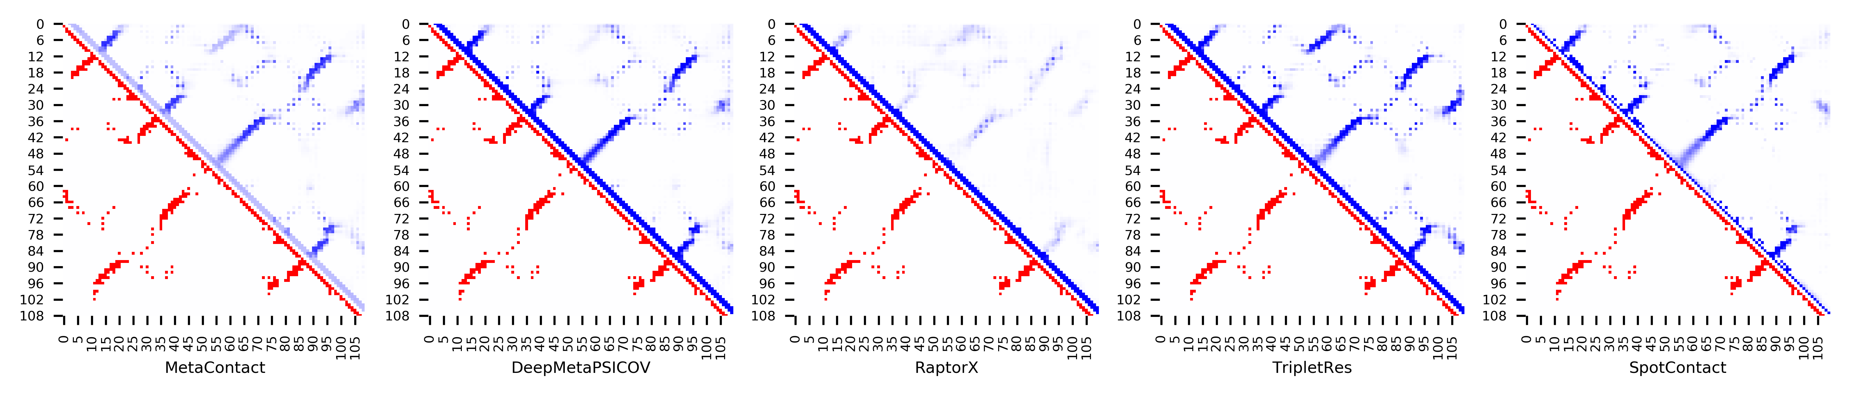

**Figure S104.** Five predicted contact maps (blue) with nature contacts (red) of target protein (3W1Z_D)

**Table S111**. Precision of five contact maps (Protein ID: 4AIH_A)

|  |  |  |  |  |  |  |  |  |  |  |  |
| --- | --- | --- | --- | --- | --- | --- | --- | --- | --- | --- | --- |
| ID: 4AIH_A | | MetaContact | | DeepMetaPSICOV | | RaptorX | | SpotContact | | TripletRes | |
| Range | List size | Precision | Count | Precision | Count | Precision | Count | Precision | Count | Precision | Count |
| medium and long | Top-L/5 | 0.821 | 28 | 0.786 | 28 | 0.500 | 28 | 0.821 | 28 | 0.679 | 28 |
| Top-L/2 | 0.757 | 70 | 0.700 | 70 | 0.400 | 70 | 0.800 | 70 | 0.700 | 70 |
| Top-L | 0.511 | 139 | 0.482 | 139 | 0.324 | 139 | 0.518 | 139 | 0.482 | 139 |
| Top-NC | 0.731 | 78 | 0.692 | 78 | 0.372 | 78 | 0.795 | 78 | 0.705 | 78 |
| long | Top-L/5 | 0.679 | 28 | 0.643 | 28 | 0.393 | 28 | 0.750 | 28 | 0.536 | 28 |
| Top-L/2 | 0.614 | 70 | 0.571 | 70 | 0.314 | 70 | 0.629 | 70 | 0.571 | 70 |
| Top-L | 0.338 | 139 | 0.338 | 139 | 0.252 | 139 | 0.345 | 139 | 0.331 | 139 |
| Top-NC | 0.686 | 51 | 0.647 | 51 | 0.392 | 51 | 0.765 | 51 | 0.647 | 51 |

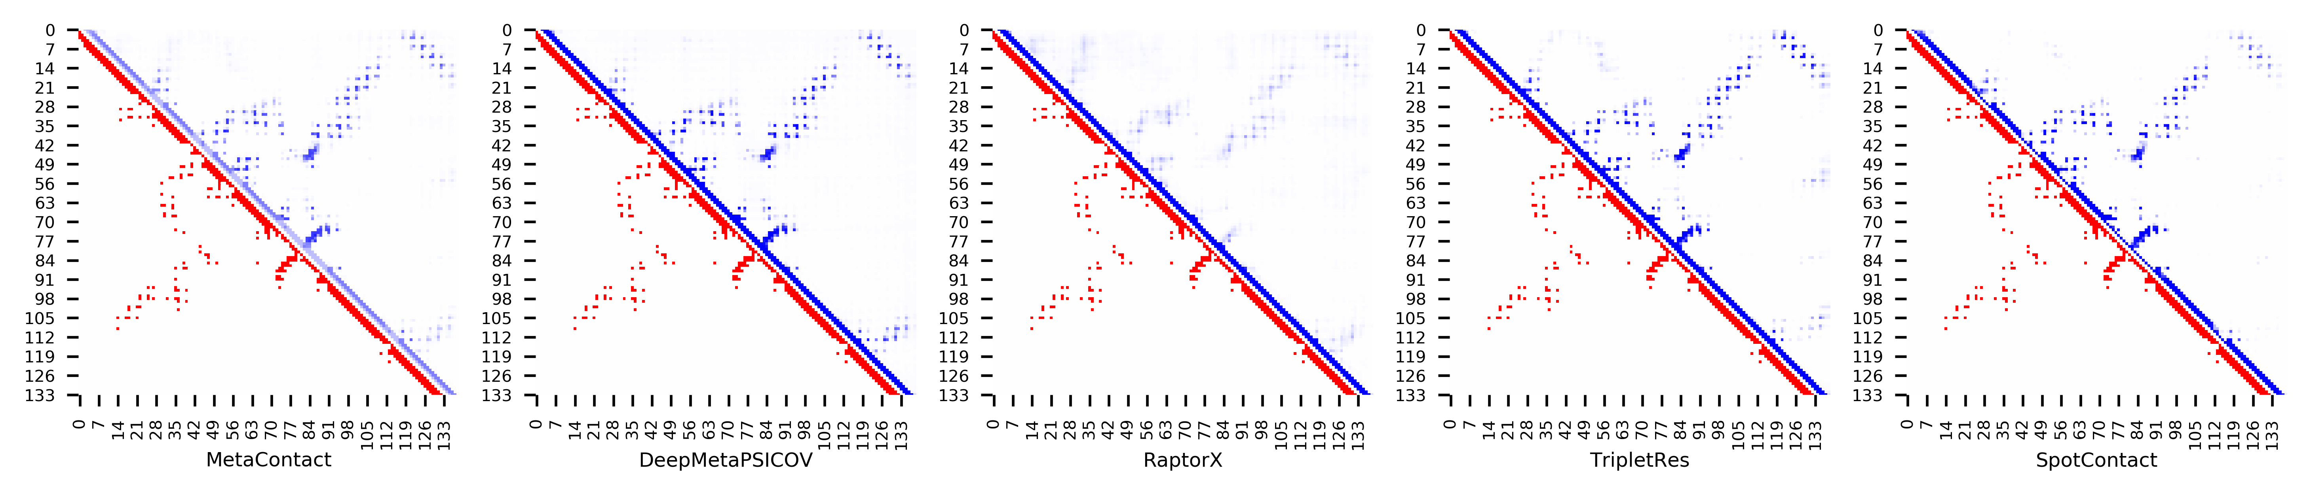

**Figure S105.** Five predicted contact maps (blue) with nature contacts (red) of target protein (4AIH_A)

**Table S112**. Precision of five contact maps (Protein ID: 4ASW_C)

|  |  |  |  |  |  |  |  |  |  |  |  |
| --- | --- | --- | --- | --- | --- | --- | --- | --- | --- | --- | --- |
| ID: 4ASW_C | | MetaContact | | DeepMetaPSICOV | | RaptorX | | SpotContact | | TripletRes | |
| Range | List size | Precision | Count | Precision | Count | Precision | Count | Precision | Count | Precision | Count |
| medium and long | Top-L/5 | 1.000 | 16 | 0.938 | 16 | 0.813 | 16 | 1.000 | 16 | 1.000 | 16 |
| Top-L/2 | 0.950 | 40 | 0.975 | 40 | 0.775 | 40 | 0.975 | 40 | 0.950 | 40 |
| Top-L | 0.914 | 81 | 0.877 | 81 | 0.630 | 81 | 0.914 | 81 | 0.901 | 81 |
| Top-NC | 0.772 | 127 | 0.717 | 127 | 0.559 | 127 | 0.811 | 127 | 0.732 | 127 |
| long | Top-L/5 | 1.000 | 16 | 0.938 | 16 | 0.938 | 16 | 1.000 | 16 | 1.000 | 16 |
| Top-L/2 | 0.950 | 40 | 0.975 | 40 | 0.825 | 40 | 0.975 | 40 | 0.950 | 40 |
| Top-L | 0.815 | 81 | 0.765 | 81 | 0.605 | 81 | 0.852 | 81 | 0.802 | 81 |
| Top-NC | 0.805 | 82 | 0.756 | 82 | 0.598 | 82 | 0.841 | 82 | 0.805 | 82 |

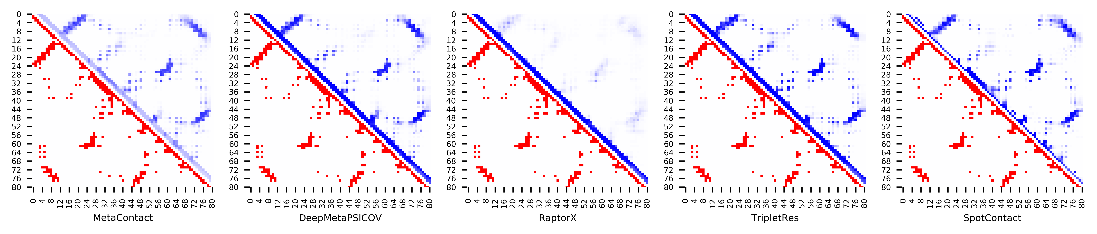

**Figure S106.** Five predicted contact maps (blue) with nature contacts (red) of target protein (4ASW_C)

**Table S113**. Precision of five contact maps (Protein ID: 4ESB_A)

|  |  |  |  |  |  |  |  |  |  |  |  |
| --- | --- | --- | --- | --- | --- | --- | --- | --- | --- | --- | --- |
| ID: 4ESB_A | | MetaContact | | DeepMetaPSICOV | | RaptorX | | SpotContact | | TripletRes | |
| Range | List size | Precision | Count | Precision | Count | Precision | Count | Precision | Count | Precision | Count |
| medium and long | Top-L/5 | 1.000 | 21 | 0.952 | 21 | 0.952 | 21 | 1.000 | 21 | 1.000 | 21 |
| Top-L/2 | 0.962 | 52 | 0.962 | 52 | 0.808 | 52 | 0.981 | 52 | 0.962 | 52 |
| Top-L | 0.806 | 103 | 0.767 | 103 | 0.602 | 103 | 0.796 | 103 | 0.748 | 103 |
| Top-NC | 0.840 | 94 | 0.809 | 94 | 0.617 | 94 | 0.851 | 94 | 0.787 | 94 |
| long | Top-L/5 | 1.000 | 21 | 1.000 | 21 | 0.857 | 21 | 1.000 | 21 | 1.000 | 21 |
| Top-L/2 | 0.865 | 52 | 0.865 | 52 | 0.577 | 52 | 0.865 | 52 | 0.788 | 52 |
| Top-L | 0.534 | 103 | 0.495 | 103 | 0.369 | 103 | 0.553 | 103 | 0.485 | 103 |
| Top-NC | 0.797 | 59 | 0.780 | 59 | 0.508 | 59 | 0.797 | 59 | 0.729 | 59 |



**Figure S107.** Five predicted contact maps (blue) with nature contacts (red) of target protein (4ESB_A)

**Table S114**. Precision of five contact maps (Protein ID: 4GF3_A)

|  |  |  |  |  |  |  |  |  |  |  |  |
| --- | --- | --- | --- | --- | --- | --- | --- | --- | --- | --- | --- |
| ID: 4GF3_A | | MetaContact | | DeepMetaPSICOV | | RaptorX | | SpotContact | | TripletRes | |
| Range | List size | Precision | Count | Precision | Count | Precision | Count | Precision | Count | Precision | Count |
| medium and long | Top-L/5 | 1.000 | 25 | 0.920 | 25 | 1.000 | 25 | 1.000 | 25 | 1.000 | 25 |
| Top-L/2 | 0.984 | 62 | 0.839 | 62 | 0.984 | 62 | 1.000 | 62 | 0.968 | 62 |
| Top-L | 0.886 | 123 | 0.610 | 123 | 0.862 | 123 | 0.927 | 123 | 0.797 | 123 |
| Top-NC | 0.727 | 176 | 0.506 | 176 | 0.744 | 176 | 0.761 | 176 | 0.665 | 176 |
| long | Top-L/5 | 1.000 | 25 | 1.000 | 25 | 1.000 | 25 | 1.000 | 25 | 1.000 | 25 |
| Top-L/2 | 0.984 | 62 | 0.726 | 62 | 1.000 | 62 | 0.984 | 62 | 0.887 | 62 |
| Top-L | 0.756 | 123 | 0.472 | 123 | 0.748 | 123 | 0.780 | 123 | 0.675 | 123 |
| Top-NC | 0.771 | 118 | 0.492 | 118 | 0.780 | 118 | 0.814 | 118 | 0.695 | 118 |

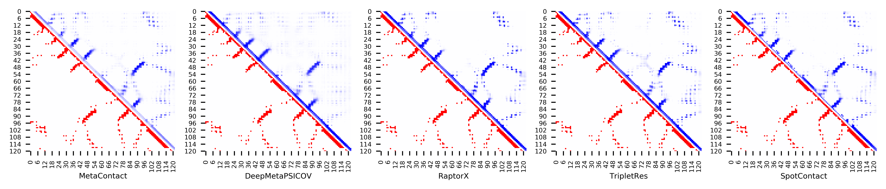

**Figure S108.** Five predicted contact maps (blue) with nature contacts (red) of target protein (4GF3_A)

**Table S115**. Precision of five contact maps (Protein ID: 4GQY_A)

|  |  |  |  |  |  |  |  |  |  |  |  |
| --- | --- | --- | --- | --- | --- | --- | --- | --- | --- | --- | --- |
| ID: 4GQY_A | | MetaContact | | DeepMetaPSICOV | | RaptorX | | SpotContact | | TripletRes | |
| Range | List size | Precision | Count | Precision | Count | Precision | Count | Precision | Count | Precision | Count |
| medium and long | Top-L/5 | 1.000 | 29 | 1.000 | 29 | 0.966 | 29 | 1.000 | 29 | 1.000 | 29 |
| Top-L/2 | 1.000 | 74 | 0.973 | 74 | 0.919 | 74 | 1.000 | 74 | 0.986 | 74 |
| Top-L | 0.959 | 147 | 0.905 | 147 | 0.776 | 147 | 0.980 | 147 | 0.946 | 147 |
| Top-NC | 0.850 | 227 | 0.775 | 227 | 0.634 | 227 | 0.868 | 227 | 0.828 | 227 |
| long | Top-L/5 | 1.000 | 29 | 0.966 | 29 | 0.966 | 29 | 1.000 | 29 | 1.000 | 29 |
| Top-L/2 | 0.973 | 74 | 0.892 | 74 | 0.797 | 74 | 0.986 | 74 | 0.946 | 74 |
| Top-L | 0.905 | 147 | 0.810 | 147 | 0.626 | 147 | 0.918 | 147 | 0.878 | 147 |
| Top-NC | 0.848 | 171 | 0.743 | 171 | 0.573 | 171 | 0.854 | 171 | 0.813 | 171 |

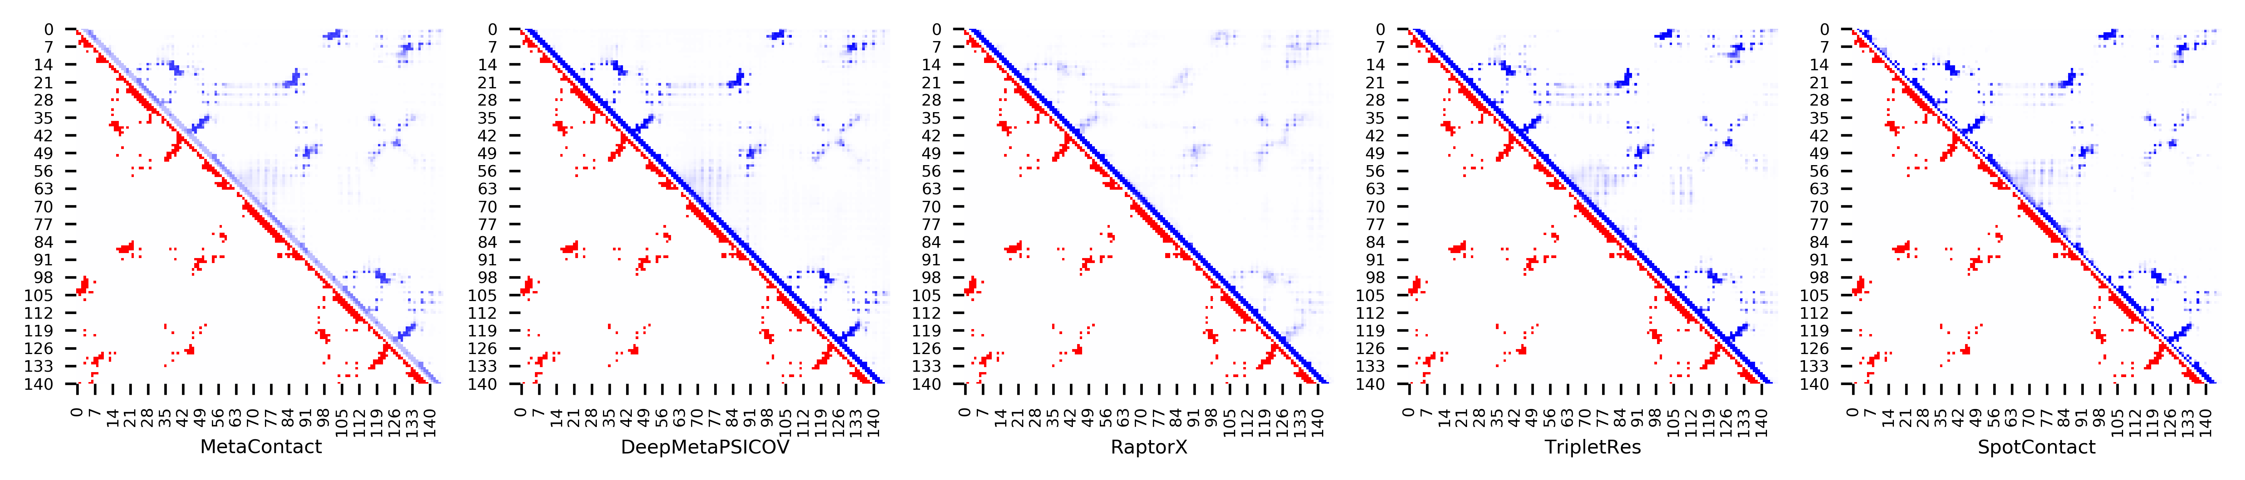

**Figure S109.** Five predicted contact maps (blue) with nature contacts (red) of target protein (4GQY_A)

**Table S116**. Precision of five contact maps (Protein ID: 4I60_A)

|  |  |  |  |  |  |  |  |  |  |  |  |
| --- | --- | --- | --- | --- | --- | --- | --- | --- | --- | --- | --- |
| ID: 4I60_A | | MetaContact | | DeepMetaPSICOV | | RaptorX | | SpotContact | | TripletRes | |
| Range | List size | Precision | Count | Precision | Count | Precision | Count | Precision | Count | Precision | Count |
| medium and long | Top-L/5 | 1.000 | 26 | 1.000 | 26 | 1.000 | 26 | 1.000 | 26 | 1.000 | 26 |
| Top-L/2 | 0.984 | 64 | 0.984 | 64 | 1.000 | 64 | 1.000 | 64 | 1.000 | 64 |
| Top-L | 0.977 | 128 | 0.898 | 128 | 0.992 | 128 | 0.984 | 128 | 0.977 | 128 |
| Top-NC | 0.831 | 237 | 0.747 | 237 | 0.848 | 237 | 0.840 | 237 | 0.781 | 237 |
| long | Top-L/5 | 0.923 | 26 | 0.769 | 26 | 0.962 | 26 | 0.962 | 26 | 0.962 | 26 |
| Top-L/2 | 0.828 | 64 | 0.594 | 64 | 0.859 | 64 | 0.828 | 64 | 0.750 | 64 |
| Top-L | 0.609 | 128 | 0.516 | 128 | 0.625 | 128 | 0.617 | 128 | 0.547 | 128 |
| Top-NC | 0.694 | 98 | 0.561 | 98 | 0.724 | 98 | 0.714 | 98 | 0.602 | 98 |

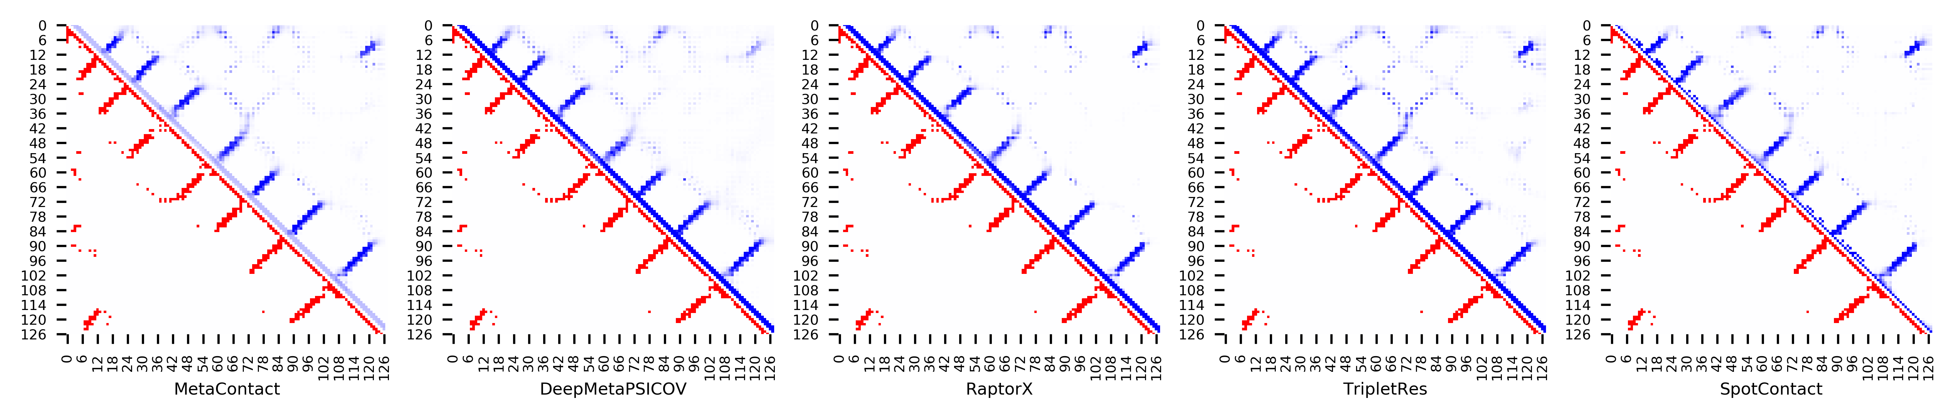

**Figure S110.** Five predicted contact maps (blue) with nature contacts (red) of target protein (4I60_A)

**Table S117**. Precision of five contact maps (Protein ID: 4JGX_B)

|  |  |  |  |  |  |  |  |  |  |  |  |
| --- | --- | --- | --- | --- | --- | --- | --- | --- | --- | --- | --- |
| ID: 4JGX_B | | MetaContact | | DeepMetaPSICOV | | RaptorX | | SpotContact | | TripletRes | |
| Range | List size | Precision | Count | Precision | Count | Precision | Count | Precision | Count | Precision | Count |
| medium and long | Top-L/5 | 1.000 | 26 | 1.000 | 26 | 0.962 | 26 | 1.000 | 26 | 1.000 | 26 |
| Top-L/2 | 0.969 | 64 | 0.953 | 64 | 0.906 | 64 | 0.969 | 64 | 0.922 | 64 |
| Top-L | 0.867 | 128 | 0.852 | 128 | 0.781 | 128 | 0.867 | 128 | 0.859 | 128 |
| Top-NC | 0.686 | 223 | 0.677 | 223 | 0.592 | 223 | 0.677 | 223 | 0.632 | 223 |
| long | Top-L/5 | 1.000 | 26 | 1.000 | 26 | 1.000 | 26 | 1.000 | 26 | 1.000 | 26 |
| Top-L/2 | 0.953 | 64 | 0.938 | 64 | 0.844 | 64 | 0.938 | 64 | 0.891 | 64 |
| Top-L | 0.758 | 128 | 0.750 | 128 | 0.648 | 128 | 0.734 | 128 | 0.688 | 128 |
| Top-NC | 0.663 | 166 | 0.663 | 166 | 0.566 | 166 | 0.651 | 166 | 0.596 | 166 |

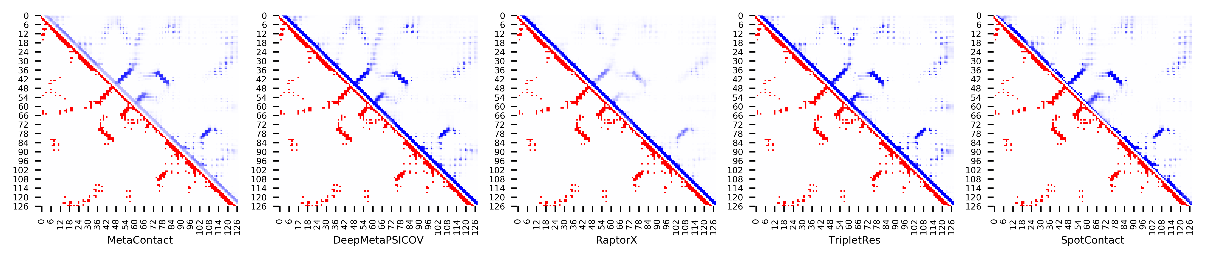

**Figure S111.** Five predicted contact maps (blue) with nature contacts (red) of target protein (4JGX_B)

**Table S118**. Precision of five contact maps (Protein ID: 4K1F_A)

|  |  |  |  |  |  |  |  |  |  |  |  |
| --- | --- | --- | --- | --- | --- | --- | --- | --- | --- | --- | --- |
| ID: 4K1F_A | | MetaContact | | DeepMetaPSICOV | | RaptorX | | SpotContact | | TripletRes | |
| Range | List size | Precision | Count | Precision | Count | Precision | Count | Precision | Count | Precision | Count |
| medium and long | Top-L/5 | 1.000 | 40 | 1.000 | 40 | 1.000 | 40 | 1.000 | 40 | 1.000 | 40 |
| Top-L/2 | 0.970 | 99 | 0.960 | 99 | 0.949 | 99 | 0.960 | 99 | 1.000 | 99 |
| Top-L | 0.914 | 198 | 0.859 | 198 | 0.869 | 198 | 0.864 | 198 | 0.899 | 198 |
| Top-NC | 0.734 | 349 | 0.679 | 349 | 0.699 | 349 | 0.705 | 349 | 0.676 | 349 |
| long | Top-L/5 | 1.000 | 40 | 1.000 | 40 | 0.975 | 40 | 1.000 | 40 | 1.000 | 40 |
| Top-L/2 | 0.960 | 99 | 0.929 | 99 | 0.919 | 99 | 0.899 | 99 | 0.980 | 99 |
| Top-L | 0.838 | 198 | 0.788 | 198 | 0.793 | 198 | 0.828 | 198 | 0.818 | 198 |
| Top-NC | 0.733 | 270 | 0.681 | 270 | 0.685 | 270 | 0.715 | 270 | 0.681 | 270 |

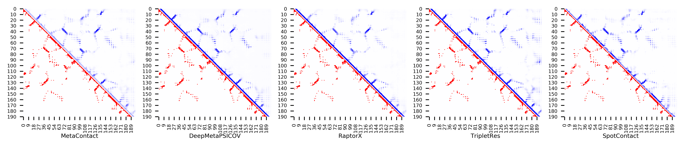

**Figure S112.** Five predicted contact maps (blue) with nature contacts (red) of target protein (4K1F_A)

**Table S119**. Precision of five contact maps (Protein ID: 4KA0_A)

|  |  |  |  |  |  |  |  |  |  |  |  |
| --- | --- | --- | --- | --- | --- | --- | --- | --- | --- | --- | --- |
| ID: 4KA0_A | | MetaContact | | DeepMetaPSICOV | | RaptorX | | SpotContact | | TripletRes | |
| Range | List size | Precision | Count | Precision | Count | Precision | Count | Precision | Count | Precision | Count |
| medium and long | Top-L/5 | 1.000 | 29 | 0.931 | 29 | 0.931 | 29 | 1.000 | 29 | 1.000 | 29 |
| Top-L/2 | 0.958 | 72 | 0.889 | 72 | 0.806 | 72 | 0.972 | 72 | 0.944 | 72 |
| Top-L | 0.874 | 143 | 0.818 | 143 | 0.699 | 143 | 0.902 | 143 | 0.867 | 143 |
| Top-NC | 0.757 | 235 | 0.702 | 235 | 0.591 | 235 | 0.757 | 235 | 0.728 | 235 |
| long | Top-L/5 | 1.000 | 29 | 1.000 | 29 | 0.931 | 29 | 1.000 | 29 | 1.000 | 29 |
| Top-L/2 | 0.944 | 72 | 0.889 | 72 | 0.764 | 72 | 0.986 | 72 | 0.972 | 72 |
| Top-L | 0.853 | 143 | 0.797 | 143 | 0.657 | 143 | 0.846 | 143 | 0.839 | 143 |
| Top-NC | 0.779 | 190 | 0.726 | 190 | 0.600 | 190 | 0.763 | 190 | 0.737 | 190 |

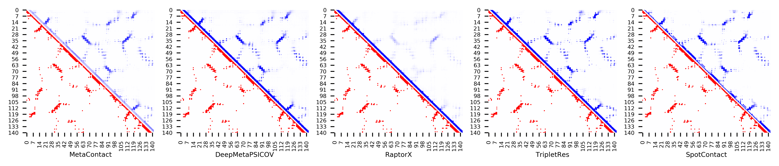

**Figure S113.** Five predicted contact maps (blue) with nature contacts (red) of target protein (4KA0_A)

**Table S120**. Precision of five contact maps (Protein ID: 4LE0_B)

|  |  |  |  |  |  |  |  |  |  |  |  |
| --- | --- | --- | --- | --- | --- | --- | --- | --- | --- | --- | --- |
| ID: 4LE0_B | | MetaContact | | DeepMetaPSICOV | | RaptorX | | SpotContact | | TripletRes | |
| Range | List size | Precision | Count | Precision | Count | Precision | Count | Precision | Count | Precision | Count |
| medium and long | Top-L/5 | 1.000 | 27 | 0.926 | 27 | 0.778 | 27 | 1.000 | 27 | 1.000 | 27 |
| Top-L/2 | 1.000 | 66 | 0.939 | 66 | 0.848 | 66 | 1.000 | 66 | 1.000 | 66 |
| Top-L | 0.970 | 133 | 0.910 | 133 | 0.722 | 133 | 0.977 | 133 | 0.985 | 133 |
| Top-NC | 0.822 | 259 | 0.737 | 259 | 0.517 | 259 | 0.815 | 259 | 0.815 | 259 |
| long | Top-L/5 | 1.000 | 27 | 0.926 | 27 | 0.741 | 27 | 1.000 | 27 | 1.000 | 27 |
| Top-L/2 | 1.000 | 66 | 0.939 | 66 | 0.788 | 66 | 1.000 | 66 | 1.000 | 66 |
| Top-L | 0.917 | 133 | 0.880 | 133 | 0.609 | 133 | 0.902 | 133 | 0.932 | 133 |
| Top-NC | 0.817 | 180 | 0.756 | 180 | 0.506 | 180 | 0.822 | 180 | 0.794 | 180 |

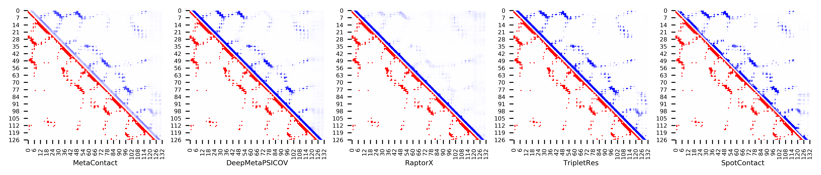

**Figure S114.** Five predicted contact maps (blue) with nature contacts (red) of target protein (4LE0_B)

**Table S121**. Precision of five contact maps (Protein ID: 4M75_F)

|  |  |  |  |  |  |  |  |  |  |  |  |
| --- | --- | --- | --- | --- | --- | --- | --- | --- | --- | --- | --- |
| ID: 4M75_F | | MetaContact | | DeepMetaPSICOV | | RaptorX | | SpotContact | | TripletRes | |
| Range | List size | Precision | Count | Precision | Count | Precision | Count | Precision | Count | Precision | Count |
| medium and long | Top-L/5 | 1.000 | 15 | 1.000 | 15 | 1.000 | 15 | 1.000 | 15 | 1.000 | 15 |
| Top-L/2 | 1.000 | 38 | 0.974 | 38 | 0.868 | 38 | 1.000 | 38 | 1.000 | 38 |
| Top-L | 0.973 | 75 | 0.933 | 75 | 0.813 | 75 | 0.987 | 75 | 0.947 | 75 |
| Top-NC | 0.845 | 110 | 0.800 | 110 | 0.655 | 110 | 0.855 | 110 | 0.818 | 110 |
| long | Top-L/5 | 1.000 | 15 | 1.000 | 15 | 1.000 | 15 | 1.000 | 15 | 1.000 | 15 |
| Top-L/2 | 0.842 | 38 | 0.895 | 38 | 0.711 | 38 | 0.868 | 38 | 0.895 | 38 |
| Top-L | 0.587 | 75 | 0.587 | 75 | 0.440 | 75 | 0.587 | 75 | 0.560 | 75 |
| Top-NC | 0.760 | 50 | 0.720 | 50 | 0.560 | 50 | 0.780 | 50 | 0.760 | 50 |

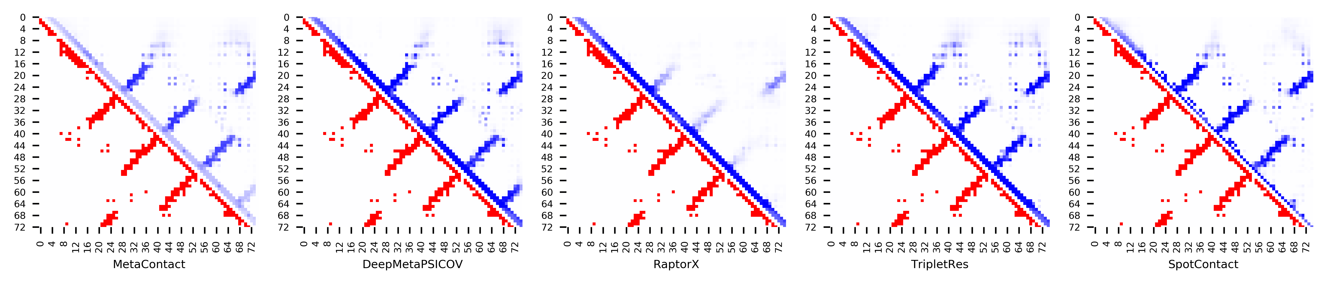

**Figure S115.** Five predicted contact maps (blue) with nature contacts (red) of target protein (4M75_F)

**Table S122**. Precision of five contact maps (Protein ID: 4MMG_A)

|  |  |  |  |  |  |  |  |  |  |  |  |
| --- | --- | --- | --- | --- | --- | --- | --- | --- | --- | --- | --- |
| ID: 4MMG_A | | MetaContact | | DeepMetaPSICOV | | RaptorX | | SpotContact | | TripletRes | |
| Range | List size | Precision | Count | Precision | Count | Precision | Count | Precision | Count | Precision | Count |
| medium and long | Top-L/5 | 1.000 | 18 | 1.000 | 18 | 0.833 | 18 | 1.000 | 18 | 1.000 | 18 |
| Top-L/2 | 0.978 | 46 | 0.957 | 46 | 0.696 | 46 | 0.978 | 46 | 0.957 | 46 |
| Top-L | 0.846 | 91 | 0.813 | 91 | 0.582 | 91 | 0.901 | 91 | 0.813 | 91 |
| Top-NC | 0.808 | 99 | 0.778 | 99 | 0.545 | 99 | 0.848 | 99 | 0.768 | 99 |
| long | Top-L/5 | 1.000 | 18 | 0.944 | 18 | 0.722 | 18 | 0.944 | 18 | 1.000 | 18 |
| Top-L/2 | 0.891 | 46 | 0.848 | 46 | 0.543 | 46 | 0.957 | 46 | 0.826 | 46 |
| Top-L | 0.615 | 91 | 0.560 | 91 | 0.407 | 91 | 0.626 | 91 | 0.538 | 91 |
| Top-NC | 0.783 | 60 | 0.733 | 60 | 0.483 | 60 | 0.817 | 60 | 0.717 | 60 |

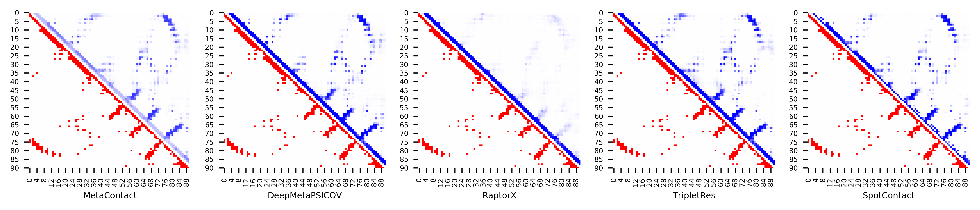

**Figure S116.** Five predicted contact maps (blue) with nature contacts (red) of target protein (4MMG_A)

**Table S123**. Precision of five contact maps (Protein ID: 4Q2O_A)

|  |  |  |  |  |  |  |  |  |  |  |  |
| --- | --- | --- | --- | --- | --- | --- | --- | --- | --- | --- | --- |
| ID: 4Q2O_A | | MetaContact | | DeepMetaPSICOV | | RaptorX | | SpotContact | | TripletRes | |
| Range | List size | Precision | Count | Precision | Count | Precision | Count | Precision | Count | Precision | Count |
| medium and long | Top-L/5 | 1.000 | 18 | 1.000 | 18 | 0.611 | 18 | 1.000 | 18 | 1.000 | 18 |
| Top-L/2 | 1.000 | 46 | 0.978 | 46 | 0.717 | 46 | 1.000 | 46 | 1.000 | 46 |
| Top-L | 0.957 | 92 | 0.696 | 92 | 0.620 | 92 | 0.957 | 92 | 0.935 | 92 |
| Top-NC | 0.793 | 150 | 0.560 | 150 | 0.507 | 150 | 0.793 | 150 | 0.760 | 150 |
| long | Top-L/5 | 1.000 | 18 | 1.000 | 18 | 0.889 | 18 | 1.000 | 18 | 1.000 | 18 |
| Top-L/2 | 0.978 | 46 | 0.935 | 46 | 0.739 | 46 | 0.957 | 46 | 0.957 | 46 |
| Top-L | 0.783 | 92 | 0.663 | 92 | 0.554 | 92 | 0.783 | 92 | 0.750 | 92 |
| Top-NC | 0.730 | 100 | 0.630 | 100 | 0.530 | 100 | 0.740 | 100 | 0.710 | 100 |

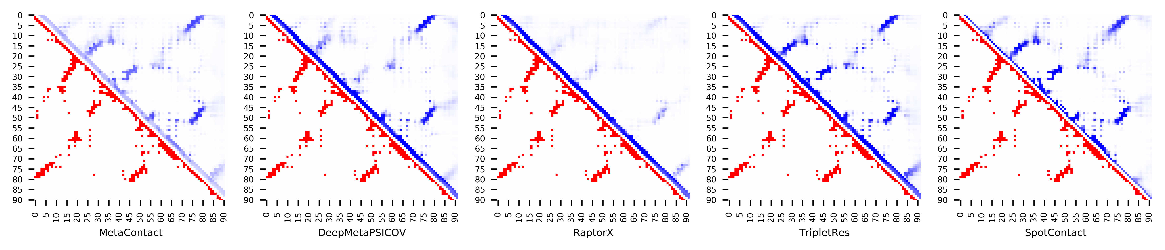

**Figure S117.** Five predicted contact maps (blue) with nature contacts (red) of target protein (4Q2O_A)

**Table S124**. Precision of five contact maps (Protein ID: 4R67_0)

|  |  |  |  |  |  |  |  |  |  |  |  |
| --- | --- | --- | --- | --- | --- | --- | --- | --- | --- | --- | --- |
| ID: 4R67_0 | | MetaContact | | DeepMetaPSICOV | | RaptorX | | SpotContact | | TripletRes | |
| Range | List size | Precision | Count | Precision | Count | Precision | Count | Precision | Count | Precision | Count |
| medium and long | Top-L/5 | 1.000 | 40 | 1.000 | 40 | 1.000 | 40 | 1.000 | 40 | 1.000 | 40 |
| Top-L/2 | 0.990 | 100 | 0.970 | 100 | 1.000 | 100 | 0.980 | 100 | 0.970 | 100 |
| Top-L | 0.920 | 199 | 0.854 | 199 | 0.955 | 199 | 0.905 | 199 | 0.900 | 199 |
| Top-NC | 0.789 | 375 | 0.659 | 375 | 0.797 | 375 | 0.731 | 375 | 0.755 | 375 |
| long | Top-L/5 | 1.000 | 40 | 1.000 | 40 | 1.000 | 40 | 1.000 | 40 | 1.000 | 40 |
| Top-L/2 | 0.970 | 100 | 0.950 | 100 | 1.000 | 100 | 0.970 | 100 | 0.940 | 100 |
| Top-L | 0.874 | 199 | 0.784 | 199 | 0.935 | 199 | 0.854 | 199 | 0.829 | 199 |
| Top-NC | 0.780 | 287 | 0.659 | 287 | 0.801 | 287 | 0.732 | 287 | 0.746 | 287 |

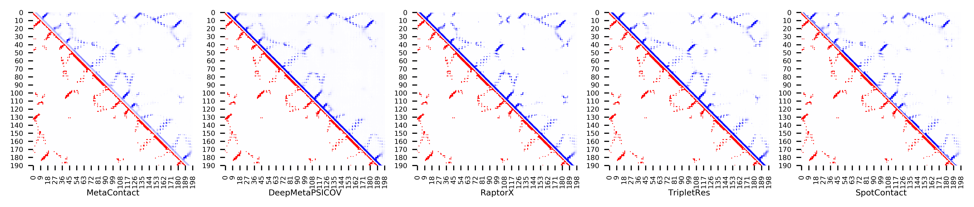

**Figure S118.** Five predicted contact maps (blue) with nature contacts (red) of target protein (4R67_0)

**Table S125**. Precision of five contact maps (Protein ID: 4RUV_A)

|  |  |  |  |  |  |  |  |  |  |  |  |
| --- | --- | --- | --- | --- | --- | --- | --- | --- | --- | --- | --- |
| ID: 4RUV_A | | MetaContact | | DeepMetaPSICOV | | RaptorX | | SpotContact | | TripletRes | |
| Range | List size | Precision | Count | Precision | Count | Precision | Count | Precision | Count | Precision | Count |
| medium and long | Top-L/5 | 1.000 | 21 | 1.000 | 21 | 0.905 | 21 | 1.000 | 21 | 1.000 | 21 |
| Top-L/2 | 0.981 | 53 | 0.962 | 53 | 0.811 | 53 | 1.000 | 53 | 0.981 | 53 |
| Top-L | 0.953 | 106 | 0.849 | 106 | 0.698 | 106 | 0.953 | 106 | 0.887 | 106 |
| Top-NC | 0.761 | 159 | 0.736 | 159 | 0.553 | 159 | 0.836 | 159 | 0.755 | 159 |
| long | Top-L/5 | 1.000 | 21 | 1.000 | 21 | 0.905 | 21 | 1.000 | 21 | 1.000 | 21 |
| Top-L/2 | 1.000 | 53 | 0.981 | 53 | 0.811 | 53 | 1.000 | 53 | 1.000 | 53 |
| Top-L | 0.925 | 106 | 0.840 | 106 | 0.670 | 106 | 0.943 | 106 | 0.849 | 106 |
| Top-NC | 0.822 | 129 | 0.783 | 129 | 0.597 | 129 | 0.853 | 129 | 0.791 | 129 |

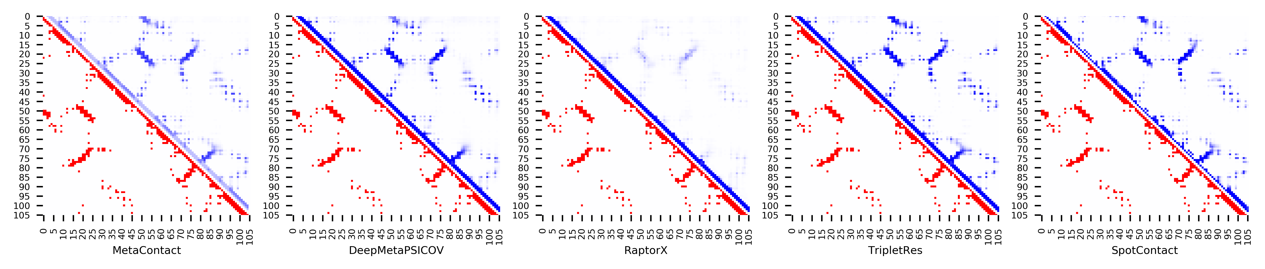

**Figure S119.** Five predicted contact maps (blue) with nature contacts (red) of target protein (4RUV_A)

**Table S126**. Precision of five contact maps (Protein ID: 4UIJ_A)

|  |  |  |  |  |  |  |  |  |  |  |  |
| --- | --- | --- | --- | --- | --- | --- | --- | --- | --- | --- | --- |
| ID: 4UIJ_A | | MetaContact | | DeepMetaPSICOV | | RaptorX | | SpotContact | | TripletRes | |
| Range | List size | Precision | Count | Precision | Count | Precision | Count | Precision | Count | Precision | Count |
| medium and long | Top-L/5 | 0.952 | 21 | 0.952 | 21 | 0.952 | 21 | 1.000 | 21 | 1.000 | 21 |
| Top-L/2 | 0.942 | 52 | 0.923 | 52 | 0.846 | 52 | 0.923 | 52 | 0.923 | 52 |
| Top-L | 0.817 | 104 | 0.683 | 104 | 0.702 | 104 | 0.788 | 104 | 0.798 | 104 |
| Top-NC | 0.786 | 112 | 0.670 | 112 | 0.688 | 112 | 0.777 | 112 | 0.768 | 112 |
| long | Top-L/5 | 1.000 | 21 | 0.952 | 21 | 0.857 | 21 | 0.952 | 21 | 0.952 | 21 |
| Top-L/2 | 0.904 | 52 | 0.827 | 52 | 0.769 | 52 | 0.904 | 52 | 0.904 | 52 |
| Top-L | 0.683 | 104 | 0.558 | 104 | 0.615 | 104 | 0.673 | 104 | 0.644 | 104 |
| Top-NC | 0.800 | 85 | 0.624 | 85 | 0.659 | 85 | 0.765 | 85 | 0.729 | 85 |

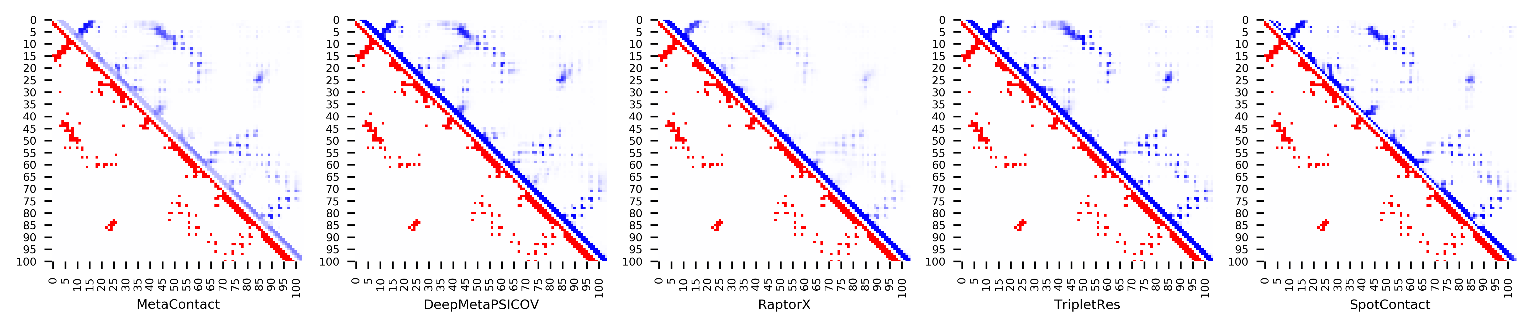

**Figure S120.** Five predicted contact maps (blue) with nature contacts (red) of target protein (4UIJ_A)

**Table S127**. Precision of five contact maps (Protein ID: 4Z6J_A)

|  |  |  |  |  |  |  |  |  |  |  |  |
| --- | --- | --- | --- | --- | --- | --- | --- | --- | --- | --- | --- |
| ID: 4Z6J_A | | MetaContact | | DeepMetaPSICOV | | RaptorX | | SpotContact | | TripletRes | |
| Range | List size | Precision | Count | Precision | Count | Precision | Count | Precision | Count | Precision | Count |
| medium and long | Top-L/5 | 1.000 | 27 | 1.000 | 27 | 1.000 | 27 | 1.000 | 27 | 1.000 | 27 |
| Top-L/2 | 0.985 | 66 | 0.970 | 66 | 1.000 | 66 | 1.000 | 66 | 0.985 | 66 |
| Top-L | 0.955 | 133 | 0.902 | 133 | 0.970 | 133 | 0.955 | 133 | 0.910 | 133 |
| Top-NC | 0.792 | 226 | 0.721 | 226 | 0.792 | 226 | 0.805 | 226 | 0.726 | 226 |
| long | Top-L/5 | 0.963 | 27 | 0.889 | 27 | 1.000 | 27 | 0.963 | 27 | 0.963 | 27 |
| Top-L/2 | 0.848 | 66 | 0.606 | 66 | 0.879 | 66 | 0.833 | 66 | 0.697 | 66 |
| Top-L | 0.594 | 133 | 0.466 | 133 | 0.579 | 133 | 0.602 | 133 | 0.481 | 133 |
| Top-NC | 0.683 | 101 | 0.535 | 101 | 0.693 | 101 | 0.683 | 101 | 0.535 | 101 |

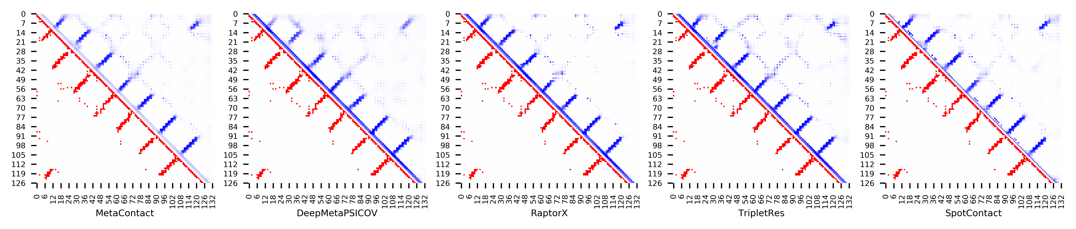

**Figure S121.** Five predicted contact maps (blue) with nature contacts (red) of target protein (4Z6J_A)

**Table S128**. Precision of five contact maps (Protein ID: 5CJ3_B)

|  |  |  |  |  |  |  |  |  |  |  |  |
| --- | --- | --- | --- | --- | --- | --- | --- | --- | --- | --- | --- |
| ID: 5CJ3_B | | MetaContact | | DeepMetaPSICOV | | RaptorX | | SpotContact | | TripletRes | |
| Range | List size | Precision | Count | Precision | Count | Precision | Count | Precision | Count | Precision | Count |
| medium and long | Top-L/5 | 1.000 | 25 | 1.000 | 25 | 0.920 | 25 | 1.000 | 25 | 1.000 | 25 |
| Top-L/2 | 1.000 | 63 | 0.968 | 63 | 0.762 | 63 | 1.000 | 63 | 0.968 | 63 |
| Top-L | 0.921 | 126 | 0.897 | 126 | 0.667 | 126 | 0.937 | 126 | 0.802 | 126 |
| Top-NC | 0.726 | 197 | 0.731 | 197 | 0.553 | 197 | 0.797 | 197 | 0.660 | 197 |
| long | Top-L/5 | 1.000 | 25 | 1.000 | 25 | 0.840 | 25 | 1.000 | 25 | 1.000 | 25 |
| Top-L/2 | 0.952 | 63 | 0.921 | 63 | 0.698 | 63 | 0.952 | 63 | 0.841 | 63 |
| Top-L | 0.714 | 126 | 0.730 | 126 | 0.548 | 126 | 0.786 | 126 | 0.635 | 126 |
| Top-NC | 0.724 | 123 | 0.748 | 123 | 0.561 | 123 | 0.797 | 123 | 0.642 | 123 |

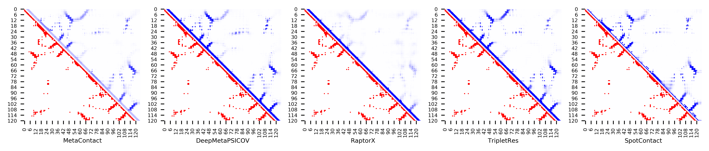

**Figure S122.** Five predicted contact maps (blue) with nature contacts (red) of target protein (5CJ3_B)

**Table S129**. Precision of five contact maps (Protein ID: 5IAO_A)

|  |  |  |  |  |  |  |  |  |  |  |  |
| --- | --- | --- | --- | --- | --- | --- | --- | --- | --- | --- | --- |
| ID: 5IAO_A | | MetaContact | | DeepMetaPSICOV | | RaptorX | | SpotContact | | TripletRes | |
| Range | List size | Precision | Count | Precision | Count | Precision | Count | Precision | Count | Precision | Count |
| medium and long | Top-L/5 | 1.000 | 34 | 1.000 | 34 | 1.000 | 34 | 1.000 | 34 | 1.000 | 34 |
| Top-L/2 | 1.000 | 86 | 1.000 | 86 | 0.977 | 86 | 1.000 | 86 | 1.000 | 86 |
| Top-L | 0.971 | 171 | 0.936 | 171 | 0.942 | 171 | 0.947 | 171 | 0.971 | 171 |
| Top-NC | 0.753 | 364 | 0.714 | 364 | 0.755 | 364 | 0.736 | 364 | 0.739 | 364 |
| long | Top-L/5 | 1.000 | 34 | 1.000 | 34 | 1.000 | 34 | 1.000 | 34 | 1.000 | 34 |
| Top-L/2 | 0.977 | 86 | 0.965 | 86 | 0.965 | 86 | 0.988 | 86 | 0.988 | 86 |
| Top-L | 0.942 | 171 | 0.854 | 171 | 0.895 | 171 | 0.918 | 171 | 0.895 | 171 |
| Top-NC | 0.747 | 281 | 0.698 | 281 | 0.740 | 281 | 0.719 | 281 | 0.722 | 281 |

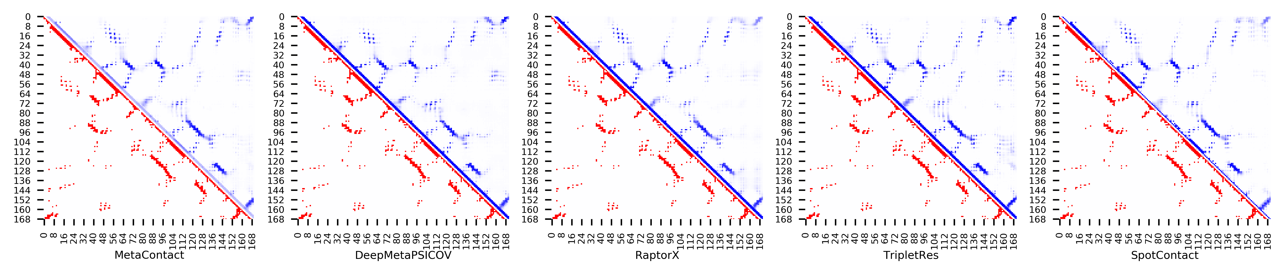

**Figure S123.** Five predicted contact maps (blue) with nature contacts (red) of target protein (5IAO_A)

**Table S130**. Precision of five contact maps (Protein ID: 5L38_A)

|  |  |  |  |  |  |  |  |  |  |  |  |
| --- | --- | --- | --- | --- | --- | --- | --- | --- | --- | --- | --- |
| ID: 5L38_A | | MetaContact | | DeepMetaPSICOV | | RaptorX | | SpotContact | | TripletRes | |
| Range | List size | Precision | Count | Precision | Count | Precision | Count | Precision | Count | Precision | Count |
| medium and long | Top-L/5 | 1.000 | 18 | 1.000 | 18 | 1.000 | 18 | 1.000 | 18 | 1.000 | 18 |
| Top-L/2 | 1.000 | 46 | 1.000 | 46 | 1.000 | 46 | 1.000 | 46 | 1.000 | 46 |
| Top-L | 0.978 | 91 | 0.967 | 91 | 0.978 | 91 | 0.989 | 91 | 0.967 | 91 |
| Top-NC | 0.807 | 192 | 0.802 | 192 | 0.797 | 192 | 0.818 | 192 | 0.781 | 192 |
| long | Top-L/5 | 1.000 | 18 | 1.000 | 18 | 1.000 | 18 | 1.000 | 18 | 1.000 | 18 |
| Top-L/2 | 1.000 | 46 | 1.000 | 46 | 1.000 | 46 | 1.000 | 46 | 1.000 | 46 |
| Top-L | 0.967 | 91 | 0.967 | 91 | 0.956 | 91 | 0.945 | 91 | 0.923 | 91 |
| Top-NC | 0.797 | 158 | 0.797 | 158 | 0.785 | 158 | 0.797 | 158 | 0.753 | 158 |

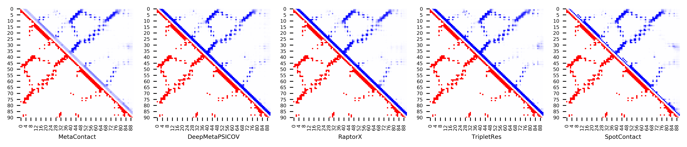

**Figure S124.** Five predicted contact maps (blue) with nature contacts (red) of target protein (5L38_A)

**Table S131**. Precision of five contact maps (Protein ID: 5O2V_A)

|  |  |  |  |  |  |  |  |  |  |  |  |
| --- | --- | --- | --- | --- | --- | --- | --- | --- | --- | --- | --- |
| ID: 5O2V_A | | MetaContact | | DeepMetaPSICOV | | RaptorX | | SpotContact | | TripletRes | |
| Range | List size | Precision | Count | Precision | Count | Precision | Count | Precision | Count | Precision | Count |
| medium and long | Top-L/5 | 1.000 | 18 | 1.000 | 18 | 0.833 | 18 | 1.000 | 18 | 1.000 | 18 |
| Top-L/2 | 0.978 | 46 | 0.978 | 46 | 0.848 | 46 | 0.978 | 46 | 1.000 | 46 |
| Top-L | 0.935 | 92 | 0.935 | 92 | 0.772 | 92 | 0.924 | 92 | 0.924 | 92 |
| Top-NC | 0.839 | 149 | 0.812 | 149 | 0.685 | 149 | 0.866 | 149 | 0.792 | 149 |
| long | Top-L/5 | 1.000 | 18 | 1.000 | 18 | 0.722 | 18 | 0.944 | 18 | 1.000 | 18 |
| Top-L/2 | 0.935 | 46 | 0.957 | 46 | 0.848 | 46 | 0.957 | 46 | 0.935 | 46 |
| Top-L | 0.880 | 92 | 0.870 | 92 | 0.750 | 92 | 0.913 | 92 | 0.848 | 92 |
| Top-NC | 0.832 | 113 | 0.796 | 113 | 0.655 | 113 | 0.850 | 113 | 0.761 | 113 |

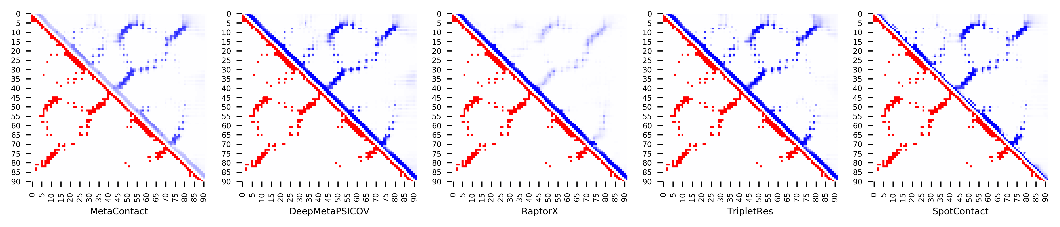

**Figure S125.** Five predicted contact maps (blue) with nature contacts (red) of target protein (5O2V_A)

**Table S132**. Precision of five contact maps (Protein ID: 5O8G _A)

|  |  |  |  |  |  |  |  |  |  |  |  |
| --- | --- | --- | --- | --- | --- | --- | --- | --- | --- | --- | --- |
| ID: 5O8G _A | | MetaContact | | DeepMetaPSICOV | | RaptorX | | SpotContact | | TripletRes | |
| Range | List size | Precision | Count | Precision | Count | Precision | Count | Precision | Count | Precision | Count |
| medium and long | Top-L/5 | 1.000 | 24 | 1.000 | 24 | 0.917 | 24 | 1.000 | 24 | 1.000 | 24 |
| Top-L/2 | 0.934 | 61 | 0.934 | 61 | 0.820 | 61 | 0.951 | 61 | 0.984 | 61 |
| Top-L | 0.885 | 122 | 0.852 | 122 | 0.721 | 122 | 0.869 | 122 | 0.902 | 122 |
| Top-NC | 0.778 | 176 | 0.722 | 176 | 0.648 | 176 | 0.761 | 176 | 0.761 | 176 |
| long | Top-L/5 | 0.958 | 24 | 0.958 | 24 | 0.833 | 24 | 1.000 | 24 | 1.000 | 24 |
| Top-L/2 | 0.934 | 61 | 0.902 | 61 | 0.803 | 61 | 0.918 | 61 | 0.918 | 61 |
| Top-L | 0.770 | 122 | 0.697 | 122 | 0.615 | 122 | 0.746 | 122 | 0.730 | 122 |
| Top-NC | 0.770 | 122 | 0.697 | 122 | 0.615 | 122 | 0.746 | 122 | 0.730 | 122 |

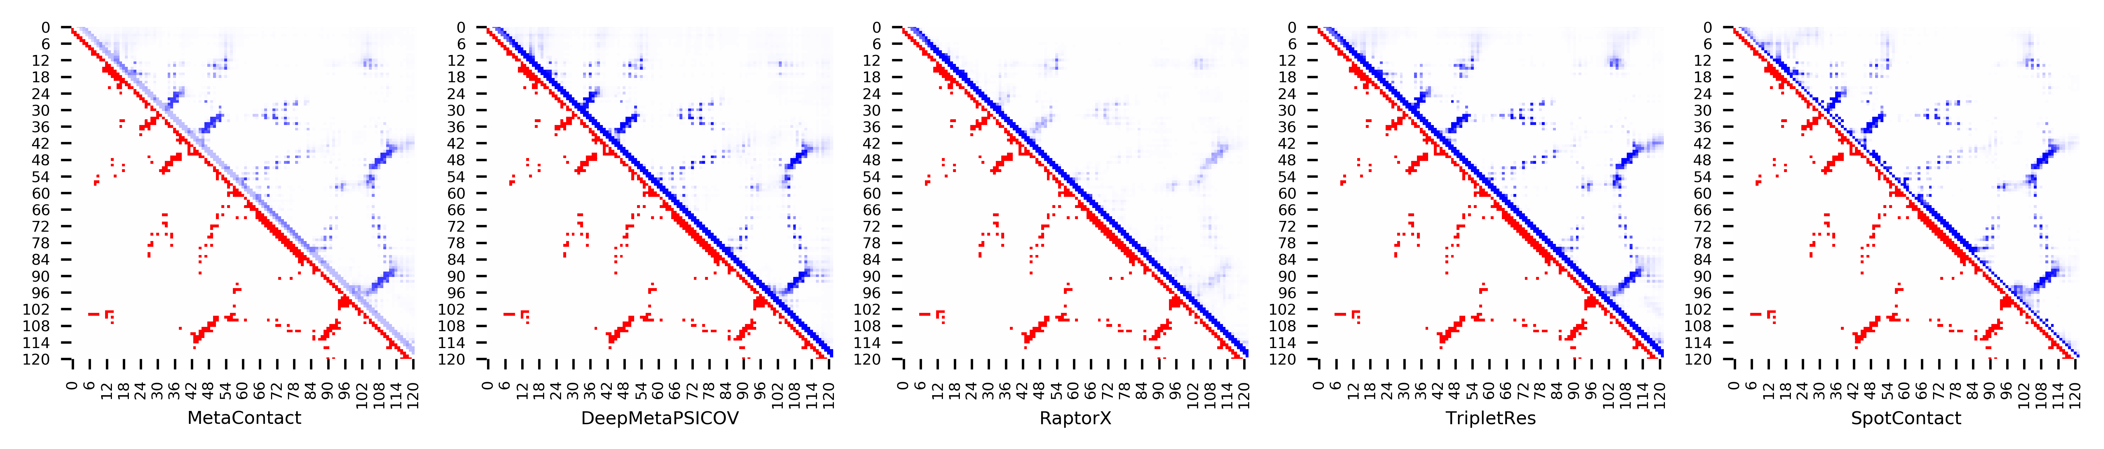

**Figure S126.** Five predicted contact maps (blue) with nature contacts (red) of target protein (5O8G _A)

**Table S133**. Precision of five contact maps (Protein ID: 5T17_A)

|  |  |  |  |  |  |  |  |  |  |  |  |
| --- | --- | --- | --- | --- | --- | --- | --- | --- | --- | --- | --- |
| ID: 5T17_A | | MetaContact | | DeepMetaPSICOV | | RaptorX | | SpotContact | | TripletRes | |
| Range | List size | Precision | Count | Precision | Count | Precision | Count | Precision | Count | Precision | Count |
| medium and long | Top-L/5 | 0.941 | 17 | 1.000 | 17 | 0.941 | 17 | 1.000 | 17 | 0.941 | 17 |
| Top-L/2 | 0.905 | 42 | 0.952 | 42 | 0.786 | 42 | 0.976 | 42 | 0.929 | 42 |
| Top-L | 0.882 | 85 | 0.882 | 85 | 0.659 | 85 | 0.871 | 85 | 0.871 | 85 |
| Top-NC | 0.680 | 178 | 0.691 | 178 | 0.522 | 178 | 0.691 | 178 | 0.663 | 178 |
| long | Top-L/5 | 0.941 | 17 | 1.000 | 17 | 0.941 | 17 | 1.000 | 17 | 0.941 | 17 |
| Top-L/2 | 0.905 | 42 | 0.952 | 42 | 0.762 | 42 | 0.976 | 42 | 0.929 | 42 |
| Top-L | 0.859 | 85 | 0.859 | 85 | 0.624 | 85 | 0.859 | 85 | 0.824 | 85 |
| Top-NC | 0.690 | 145 | 0.703 | 145 | 0.545 | 145 | 0.703 | 145 | 0.669 | 145 |

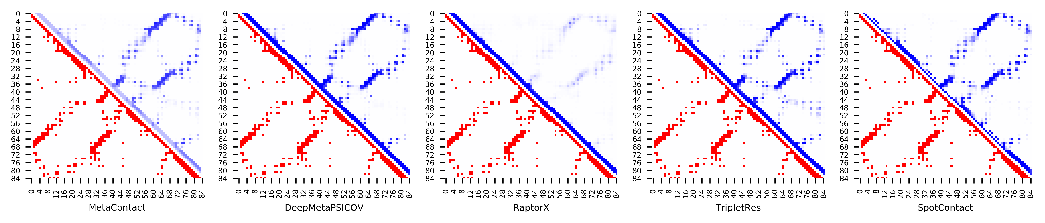

**Figure S127.** Five predicted contact maps (blue) with nature contacts (red) of target protein (5T17_A)

**Table S134**. Precision of five contact maps (Protein ID: 5TMF_E)

|  |  |  |  |  |  |  |  |  |  |  |  |
| --- | --- | --- | --- | --- | --- | --- | --- | --- | --- | --- | --- |
| ID: 5TMF_E | | MetaContact | | DeepMetaPSICOV | | RaptorX | | SpotContact | | TripletRes | |
| Range | List size | Precision | Count | Precision | Count | Precision | Count | Precision | Count | Precision | Count |
| medium and long | Top-L/5 | 0.947 | 19 | 0.632 | 19 | 0.947 | 19 | 0.947 | 19 | 0.895 | 19 |
| Top-L/2 | 0.688 | 48 | 0.438 | 48 | 0.771 | 48 | 0.708 | 48 | 0.625 | 48 |
| Top-L | 0.432 | 95 | 0.295 | 95 | 0.400 | 95 | 0.411 | 95 | 0.411 | 95 |
| Top-NC | 0.563 | 71 | 0.338 | 71 | 0.535 | 71 | 0.507 | 71 | 0.535 | 71 |
| long | Top-L/5 | 0.947 | 19 | 0.632 | 19 | 0.947 | 19 | 0.947 | 19 | 0.895 | 19 |
| Top-L/2 | 0.708 | 48 | 0.458 | 48 | 0.771 | 48 | 0.729 | 48 | 0.583 | 48 |
| Top-L | 0.411 | 95 | 0.305 | 95 | 0.411 | 95 | 0.411 | 95 | 0.432 | 95 |
| Top-NC | 0.603 | 63 | 0.397 | 63 | 0.603 | 63 | 0.571 | 63 | 0.540 | 63 |

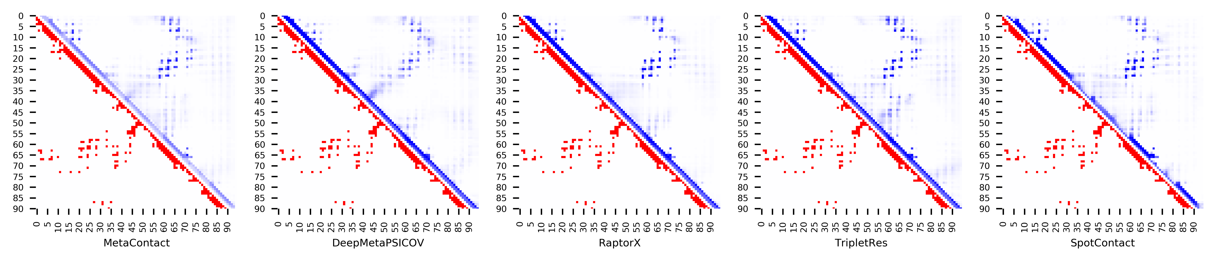

**Figure S128.** Five predicted contact maps (blue) with nature contacts (red) of target protein (5TMF_E)